Date: | October 14, 2003
To: | Board of Directors
From: | Beth Garza, TAC Chair
Subject: | 2004 Commercial Significant Constraints and Congestion Zones

Issue for the ERCOT Board of Directors

ERCOT Board of Director Meeting Date: October 21, 2003
Agenda Item No.: 11b

Issue: Designation of Commercially Significant Constraints (CSCs) in the ERCOT transmission system and Transmission Congestion Zones.

Background/History:

Section 7.2.1.1 Process for Determining CSCs of the ERCOT Protocols states:
ERCOT will reassess CSCs annually, based on changes to the ERCOT System topology, and will identify new Congestion Zones based on the reassessed CSC’s by November 1 of each year. (emphasis added)

Section 7.2.1.3, Determining Closely Related Elements (CREs)
By November 1 of each year, the appropriate ERCOT subcommittee will report to the TAC and ERCOT Board with recommended CSC designations, resulting Congestion Zone boundaries, CRE designations and associated Boundary Generation Resources for ERCOT Board review and approval.

The ERCOT Protocols define two types of transmission congestion: (1) CSC Congestion and (2) Local or Operational Congestion. CSC Congestion is that transmission congestion that is determined to be “commercially significant” and is used to establish annual Congestion Zones. The Protocols require ERCOT to identify CSCs on an annual basis in the process described in ERCOT Protocols Section 7.2.1. ERCOT manages Zonal Congestion in accordance with Section 7.3. The costs of Zonal Congestion are directly assigned to the QSEs whose schedules cause Zonal Congestion. Section 7.5 provides QSEs a hedging tool, Transmission Congestion Rights (TCRs) that can be used to offset the costs of Zonal Congestion.

The Congestion Management Working Group (CMWG), under the auspices of the WMS and TAC, has been working on this issue for several months. ERCOT Staff provided the underlying analysis, and the PUCT Staff has been very involved in the review.

The Wholesale Market Subcommittee considered the following sets of CSCs and Zones:

- 3 CSCs, 4 Zones – Same as 2003
- 4 CSCs, 4 Zones – Same as 2003 and adds N to H CSC
- 5 CSCs, 5 Zones – Adds N to H CSC and Farmersville CSC which adds NE Zone
- 11 CSCs, 7 Zones

These alternative configurations are attached as Attachment A. On September 17, 2003, the Wholesale Market Subcommittee eliminated the 3 CSCs, 4 Zones option and the 11 CSCs, 7 Zones option from further consideration. On October 2, 3003, the Wholesale Market Subcommittee approved a motion to approve the 5 CSCs, 5 Zones option for 2004, and made that recommendation to TAC at its October 9, 2003 meeting.

At its October 9, 2003 meeting, TAC considered the WMS recommendation. There was considerable discussion about this issue including the impacts and effects of adding CSCs. Several motions were considered. However, none of the motions passed. The following is a summary of the TAC motions:

Motion No. 1: A motion was made by John Meyer and seconded by Henry Wood that the TAC approve the 5 CSCs, 5 Zones Option for 2004. The motion failed by a 13 to 13 vote, with 4 abstentions.

Motion No. 2: A motion was made by Brad Jones and seconded by Dudley Piland that for 2004, ERCOT will utilize 4 CSCs, 4 Zones for the purpose of managing inter-zonal congestion. For a period up to and ending December 31, 2004, no Market Solution shall be determined to exist for the payment to Resources being deployed in resolving Local Congestion. [NOTE: This approach would also require a Protocols Revision in regards to the Market Solution modification.] The TAC discussed at length. The motion failed by a 14 to 13 vote, with 3 abstentions.

Motion No. 3: A motion was made by Sharon Mays and seconded by Ray Cunningham that for 2004, ERCOT will utilize 5 CSCs, 5 Zones for the purpose of managing inter-zonal congestion. For a period up to and ending December 31, 2004, no Market Solution shall be determined to exist for the payment to Resources being deployed in resolving Local Congestion. [NOTE: This approach would also require a Protocols Revision in regards to the Market Solution modification.] The motion failed by a 17 to 10 vote, with 3 abstentions.

Motion No. 4: A motion was made by Brad Jones and seconded by Clayton Greer that for 2004, ERCOT will utilize 4 CSCs, 4 Zones for the purpose of managing inter-zonal congestion, with no Market Solution through the end of the year, and contingent on the approval and implementation of the Oncor Special Protection Scheme (SPS) Proposal. [NOTE: This approach would also require a Protocols Revision in regards to the Market Solution modification.] ERCOT estimates that it would need several months to evaluate the proposed SPSs. A great amount of concern was again expressed about the additional use of SPSs. After a significant amount of discussion, the motion was withdrawn by Jones.

Motion No. 5: A motion was then made by John Meyer and seconded by Randy Jones that for 2004, ERCOT will utilize 5 CSCs, 5 Zones for the purpose of managing inter-zonal congestion and that there would be no Market Solution for resolving Local Congestion until an alternative to the current Market Solution Mechanism is implemented or through the end of the year, whichever occurs sooner. The motion failed by a 19 to 10 vote with 1 abstention.

Additional Background

Oncor has performed a study to investigate and determine if viable and acceptable options exist that could be implemented to reduce Northeast ERCOT congestion in 2004 (Farmersville area). The study examined only options to congestion that could be implemented by the 2004 summer peak. Specifically it examined the use of additional Special Protection Schemes (SPS), system configuration changes, and possible switchable 138 kV series reactors. At the October WMS and TAC meetings, there were several concerns expressed over the increased use of Special Protection Schemes (SPSs).

ERCOT Staff has raised concerns related to the proposed SPSs. These would be the first SPSs installed in ERCOT that rely on the application of remote tripping via communications circuits. Operator intervention would be required if the SPSs fail in addition to two Remedial Action Plans (RAPs). Even if started immediately, the SPSs cannot be implemented before June 2004. ERCOT Staff’s experience indicates that the schedules of transmission projects tend to slip. Stability has also not been adequately considered and no SPS exit strategies have been developed. It was noted that this proposal would set a new precedent for additional complex SPSs in the future. Given the reliability risks posed by any new SPS, the proposal should be thoroughly evaluated by TDSPs, ERCOT, the ROS, and the relevant ROS Working Groups prior to any proposed implementation.

TAC has called a special meeting for Friday, October 17 to continue discussion and attempt to reach a recommendation for the Board. Additional information will be provided at the Board meeting.

Key Factors Influencing Issue:
The Board has the responsibility of approving CSC designations and resulting Congestion Zone boundaries.

Alternatives:

(1) Approve TAC’s recommendation regarding CSCs and Congestion Zones (if a recommendation is achieved on October 17); (2) Reject TAC’s recommendation and remand to TAC with instructions (for expedited resolution and Board action by October 31); or (2) approve one of the other proposed CSC and zone configurations described in Attachment A.

Conclusion/Recommendation:

TAC and ERCOT Staff recommend that the Board approve the CSC and Congestions Zones recommended by TAC, if one is provided.

Attachment A
3 CSCs 4 CM Zones
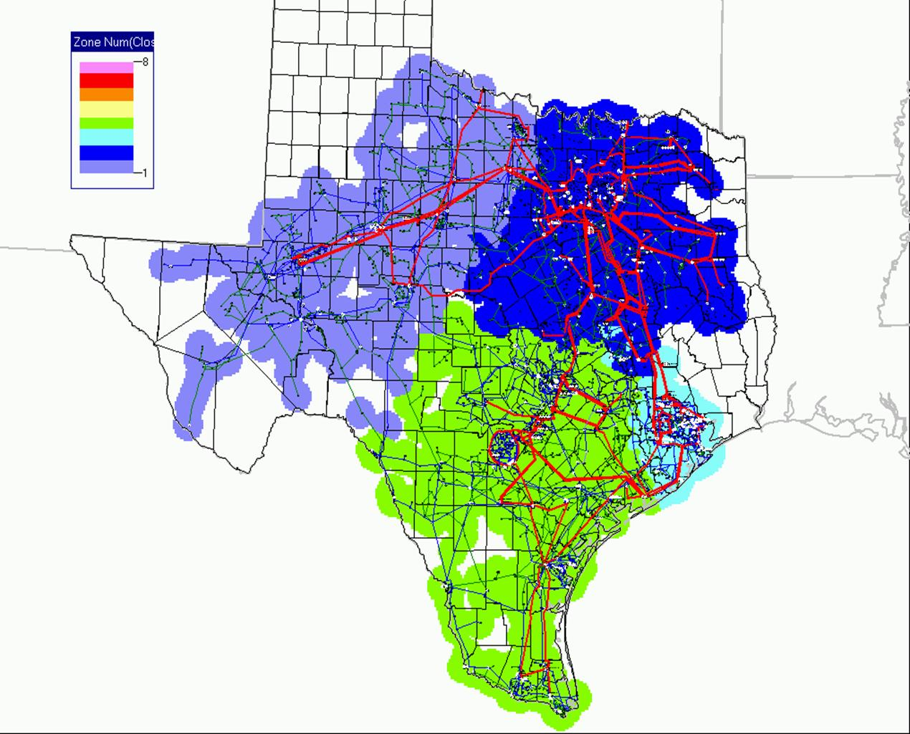
4 CSCs 4 CM Zones
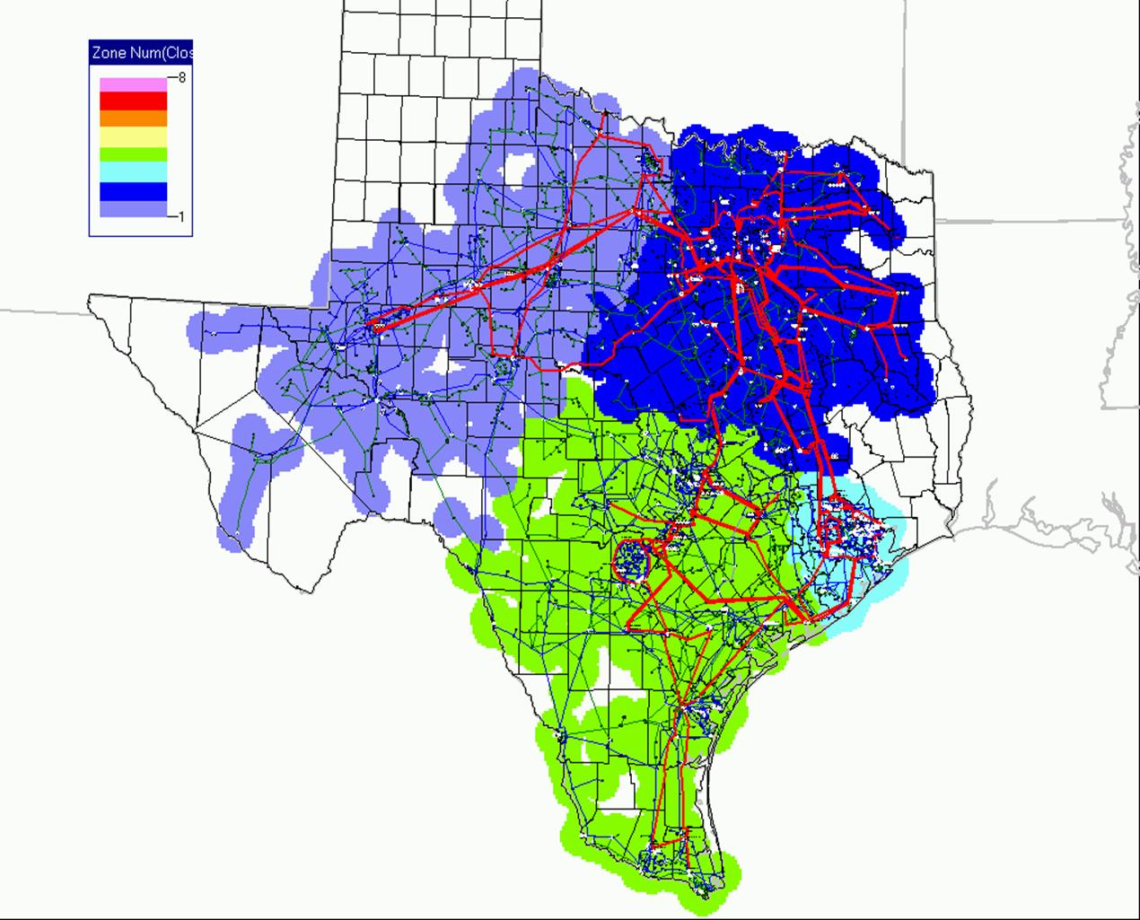
5 CSCs 5 CM Zones
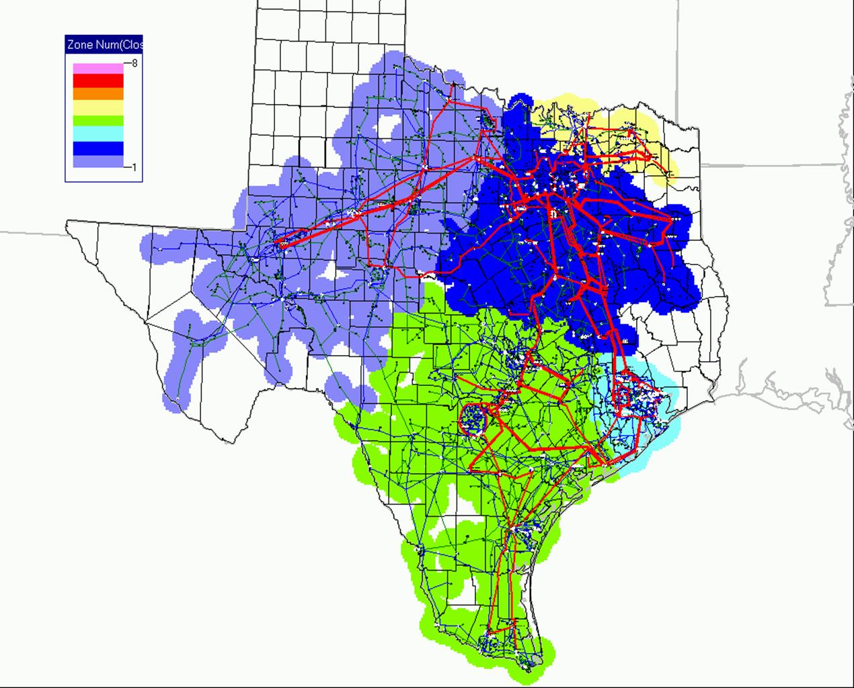
11 CSCs 7 CM Zones
