

ERCOT Transient Voltage Security criteria DEVELOPMENT (part i)

prEpared for ercot REliability Operations SUBCOMMITTEE
BY ERCOT DYNAMICS WORKING GROUP

September 9, 2003

Draft Version 3

Table of Contents:

Acknowledgments
Transient Voltage Security Subgroup
Disclaimer

1. Executive Summary and Recommendations

2. Scope of Work and Voltage Stability Problem
2.1 Scope of Work
2.2 Introduction
2.3 Transient Voltage Security

3. Development of Transient Voltage Dip Acceptability Criteria
3.1 Absolute Voltage Magnitude vs. Percent of the Initial Value
3.2 ERCOT TVD Criteria

4. Development of Transient Voltage Stability Criteria
4.1 Factors Involved in TVS and Load Modeling requirements
4.2 Analytical Techniques and Dynamic Simulation
4.3 Margin to Voltage Instability
4.4 ERCOT TVS criteria

5. Conclusions and Further Investigations

6. Bibliography

Appendix A. ERCOT Transient Voltage Security Criteria
Appendix B. A Sample System Transient Voltage Stability Analysis

Acknowledgments

The ERCOT DWG members thank Mike Connolly of Center Point Energy, and Biju Mathew, and James Armke of Austin Energy for their support, reviews and suggestions.

Transient Voltage Security Subgroup:
From 2003 ERCOT Dynamics Working Group

Tom Bao | Lower Colorado River Authority
Vance Beauregard | American Electric Power
Roy Boyer | Oncor
Jose Conto | ERCOT System Planning
Reza Ebrahimian* | Austin Energy
John Moore | South Texas Electric Cooperative
Yan Ou | ERCOT Operations
Juan Santos | ERCOT System Planning
Wesley Woitt | Center Point Energy

* 2003 Chair of DWG

Disclaimer

The Electric Reliability Council of Texas (ERCOT) Dynamics Working Group prepared this document. Conclusions reached in this report are a “snapshot in time” that can change with the addition (or elimination) of plans for new generation, transmission facilities, equipment, or loads.

ERCOT AND ITS CONTRIBUTING MEMBER COMPANIES DISCLAIM ANY WARRANTY, EXPRESS OR IMPLIED, INCLUDING ANY WARRANTY OF MERCHANTABILITY OR FITNESS FOR ANY PARTICULAR PURPOSE WHATSOEVER WITH RESPECT TO THE INFORMATION BEING PROVIDED IN THIS REPORT.

The use of this information in any manner constitutes an agreement to hold harmless and indemnify ERCOT, its Member Companies, employees and/or representatives from all claims of any damages. In no event shall ERCOT, its Member Companies, employees and/or representatives be liable for actual, indirect, special or consequential damages in connection with the use of this data. Users are advised to verify the accuracy of this information with the original source of the data.

ERCOT is the corporation that administers the state's power grid. ERCOT serves approximately 85 percent of the state's electric load and oversees the operation of approximately 70,000 megawatts of generation and over 37,000 miles of transmission lines. Its members include retail consumers, investor and municipally owned electric utilities, rural electric co-ops, river authorities, independent generators, power marketers, and retail electric providers.

ERCOT is one of ten regional reliability councils in North America operating under the reliability and safety standards set by the North American Electric Reliability Council (NERC). As a NERC member, ERCOT's primary responsibility is to facilitate reliable power grid operations in the ERCOT region by working with the area's electric utility industry organizations. The Public Utility Council of Texas (PUCT) has primary jurisdictional authority over ERCOT to ensure the adequacy and reliability of electricity across the state's main interconnected power grid. An independent Board of Directors comprised of electric utility Market Participants governs ERCOT.

1. Executive Summary and Recommendations:

The ERCOT Dynamic Working Group (DWG) was directed by the ERCOT Reliability and Operations subcommittee (ROS) on March 12, 2003 to develop the ERCOT Transient Voltage Security criteria. The directive was given in the following form:

- Make a recommendation on an interim operating criteria regarding transient voltage dip to be used in determining operating limits and making other operational decisions. Consider effects on loads. Review industry standards as they apply.
- At this time, do not attempt to determine the costs of compliance.
- Include in the scope of the investigation what transient voltage performance and operating criteria, if any, should be adopted for new generating units connecting to the ERCOT transmission system.

In response, the DWG has developed the following criteria to address ERCOT’S transient voltage security requirements. These criteria have two parts, part one addresses transient voltage stability and part two addresses transient voltage dip acceptability. The main focuses of these two subsets are as follows:

- Transient Voltage Stability criteria, relate to maintaining transient voltage stability at a bus.
- Transient Voltage Dip Acceptability criteria are based on load sensitivity and are intended to reduce uncontrolled loss of load.

These criteria described in Appendix A of this report, are intended as interim and should not be incorporated into the ERCOT operating guides at this time. Since there is a high degree of uncertainty regarding load models for transient voltage security assessment, DWG does not recommend these criteria to become mandatory until sufficient experience is gained with their application within ERCOT, and after they have been proven to be appropriate. However, the DWG encourages and recommends that the member TDSPs apply these criteria and share their experience regarding their effectiveness for their future refinements.

This report describes the development of the above ERCOT transient voltage security criteria, and the procedures for conducting dynamic simulation for transient voltage security using PTI’s PSS/E dynamics software.

General voltage stability assessment should generally follow this order:
    - Steady-state voltage security analysis
    - Generator rotor angle stability analysis
    - Transient voltage stability analysis
    - Transient voltage dip acceptability analysis.

Within the past few months ERCOT has adopted a voltage/reactive series of standards that includes a steady-state voltage stability criteria. This document has been approved by the ERCOT Technical Advisory Committee (TAC) and will merge into the ERCOT Operating Guides and Protocols.

The proposed transient voltage stability and transient voltage dip acceptability criteria given in this report should be considered for revision within a few years based on experience gained from their application to ERCOT power system, and further investigation of the ERCOT dynamic load model.

In our investigations we did not find any robust and uniformly applicable criteria to address transient voltage security. Although the industry has made great strides in understanding the related phenomena there is still a great deal of work to be done in the areas of load modeling and development of a robust and uniform approach for assessing transient voltage security. This report intends to describe the present level of knowledge and techniques used in transient voltage analysis using time-domain transient stability utilizing PTI’s PSS/E software. It is possible that other robust and uniform methodologies may emerge that may be more suitable for transient voltage security assessment. However, utilizing the methodology described in this report will shed light on and provide a better understanding of the problem. As mentioned the load model is a major uncertainty factor. At this time EPRI has initiated another research project to improve load model and has solicited ERCOT participation and support. The study team believes strongly that it is in the interest of ERCOT to support and participate actively in this project.

Because of the load model uncertainties and sensitivity of the load to transient voltage security at each bus, and lack of experience with the application of these criteria, the proposed criteria given in this report should be considered as preliminary guides to be used when there are not any better information or guides available. Each TDSP should exercise judgment in assessing their transient voltage security depending on the nature of the loads and consequences of possible transient voltage security problems at each bus to make proper decisions regarding reactive support requirements at that bus.

The open planning process that ERCOT has recently implemented will be a valuable venue in assessing the effectiveness of these criteria over the next few yeas, if the member TDSPs also consider these criteria when conducting transient voltage security analysis.

The issue of potential cost for reactive compensation and its balance with the level of desired security has not been analyzed in this project. Of course with any good engineering solution, the economic feasibility should be considered. When these criteria are revisited, it may be appropriate to perform an economic feasibility analysis of their application.

This is the first part of the ERCOT transient voltage security criteria report. A second part will be amended to this report within a few months briefly describing the effect of generation performance and operating philosophy on transient voltage security, as described in the third directive given by the ROS to the DWG.

Remedial measures for reactive support for transient voltage stability are not described in this report.

Summary of the DWG Recommendations:

- TDSPs should apply these criteria when appropriate and share their experience regarding their effectiveness. The ERCOT planning open process provides an excellent venue for this activity.
- These criteria should not be made mandatory until the load model is further investigated and sufficient experience is gained in their application to ERCOT.
- ERCOT should participate in the present EPRI project on dynamic load modeling. Additional load modeling and data collection should be performed to fill any gaps not covered by the EPRI effort.
- Additional investigations will be needed to evaluate cost effectiveness of these guides.
- After a reasonable period, when enough experience is gained in applying these criteria, they should be revisited, and possibly revised. At that time also the issue of including these criteria in the ERCOT Operating Guides should be considered.
2. Scope of Work and Voltage Stability Problem

2.1 Scope of Work

The ERCOT DWG was given the following directives by the ERCOT ROS on March 12, 2003 for the development of the ERCOT transient voltage security criteria:

- Make a recommendation on an interim operating criteria regarding transient voltage dip to be used in determining operating limits and making other operational decisions. Consider effects on loads. Review industry standards as they apply.
- At this time, do not attempt to determine the costs of compliance.
- Include in the scope of the investigation what transient voltage performance and operating criteria, if any, should be adopted for new generating units connecting to the ERCOT transmission system.

In the interim and in response to item 1, the DWG developed criteria using the Western Electric Coordinating Council (WECC) Transient Voltage Dip (TVD) criteria as a reference (See Appendix A). This report describes the ERCOT transient voltage security criteria, which also includes transient voltage stability criteria. The work on the third task will begin after completion of the development of part I of the ERCOT transient voltage security criteria. The time required for the completion of the third task is estimated to be three months.

The objective for the development of these criteria is to protect the ERCOT transmission system from a potential transient voltage instability or voltage collapse. In addition, relevant industry standards and the effect of the criteria on the load are also investigated.

The DWG conducted a literature search to survey the present level of knowledge and standards available on the transient voltage security and relevant criteria. Furthermore, the DWG conducted a survey to gauge the present practices and established criteria by other NERC regional councils. However, no useful response was received from the survey. This may be an indication that such criteria presently do not exist.

At this stage, the effect of the economics of the criteria is not investigated. Furthermore, since ERCOT members that would conduct transient voltage stability analysis use PSS/E to conduct their dynamic stability studies, this work is focused on providing guidance such that relevant analysis can be conducted and understood using PSS/E dynamics module. Therefore, this report does not cover any emerging methodologies such as use of Bifurcation theory, and eigenvalue techniques.

2.2 Introduction

Voltage collapse is often a complex process involving several elements including system component behavior and system operation. The following provides some brief background information. More detailed information can be obtained from the listed references or from a large body of literature available elsewhere [1].

Voltage collapse is typically associated with the reactive power demands of loads not being met because of limitations on the production and transmission of reactive power. Limitations on the production of reactive power include generator and SVC reactive power limits and the reduced reactive power production by capacitors at low voltages. The primary limitations on the transmission of power are the high reactive power loss on heavily loaded lines, as well as possible line outages that reduce transmission capacity. Reactive power demands of loads increase with load increases (examples include additional motor load and increased air conditioning use with increasing temperature), changes in voltage, motor stalling, or changes in load composition.

A power system without adequate dynamic reactive support can become unstable when subjected to large disturbances. During such disturbances the transmission system voltage can fall below a critical threshold, resulting in induction motors dropping out (control devices disconnecting the motors) or motor stalling. Transient voltage instability or voltage collapse can occur when stalled motors remain connected to the system, or motors previously disconnected are automatically reconnected causing a large, mostly reactive, starting current. Furthermore, motors at power plants can drop out or stall upon low voltage, thus leading to tripping of generators as well. Such a disturbance is classified as a transient voltage stability phenomenon, with a time frame in the order of seconds. The IEEE/CIGRE task force on power system stability terms, definitions and classifications refers to this as “short-term voltage stability”. Factors such as increased use of low inertia compressor motors, air conditioning, heat pumps, and refrigeration, increased use of voltage-insensitive power electronic loads, and increased use of capacitor banks for reactive compensation, and more intensive use of transmission systems, are increasing the likelihood of transient voltage instability [2].

There are several power system changes known to contribute to voltage collapse.

  - Increase in loading
  - Generators, synchronous condensers, or SVC reaching reactive power limits
  - Action of tap-changing transformers
  - Load recovery dynamics
  - Line tripping or generator outages

Most of these changes have a significant effect on reactive power production, consumption and transmission. Switching of shunt capacitors, blocking of tap-changing transformers, re-dispatch of generation, rescheduling of generator and pilot bus voltages, secondary voltage regulation, load shedding, and temporary reactive power overload of generators are some of the control actions used as countermeasures against voltage collapse.

It appears that there are two distinct time frames to consider for voltage stability, transient (0 to 10 seconds or so) and longer term voltage stability (10 seconds to 2 or more hours)[3]. With proper modeling and data, traditional transient stability programs can be used for the transient time frame. For the longer time frame, three possibilities exist, traditional load flow based tools, extended term time domain simulation, or Quasi-Dynamic simulation programs. Because of the significant amount of CPU and engineering time involved, it seems reasonable to suggest using power flow based tools to calculate voltage stability margins for the base case and all contingency cases, and use extended term time domain simulation only to bench mark the power flow results, and to determine the chronology of voltage instability following a few selected critical contingencies.

While the literature indicates several tools available for voltage stability analysis [2], [4], the tools currently available for most DWG members are load flow and traditional transient stability programs. The use of these tools does not guarantee voltage collapse will not occur, or that decisions made as a result of studies using these tools will be optimum and the most economical. Judgment must be used, both in making the studies and interpreting the results.

Performing a voltage stability study usually involves the following activities:

- Determine the margin for all design contingencies with all elements in service and some elements out of service in accordance with the ERCOT planning standards.
- In general, voltage stability margins are defined as the difference between the value of a Key System Parameter at the current operating condition and at the voltage stability critical point.
- Key System Parameters used include P-V based parameters, such as area load or power transfer across an interface; and Q-V based parameters, such as reactive reserve or reactive injection at a bus or group of buses.
- In addition to the criterion for voltage stability margin, TDSPs must establish bus voltage limits. They may need to establish other criteria such as reactive reserve criteria.
- The criteria appropriate for a given system can only be determined after extensive analysis of the system in order to establish the Key System Parameter and the sensitivities of the system stability to changes in the Key System Parameter values.

2.3 Transient Voltage Security

There are several factors that may describe transient voltage security at a bus [5], [6], [7]. These include transient angle stability, transient voltage stability, and transient voltage dip acceptability. Transient angle stability relates to synchronous generators maintaining synchronism. Loss of synchronism and tripping of generators can cause transient voltage swings. This issue is well understood and relevant studies are conducted by TDSPs addressing this issue. There is also an oscillatory phenomenon, which is associated with power systems that fit the structure of a single equivalent generator supplying an equivalent composite load, which may be traceable to interaction of induction motor loads with automatic voltage regulators [8].

Transient voltage stability is related mostly to the stability of dynamic loads such as induction motors. The small low inertia induction motors that are used in the residential air conditioners are perhaps major contributors to such phenomenon, during the summer peaks in ERCOT. A typical scenario would be a fault resulting in a significant, momentary drop in voltage. Motors can react to the voltage drop in several ways depending on such factors as the type of motor, the type of load, and the motor controls. Residential window air conditioning units typically have very simple controls. Thus, if the voltage drops and reduces the electrical torque below the mechanical load torque, the motor may stall, and eventually be disconnected by the motor thermal overload. Residential split system air conditioners usually have contactors to control the compressor motor. On low voltage, the contactor will usually disconnect the motor before it stalls. However, once the fault is cleared and voltage is restored, the contactor may close restarting the motor. The starting motor will have a highly reactive inrush current, typically 4 to 6 times full load. Air conditioners with mechanical thermostats are most likely to restart immediately upon restoration of voltage. Air conditioners with electronic thermostats often have a time delay that will postpone restarting the compressor motor after voltage is restored for, typically, 5 minutes.

Transient voltage dip acceptability is related to the load sensitivity and is not particularly related to a system-wide stability problem.

Our investigations have shown that system-wide voltage stability criteria involving a voltage dip magnitude and duration to be used for all of the ERCOT transmission buses may not exist. The criterion for each bus may be different. The transient voltage trajectory at each bus depends on the effect of the performance of the generators supplying reactive power to the bus (particularly their excitation systems performance), other sources of reactive power, and the thevenin impedance of the system at that bus, and its load characteristics. Thus each bus would have different requirements to maintain voltage stability. If the criteria for transient voltage stability and transient voltage dip acceptability for a bus are determined, the values describing them maybe different. In other words transient voltage dip acceptability at a bus does not guarantee that the bus is “transient voltage-stable” and vise versa. To help clarify this issue, in Appendix B we present a brief description of how to conduct transient voltage stability studies using PSS/E dynamics program, including an example of the above scenarios.

3. Development of the ERCOT Transient Voltage Dip (TVD)
Acceptability Criteria:

As was described in the previous section, transient voltage dip acceptability is different from transient voltage stability. TVD is based on load sensitivity. Several organizations such as CBEMA (now ITI), ANSI, and IBM have proposed such standards to be applied anywhere in a power system to protect the voltage-sensitive loads. Members of some regional reliability councils such as WECC use TVD criteria as part of their planning criteria for protection of their loads.

As a starting point, the DWG investigated the development of the WECC criteria. Reference [9] describes the development of the WECC criteria [10]. The present WECC criteria were developed in the early 1990’s. Some of the WECC members previously had used a minimum swing voltage magnitude of 0.8 p.u. of nominal voltage for assessing their transmission system transient stability. This criterion included margins to avoid the tripping of the auxiliary nuclear plant induction motors that are protected with under-voltage relays.

The present WECC criteria are established to avoid uncontrolled loss of load for the NERC category B and C disturbances. The values selected are based upon the response of electronic equipment to voltage dips. It was believed that these loads are the most sensitive to voltage swings. The values were selected based on evaluation of the load sensitivity curves to voltage dip and durations published by IBM. The ANSI/IEEE 446.1987, CBEMA, and SDG&E (San Diego Gas and Electric) curves were also evaluated. During a one-year trial WECC conducted load sensitivity studies for evaluation of the appropriateness of the voltage dip criteria and concluded that the criteria was appropriate.

3.1 Absolute Voltage Magnitude vs. Percent of the Initial Value:

The ERCOT TVD criteria are stated in terms of an initial bus voltage. This initial voltage can be defined in at least two ways, absolute voltage magnitude or percent of initial value. If the absolute voltage magnitude is used as a criterion where the load is represented at high voltage and the initial voltage is above 1.00 p.u. (often the case for the 345 kV systems), the voltage on the low voltage buses where the load is actually connected will be less than 1.00 p.u. Hence, it is more appropriate to use percent voltage of the initial values than using the absolute voltage magnitude. Both the WECC and the ERCOT TVD criteria use a percent value relative to the per-disturbance voltage magnitude.

3.2 The ERCOT TVD Criteria

The ERCOT TVD criteria are presented in the Appendix A and were developed using the WECC criteria as a reference, some of the differences are described below.

- The ERCOT criteria are described in six sections for six different conditions to avoid ambiguities.
- The ERCOT criteria clarify that the percent voltages are relative to the pre-disturbance values and not the absolute voltage magnitudes.
- The WECC criteria refer to the effects of the voltage dip on other systems. The DWG felt that such criteria is difficult to apply since “other” systems has to be defined, and may not apply to ERCOT, since ERCOT is a single control area. Hence, the ERCOT TVD criteria do not refer to “other” systems.
- The WECC criteria do not specifically mention whether the fault duration is included in the voltage dip duration criteria. The ERCOT TVD criteria clearly specify that the fault duration is not included in the voltage dip duration criteria.

4. Development of the ERCOT Transient Voltage Stability Criteria

We described in section 2 that transient voltage stability (TVS) is a fast dynamics phenomenon occurring in the order of seconds. In this section we will describe the mechanisms involved in transient voltage stability and describe modeling requirements for accurate simulations using PSS/E.

  - Factors Involved in TVS and Load Modeling Requirements

The main factors affecting transient voltage stability of a bus are the induction motor load magnitudes and their characteristics, the thevenin impedance of the system at that bus, and the reactive sources for the bus. For proper dynamic simulation using PSS/E, the load should be decomposed into similar load types, such as small motor, large motor, discharge lighting, resistive load, constant power, transformer saturation, and “remaining load” using PSS/E CLODXX and CIM5XX and /or CIMWXX. To use CIM5XX or CIMWXX effectively, knowledge of the motor load speed-torque characteristic is required. Furthermore, the distribution power transformers, feeders, and capacitors should also be included as appropriate [11].

4.2 Analytical Techniques and Dynamic Simulation

When using PSS/E for short-term voltage stability simulations, appropriate portion of the ERCOT load should be modeled as described in section 4.1 and [11]. To observe that the system is transient voltage stable the equivalent motor load terminal voltage (load voltage) and the motor slip should be plotted. If the slip is increasing after the voltage has passed its maximum then the load is unstable. On the other hand if the slip is not increasing after the voltage has passed it minimum then the load is stable.

4.3 Margin to Voltage Instability

Margin to voltage instability is a function of the degree of uncertainty in the models, data, and actual operating conditions and the sensitivity of the stability limits to these uncertainties. Each TDSP should consider the above and other factors such as cost of adding compensation to improve voltage stability in conjunction with the effects of voltage instability on the customers being served when establishing a margin to voltage instability.

4.4 ERCOT TVS criteria

Proposing a transient voltage stability criterion based on solid data and analysis is problematic in ERCOT. Our survey suggested few if any regional reliability councils have such a criterion. There are no known standards that apply. An effective criterion may differ from one bus to another bus within ERCOT. The analysis tools used by most TDSPs will not guarantee voltage stability is maintained. One of the most critical components for any simulation, the load composition and dynamic characteristics, is generally unknown. Each TDSP should use judgment when evaluating voltage stability. With the above in mind, the following may be used as transient voltage stability criteria when no other guidance is available:

Considering realistic power transfers between zones,

- Allow a 5% margin load increase to a zone for category B contingencies and
- Allow a 2.5% margin load increase to a zone for category C contingencies.

Again as was mentioned earlier, the application of these criteria are not mandatory, and they are proposed here as guidelines. Individual TDSPs should adjust these values based on local knowledge and conditions.

Furthermore, because of the uncertainties involved in transient voltage stability analysis, particularly of the nature of the load, the approach and the criteria presented in this report should be revisited in a few years, after enough experience is gained in applying the above criteria.

5. Conclusions and Further Investigations

This report describes the development of ERCOT transient voltage security criteria. It describes and demonstrates use of PTI PSS/E in conducting such analysis. The criteria were developed considering the presently available analytical tools to majority of the ERCOT member TDSPs. The emerging technologies such as use of eigenvalue methods, energy function, Bifurcation theory, and artificial intelligence methodologies were not considered. These criteria and procedures are intended as guides and should be applied after steady state voltage security and generator rotor angle stability assessment are completed. Furthermore, transient voltage stability should be assessed before transient voltage dip acceptability is evaluated. We do not recommend that these criteria be included in the ERCOT Operating Guides at this time. They are not mandatory, and deviations from these criteria are appropriate based on engineering judgment and the nature of the loads being served. The engineer conducting such analysis should gain a good understanding of induction motor dynamics modeling and aggregate representation in power systems [12], [13], [14], [15], [16], [17]. This is important not only for the computational procedures, but also in selecting the proper models for the buses under study and in evaluating the simulation results.

The criteria given here need to be tested for their effectiveness and feasibility within ERCOT. Each TDSP is encouraged to perform the necessary evaluations, apply the criteria, and evaluate the effectiveness of the process and criteria. The recently adopted ERCOT open transmission planning process also is a valuable venue to test these criteria and evaluate their usefulness. After a few years of experience, these should be re-evaluated and revised if necessary.

Both TVD and TVS are short time-frame phenomena with maximum duration of approximately 30 seconds. Another aspect of dynamic voltage stability includes extended-term dynamics such as the effects of excitation limiters, ULTCs, AGCs, etc. Historically, most major voltage collapse incidents developed over a period of minutes to hours, and the above extended-term dynamic elements were significant contributors to voltage collapse. Thus, TVD and TVS will not capture these extended term equipment action, or voltage collapse evolving over an extended period of time. At this time none of the ERCOT DWG members conduct extended-term dynamic simulations. PTI offers such a tool as an extension to PSS/E intended for extended-term dynamic simulation. However, few, if any ERCOT members have this tool. ERCOT DWG should consider this tool or other extended-term dynamic simulation software for evaluation for further investigation of ERCOT voltage security assessment.

The results of TVD and TVS simulations are highly dependent upon the load model. Currently, there is no adequate, up-to-date load model or data for ERCOT loads. As mentioned previously, it is unlikely any one load model or set of load data will be appropriate for every load bus in ERCOT. It is anticipated that participation in the EPRI load modeling effort will result in some load models and data appropriate to ERCOT. At present, the best that can be done in most cases is to use generic load models and data, and thus obtain somewhat generic simulation results. Such results are certainly useful but may lead to overly conservative or over confident decisions about the ability of the ERCOT system to avoid voltage instability. The DWG recommends that ERCOT participate in the EPRI load modeling effort. The DWG also recommends that additional load modeling and data collection be performed to fill any gaps not covered by the EPRI effort. Establishing criteria is certainly important, but can never fully fulfill its intended purpose without adequate simulation tools, models, and data.

The second part of this project includes investigation of the effect of generators transient voltage performance and operating criteria for transient voltage stability.

6. Biblograhpy

[1] IEEE Committee Report, “Voltage Stability Assessment: Concepts, Practices and Tools”, by IEEE/PES Power System Stability Subcommittee Special Publication, Aug 2002.

[2] John Diaz de Leon II, and Carson Taylor “Understanding and Solving Short-term Voltage Stability Problems” Proceedings of the IEEE/PES 2002 Summer Meeting.

[3] Carson Taylor, “Introduction, Definitions, Time Frames/Scenarios, and Incidents”, NERC Survey of the voltage collapse phenomenon, pp 51-65, Aug. 1991.

[4] Les M. Hajogos, Behnam Danai, “Laboratory Measurements and Models of Modern Loads and Their Effects on Voltage Stability Studies”, IEEE Transactions on Power Systems, Vol. 13, No. 2, pp 584-592, May 1998

[5] Y. Xue, T. Xu, B. Liu, and Y. Li ,“Quantitative Assessments for Transient Voltage Security”, IEEE Transactions on Power Systems, Vol. 15, No. 3, pp. 1077-1083, Aug. 2000.

[6] Y. Xue, T. Xu, B. Lui, Y. Li, “The Formulation and Quantification of Transient Voltage-Dip Security. In ICEE’98, Korea, Jul. 1998.

[7] Y. Xue, T. Xu, Z. Han, and Y. Li, “A Criterion and Margin for Transient Voltage Stability Considering Induction Motors”, in IPEC’97, Singapore, May 1997.

[8] F.P. de Mello, “Voltage Oscillatory Instability Caused by Induction Motor Loads”, IEEE Transactions on Power Systems, Vol. 11, No. 3, Aug. 1996, pp 1279-1285.

[9] J. Kondragunta, and WSCC Reliability Subcommittee, “WECC Supporting Document for Reliability Criteria for Transmission Planning”, August 1994

[10] NERC/WECC Planning Standards, Revision August 9, 2002

[11] IEEE Committee Report, “Standard Load Models for Power Flow and Dynamic Performance Simulation”, IEEE Task Force on Load Representation for Dynamic Performance, IEEE Transactions on Power Systems, Vol. 10, No. 3, pp 1302-1313, August 1995

[12] P. Kundur, Power System Stability and Control, McGraw-Hill, 1994.

[13] C. W. Taylor, Power System Voltage Stability, McGraw-Hill, 1994.

[14] F. Nozari, M. D. Kankam, and W. Price, “Aggregation of Induction Motors for Transient Stability Load Modeling”, IEEE Transactions on Power Systems, Vol PWRS-2, No. 4, Nov. 1987. pp 1096-1103.

[15] D.C. Franklin, A. Morelato, “Improving Dynamic Aggregation of Induction Motor Models”, IEEE Transactions on Power Systems, Vol. 9, No. 4, Nov. 1994. pp 1934-1941.
[16] L. Pereira, D. Kosterev, P. Mackin, D. Davies, J. Undrill, W. Zhu, “An Interim Dynamic Induction Motor Model for Stability Studies in the WSCC”, IEEE Transaction on Power Systems, Vol. 17, No. 4, Nov. 2002, pp 1108-1115.

[17] T.Y.J Lem and R.T.H. Alden, “Comparison of Experimental and Aggregated Induction Motor Responses”, IEEE Transactions on Power Systems, Vol 9, No. 4, Nov. 1994. pp 1895-1900.

[18] J. Shaffer, “Air Conditioner Response to Transmission Faults”, IEEE Transactions on Power Systems, Vol. 12, No. 2, May 1997, pp 614-621.

[19] B.R. Williams, W. S. Schumus, D. C. Dawson,”Transmission Voltage Recovery Delayed by Stalled Air Conditioner Compressors”, IEEE Transactions on Power Systems,Vol 7, No.3, Aug 1992, pp 1173-1179

[20] M. Z. El-Sadek, and F.N. Abdelbarr, “Effects of Induction Motor Load in Provoking Transient Voltage Instabilities in Power Systems”, Electric Power Systems Research, 17(1989), pp 119-127.

[21] M. Z. El-Sadek, “Voltage Instabilities Subsequent to Short-Circuit Recoveries”, Electric Power Systems Research, 21(1991) 9-16.

Appendix A. ERCOT Transient Voltage Security Criteria

The ERCOT transient voltage security criteria are given in the form of two sets of criteria. After analysis has shown that there are no rotor angle stability problems, the ERCOT transient voltage stability criteria can be utilized, and then the criteria for ERCOT transient voltage dip acceptability should be applied.

These criteria are provided as interim guidance for applying the applicable sections of the Protocols and Operating Guides. This guidance does not relieve any entity from their responsibility of complying with the Protocols and Operating Guides. Deviations from this interim guideline are appropriate when local conditions or engineering judgment suggest an alternative approach fulfills the requirements of the Protocols and Operating Guides.

This guideline does not imply that transient voltage simulations for every bus or contingency should be performed. There may be other, more efficient calculation methods available or emerging for general assessment of system voltage security. Caution should be taken when using the standard “ZIP” model. Although this load model is used by ERCOT members, in many cases the ZIP model may result in overly optimistic results. When motors are a significant part of the load, it is suggested that proper dynamic load models, such as the PTI PSS/E CLODXX and CIM5XX and/ or CIMWXX models be used. Typical parameters for induction motors are available in references [11], and [13].

ERCOT Transient Voltage Stability (TVS) Criteria

According to the IEEE voltage stability working group, voltage stability and voltage collapse are defined as follows: voltage stability is the ability of a system to maintain voltage so that when load admittances are increased, load power will increase, so that both power and voltage are controllable, voltage collapse is the process by which voltage instability leads to loss of voltage in significant part of the system.

Transient voltage stability is related mostly to stability of dynamic loads such as induction motors. Transient voltage instability at a bus may lead to voltage collapse at that bus or even a large portion of the system.

Proposing a transient voltage stability criterion based on solid data and analysis is problematic in ERCOT. Our survey suggested few if any regional reliability councils have such a criterion. There are no known standards that apply. An effective criterion may differ from one bus to another bus within ERCOT. The analysis tools used by most TDSPs will not guarantee voltage stability is maintained. One of the most critical components for any simulation, the load composition and dynamic characteristics, is generally unknown. Each TDSP should use judgment when evaluating voltage stability. With the above in mind, the following may be used as transient voltage stability criteria when no other guidance is available:

Considering realistic power transfers between zones,

  - Allow a 5% margin load increase to a zone for category B contingencies and
  - Allow a 2.5% margin load increase to a zone for category C contingencies.

Again as was mentioned earlier, the application of these criteria are not mandatory, and they are proposed here as guidelines. Individual TDSPs should adjust these values based on local knowledge and conditions.

Furthermore, because of the uncertainties involved in transient voltage stability analysis, particularly of the nature of the load, the approach and the criteria presented in this report should be revisited in a few years.

ERCOT Transient Voltage Dip Acceptability (TVD) Criteria

Transient voltage dip acceptability is related to the load sensitivity and is not particularly related to system-wide stability problem. The following is proposed by the ERCOT DWG as an interim transient voltage dip acceptability criteria.

Category A Contingency*
 |  | Not applicable
Category B Contingency*
 | 1. | Except from the time of fault inception to the time the fault is cleared, the post contingency voltage at a bus should not drop below 80% of pre–disturbance voltage for longer than 20 cycles.
 | 2. | Except from the time of fault inception to the time the fault is cleared, the post contingency voltage at a load bus should not drop below 75% of pre–disturbance voltage.
 | 3. | Except from the time of fault inception to the time the fault is cleared, the post contingency voltage at a non-load bus should not drop below 70% of pre–disturbance voltage.
Category C Contingency*
 | 1. | Except from the time of fault inception to the time the fault is cleared, the post contingency voltage at a bus should not drop below 80% of pre–disturbance voltage for longer than 40 cycles.
 | 2. | Except from the time of fault inception to the time the fault is cleared, the post contingency voltage at a load bus should not drop below 70% of pre–disturbance voltage.
 | 3. | Except from the time of fault inception to the time the fault is cleared, the post contingency voltage at a non-load bus should not drop below 70% of pre–disturbance voltage.
* Contingencies and faults as defined by NERC planning criteria table and ERCOT Protocols and Operating Guides.

Note: For the purpose of dynamics simulation the fault duration should be determined based upon the equipment capabilities which include relay operation time, time delay, and breaker operation time.
Appendix B. Sample System Transient Voltage Stability Analysis

In this section we will present an example using conventional time-domain dynamic stability to conduct transient voltage stability analysis. Transient voltage dip acceptability analysis is conducted in the same fashion; however, it is more trivial.

Fig.1 shows a sample system one-line diagram used in this illustration. Fig 2, and Fig 3 show the load flow and dynamics data associated with this system in PSS/E Version 28 format. The induction motor model is taken from the reference [18]. Induction motor model parameters for several load types are given in [11] and [13], gathered through research conducted by EPRI.

Note that Fig. 1 includes the models of the distribution power transformer, line, and the capacitor banks. These are required to conduct an accurate transient voltage stability analysis [11], [13], [18], [19].

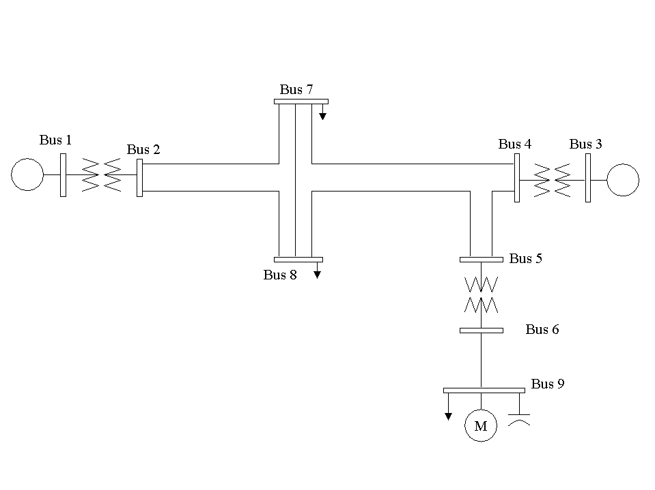
Fig 1. Study System One-line Diagram

0, 100.00 / PSS/E-28.1 TUE, SEP 02 2003 15:31
9 BUS POWER FLOW TEST CASE
BASE
1,'REMOTGEN', 20.0000,3, 0.000, 0.000, 1, 1,1.00000, 0.0000, 1
2,'REMOTGEN', 138.0000,1, 0.000, 0.000, 1, 1,1.02824, -4.9475, 1
3,'LOCALGEN', 20.0000,2, 0.000, 0.000, 1, 1,1.02577, -1.7904, 1
4,'LOCALGEN', 138.0000,1, 0.000, 0.000, 1, 1,1.02000, -6.6012, 1
5,'138TRANS', 138.0000,1, 0.000, 0.000, 1, 1,1.01246, -7.5153, 1
6,'DISTLINE', 13.8000,1, 0.000, 0.000, 1, 1,1.01966, -10.1919, 1
7,' LOAD1 ', 138.0000,1, 0.000, 0.000, 1, 1,1.01013, -7.9893, 1
8,' LOAD2 ', 138.0000,1, 0.000, 0.000, 1, 1,1.00912, -8.1124, 1
9,'DISTLOAD', 13.8000,1, 0.000, 0.000, 1, 1,0.99050, -13.7715, 1
0 / END OF BUS DATA, BEGIN LOAD DATA
7,'1 ',1, 1, 1, 0.000, 0.000, 0.000, 0.000, 100.000, -25.000, 1
8,'1 ',1, 1, 1, 0.000, 0.000, 0.000, 0.000, 100.000, -25.000, 1
9,'1 ',1, 1, 1, 0.000, 0.000, 0.000, 0.000, 50.000, -20.000, 1
9,'M ',1, 1, 1, 50.000, 20.000, 0.000, 0.000, 0.000, 0.000, 1
0 / END OF LOAD DATA, BEGIN GENERATOR DATA
1,'1 ', 155.576, 49.519, 100.000, -50.000,1.00000, 0, 300.000, 0.00000, 0.20000, 0.00000, 0.00000,1.00000,1, 100.0, 300.000, 50.000, 1,1.0000
3,'1 ', 150.000, 62.532, 75.000, -50.000,1.02000, 4, 250.000, 0.00000, 0.20000, 0.00000, 0.00000,1.00000,1, 100.0, 200.000, 50.000, 1,1.0000
0 / END OF GENERATOR DATA, BEGIN BRANCH DATA
2, 7,'1 ', 0.00800, 0.07425, 0.03600, 400.00, 500.00, 500.00, 0.00000, 0.00000, 0.00000, 0.00000,1, 25.00, 1,1.0000
2, 8,'1 ', 0.00800, 0.07425, 0.03600, 400.00, 500.00, 500.00, 0.00000, 0.00000, 0.00000, 0.00000,1, 25.00, 1,1.0000
4, 5,'1 ', 0.00160, 0.01485, 0.00720, 400.00, 500.00, 500.00, 0.00000, 0.00000, 0.00000, 0.00000,1, 5.00, 1,1.0000
4, -7,'1 ', 0.00800, 0.07425, 0.03600, 400.00, 500.00, 500.00, 0.00000, 0.00000, 0.00000, 0.00000,1, 25.00, 1,1.0000
5, -8,'1 ', 0.00800, 0.07425, 0.03600, 400.00, 500.00, 500.00, 0.00000, 0.00000, 0.00000, 0.00000,1, 25.00, 1,1.0000
6, 9,'1 ', 0.01050, 0.06630, 0.00001, 108.00, 108.00, 108.00, 0.00000, 0.00000, 0.00000, 0.00000,1, 1.00, 1,1.0000
7, -8,'1 ', 0.00320, 0.02720, 0.01580, 400.00, 500.00, 500.00, 0.00000, 0.00000, 0.00000, 0.00000,1, 10.00, 1,1.0000
0 / END OF BRANCH DATA, BEGIN TRANSFORMER DATA
1, 2, 0,'G1',1,1,1, 0.00000, 0.00000,1,' ',1, 1,1.0000
0.00000, 0.06000, 100.00
0.95000, 0.000, 0.000, 250.00, 250.00, 250.00, 0, 0, 1.10000, 0.90000, 1.10000, 0.90000, 33, 0, 0.00000, 0.00000
1.00000, 0.000
3, 4, 0,'G1',1,1,1, 0.00000, 0.00000,1,' ',1, 1,1.0000
0.00000, 0.06000, 100.00
0.97500, 0.000, 0.000, 250.00, 250.00, 250.00, 0, 0, 1.10000, 0.90000, 1.10000, 0.90000, 33, 0, 0.00000, 0.00000
1.00000, 0.000
5, 6, 0,'D1',1,1,1, 0.00000, 0.00000,1,' ',1, 1,1.0000
0.00200, 0.05000, 100.00
0.97500, 0.000, 0.000, 250.00, 250.00, 250.00, 0, 0, 1.10000, 0.90000, 1.10000, 0.90000, 33, 0, 0.00000, 0.00000
1.00000, 0.000
0 / END OF TRANSFORMER DATA, BEGIN AREA DATA
0 / END OF AREA DATA, BEGIN TWO-TERMINAL DC DATA
0 / END OF TWO-TERMINAL DC DATA, BEGIN SWITCHED SHUNT DATA
9,0,1.50000,0.50000, 0, 15.00, 1, 15.00
0 / END OF SWITCHED SHUNT DATA, BEGIN IMPEDANCE CORRECTION DATA
0 / END OF IMPEDANCE CORRECTION DATA, BEGIN MULTI-TERMINAL DC DATA
0 / END OF MULTI-TERMINAL DC DATA, BEGIN MULTI-SECTION LINE DATA
0 / END OF MULTI-SECTION LINE DATA, BEGIN ZONE DATA
0 / END OF ZONE DATA, BEGIN INTER-AREA TRANSFER DATA
0 / END OF INTER-AREA TRANSFER DATA, BEGIN OWNER DATA
0 / END OF OWNER DATA, BEGIN FACTS DEVICE DATA
0 / END OF FACTS DEVICE DATA

Fig 2. Study System Load Flow Data in PTI PSS/E RAWD Format

1,'GENROU',1,6.0,0.025,0.75,0.05,5.0,0,2.1,2.0,0.22,0.5,0.2,0.18,0.1,0.4,/REMOTGEN
1,'EXAC1',1,0,0,0,400,0.02,5,-4.5,0.166,0.03,1,0.2204,0.3986,1,3,0.044,4,0.25,/REMOTGEN
3,'GENROU',1,6.0,0.025,0.75,0.05,5.0,0,2.1,2.0,0.22,0.5,0.2,0.18,0.1,0.4,/LOCALGEN
3,'EXAC1',1,0,0,0,400,0.02,5,-4.5,0.166,0.03,1,0.2204,0.3986,1,3,0.044,4,0.25,/LOCALGEN
9,'CIM5BL',M,2,0.025,0.08,5,0.028,0.04,0.07,0.03,1,0.06,1.2,0.6,0,1.2,0.3,0,0,0,1,0,/

Fig 3. Study System Dynamics Data in PTI PSS/E DYDA Format

Figs 4, 5, 6, and 7 show the results of a simulation for duration of 2 and 5 seconds. Figs 4, and 6 show the voltage at bus 9 and the slip of aggregate induction motor model. The fault duration was 4 cycles, and the fault admittance was 1000 MVA. Plots in Fig 4 and 5 are for the same simulation as plots in figs 6 and 7, but plotted with a different time length. Note that the voltage at bus 9 recovers in less than one seconds, and the motor slip increases during the fault. However, after the fault clears the motor slip reduces and stabilizes to a constant value. Since the slip has reduced to a small constant value and voltage has recovered, the induction motor is stable; hence, bus 9 maintains transient voltage stability.

Figs 4,5, 6,and 7 show the voltages at bus 5, 6, 7, and 9, and the motor’s Telec, Tload, Slip, P, and Q. We can see that the Telec is larger than Tload after the fault clears. Since the Telect is larger than Tload, the motor remains stable [5]. Note that the reactive power is increasing during the fault and reduces and becomes constant after the fault has cleared. Similarly the real power consumption P during the fault increases, and returns to a constant value after the fault has cleared.

In summary, since Telec is larger than Tload throughout the disturbance and slip returns to a small constant value, we can conclude that this bus maintains voltage stability when subjected to the described disturbance.

Now, let us consider applying a 7-cycle fault with fault admittance of 1000 MVA. Figs 8, 9, 10, 11 show the results of this simulation for duration of 2 and 5 seconds. Figs 8, and 10 show the voltage at bus 9 and the slip of the motor. Since the slip is monotonically increasing while the motor terminal voltage has passed it is maximum, the motor is unstable. Figs 8, 9, 10, and 11 show that indeed the motor stalls, if it remains connected. Note that this example is intended to demonstrate instability. However, it is possible that the motor contactor may disconnect the motor from the system, which would yield different results. Figs 8, 9, 10, and 11show the voltage at buses 5, 6, and 9, Telec, Tload, slip, P, and Q. Note that during the fault the motor Q increases, that is the motor begins to absorb a large amount of reactive power. Telec is less than Tload, which indicates that the motor is unstable. Hence there are two indications of the motor instability 1) the slip is increasing while the terminal voltage has passed its maximum, and 2) Telec is less than Tload even after the fault has cleared [5], [20], [21].

In summary, since Telec is less than Tload and the slip increases monotonically after the voltage has passed its maximum, we can conclude that this bus does not maintains voltage stability when subjected to the described disturbance.

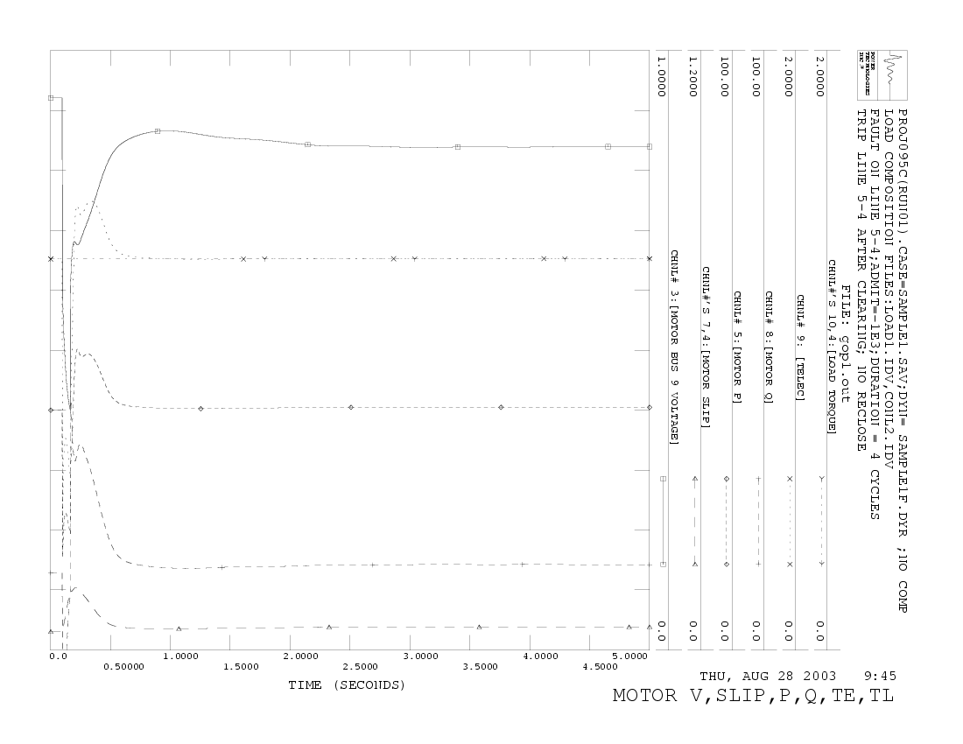
Fig 4. Stable scenario.
Fig 5. Stable scenario.
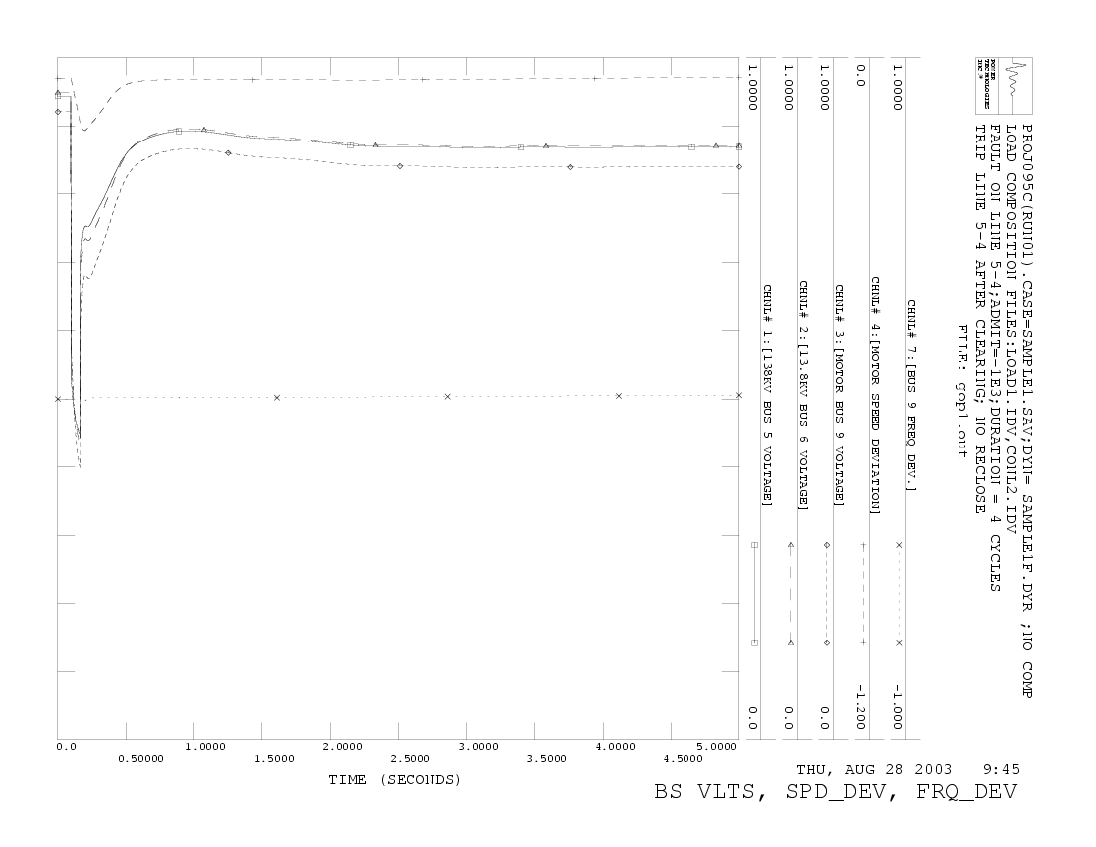
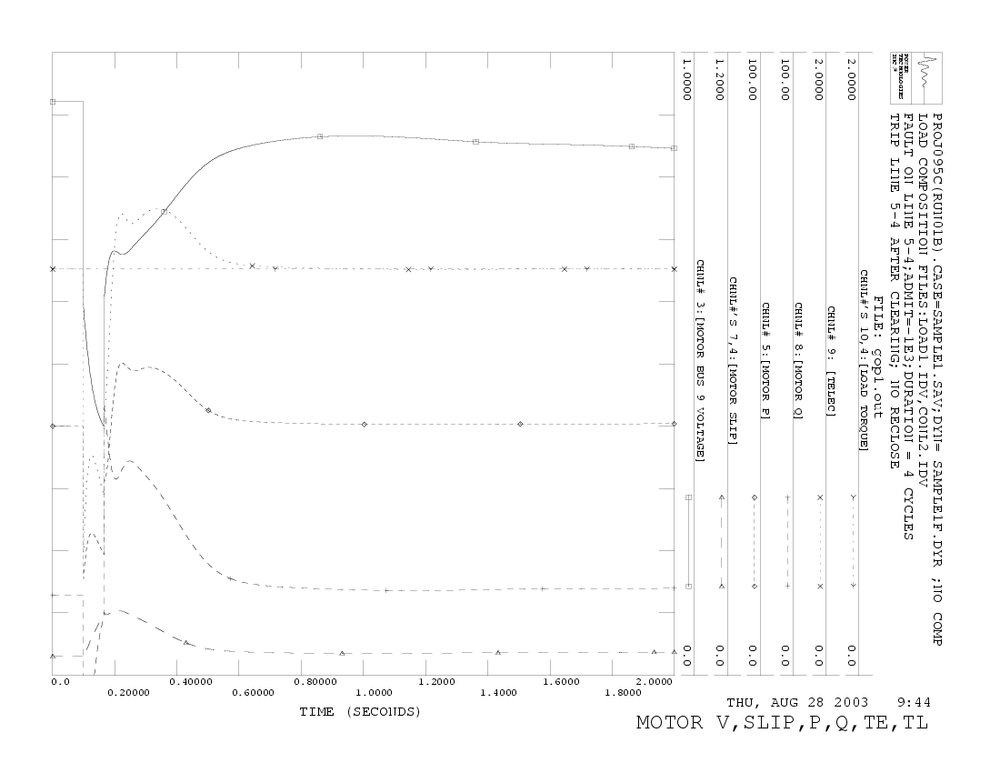
Fig 6. Stable scenario.

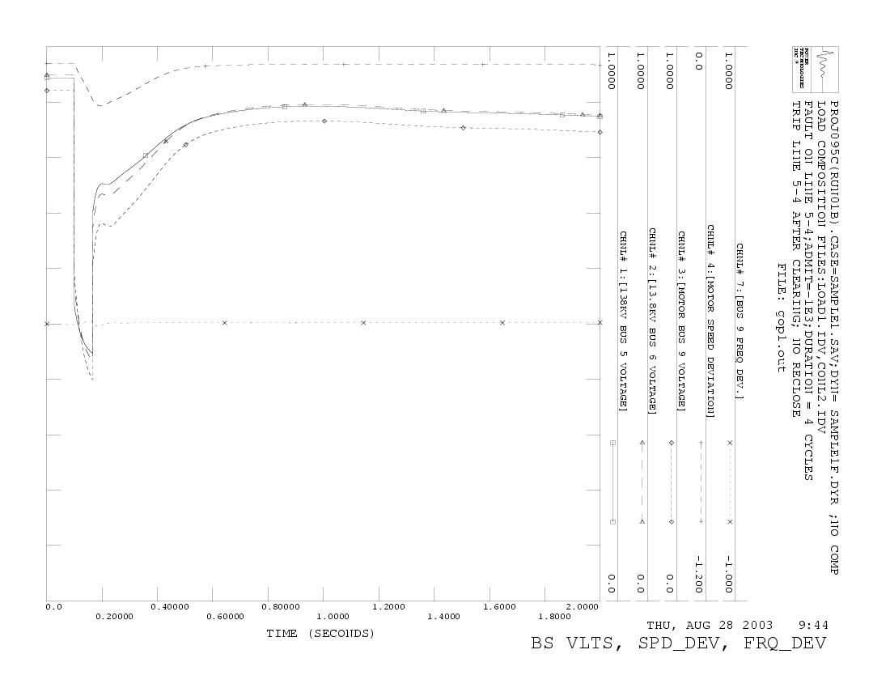
Fig 7. Stable scenario.

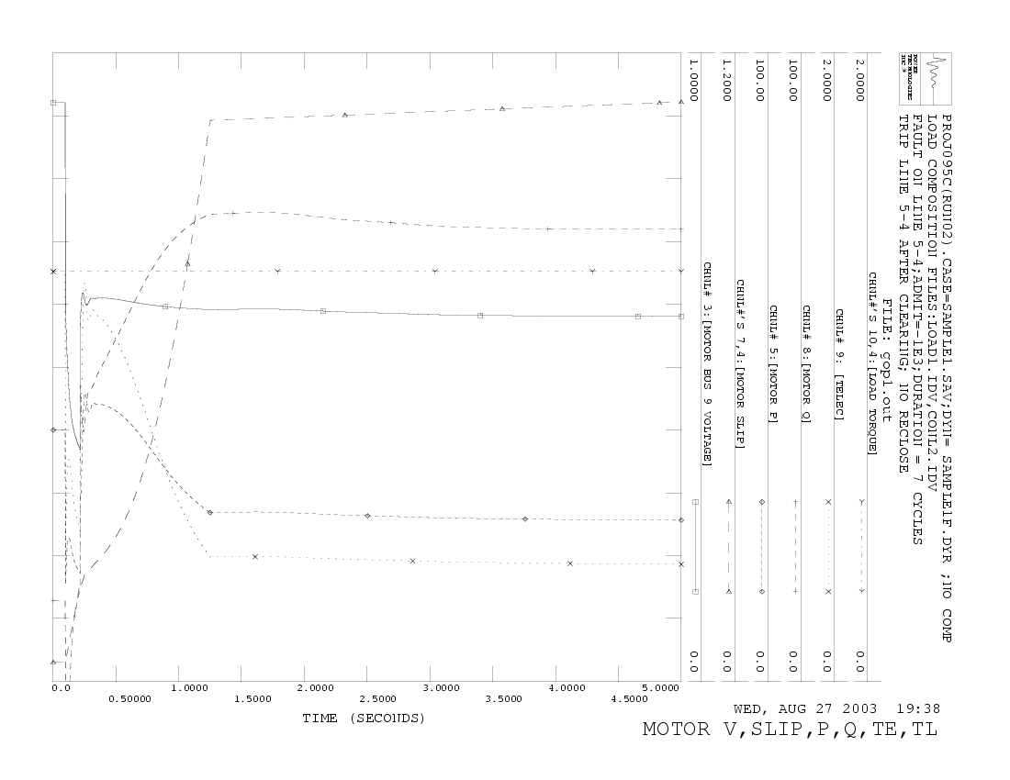
Fig 8. Unstable scenario.
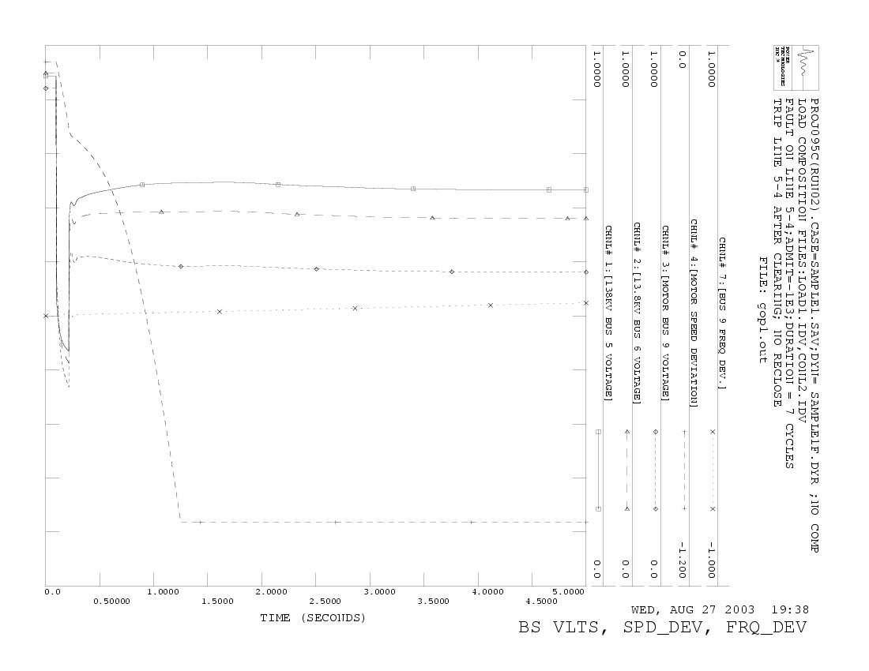
Fig 9. Unstable scenario.

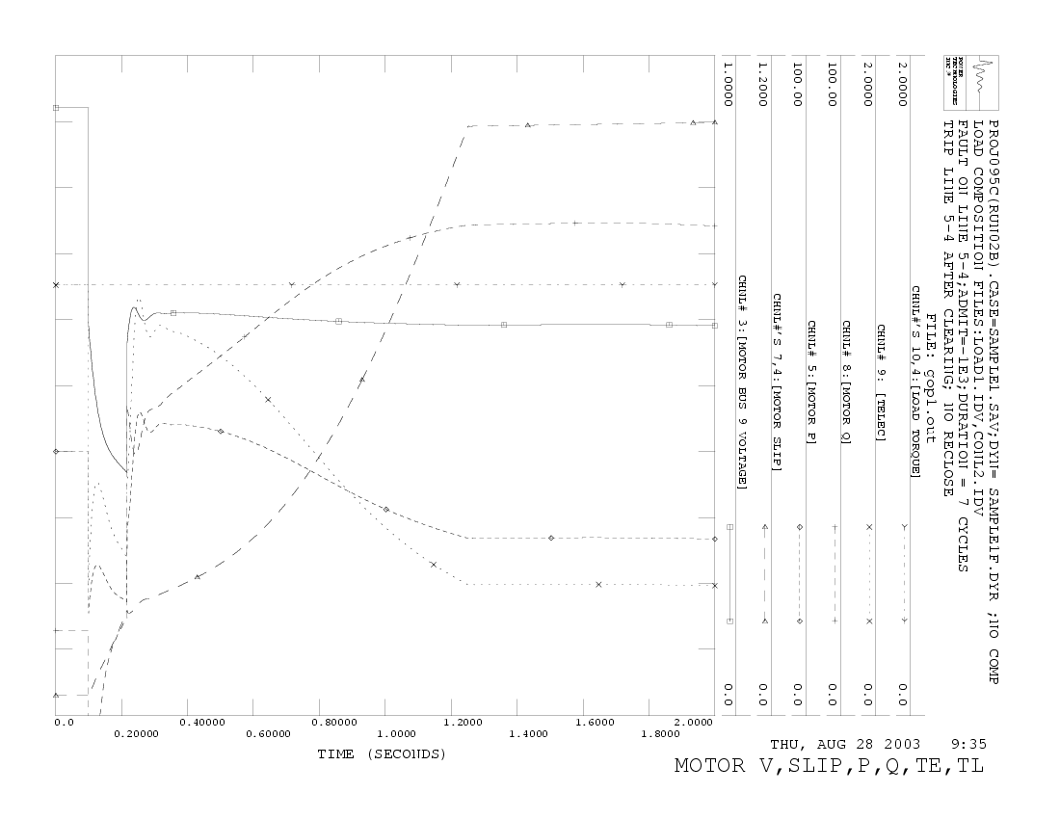

Fig 10. Unstable scenario.

Fig 11. Unstable scenario.
