STEC Request for CSC Zone Reassignment

In the CSC zone determination recommend by WMS STEC has three busses that fall into the Houston zone, two of which are 69 kV load busses (5564-Sargent, and 5566-Franklin's Camp). The third bus is on the 138 kV side of the 69/138 kV auto at Franklin’s camp and is not a load buss. All of STEC’s other busses fall into the south zone. STEC requests that these two 69 kV load busses be reassigned to the south zone for the following reasons:

- The contribution to congestion management would be negligible.

- STEC will have to acquire PCR’s to serve two native load busses with a total forecasted 2004 summer peak load of 9.6 MW.

Functionally, the 138 kV tie between Franklin’s Camp and Reliant Seaway supports the local 69 kV system via the 69/138 kV auto at Franklin’s Camp and will not contribute materially to congestion relief.

The drawing below indicates the approximate relationship of the Sargent and Franklin’s Camp subs to the CSC zonal boundary and the ERCOT bulk transmission system.

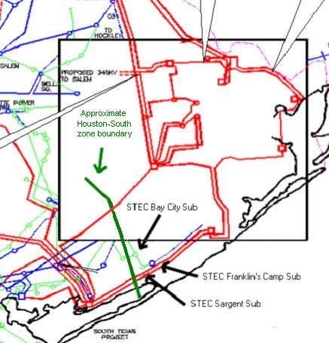

Shift Factor Comparisons

 | 43220  SEAWAY | 5560  BACT 9 | 5564  SARGNT 9 | 5566  FRMCP 9
Load | 2.8 MW | 4.0 MW | 5.3 MW | 4.3 MW
Current Zone | Houston | South | Houston | Houston
Requested Zone | Houston | South | South | South
GRA-PKR | 0.020619791 | 0.024700491 | 0.022769682 | 0.021930227
SAN-TEMP | 0.254535556 | 0.306781232 | 0.282060862 | 0.27131322
STP-DOW | -0.330601037 | -0.001044461 | -0.156976178 | -0.224770382
GIB-OB | -0.337024361 | -0.293848217 | -0.314277291 | -0.323159188
FRM-ROY | -0.04404261 | -0.041976862 | -0.042954285 | -0.043379236
Loads are from ERCOT 2004 summer peak case dated 7/24/03.

STEC requests reassignment of the boldfaced busses from the Houston zone to the South zone.

Seaway is in the Houston zone, one bus away from Franklin’s Camp.

Bay City is in the South zone, one bus away from Sargent.

