ERCOT Residential Model Performance

Prepared by
Ernie Podraza

September 22, 2003

Analysis Methodology:

Compare the normalized daily shape of the hourly average residential sample load supplied by CenterPoint Energy for the period Oct. 1, 1998 through Sept. 30, 1999 to the normalized daily shape of ERCOT published ResLowWR and ResHiWR load profiles for the same period and compare to a combination of the two ERCOT profiles weighted based on the RRI customer counts for the two ERCOT profiles on Sept. 2, 2003.

Location of referenced files:
H:\Retail Energy Supply\Forecasting\SAS\home2\i019278\ERCOTProfileCalibration\n003_20030902_ProfilevsSample

Results:

Mean Absolute Percent Error for the month is least in August. Also the only month with negative Mean Percent Error is August. The load research for CNP for the residential sample was designed for a summer peak criteria. Therefore perhaps there is no surprise that August has the least Error.

Mean Absolute Percent Error for the hour of the day is generally larger in the earlier hours of the day across the year. It is interesting that Mean Percent Error is negative for the first 8 hours of the day. This suggests that the model is over estimating in the morning, which is what the ERCOT UFE Analysis has also reported.

In addition, the mean percent error between the RRI blended normalized shape and the sample normalized shape seems relatively even over all seasons. The following is a plot of hour 17 for example.

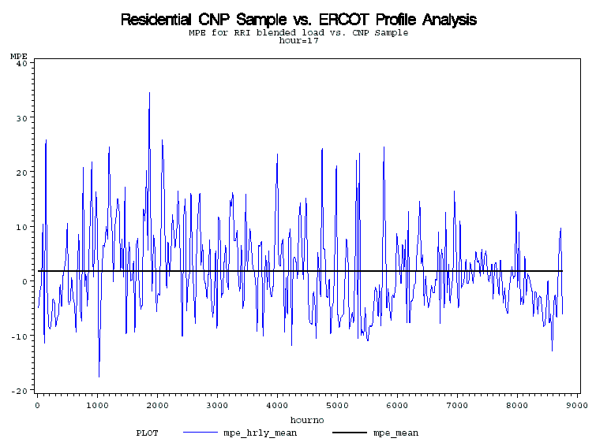
Scatter Plots found in file, hourlydata_master.xls do not show a definitive pattern of error verses rainfall. The following is hour 17 across the 365 days in the year.

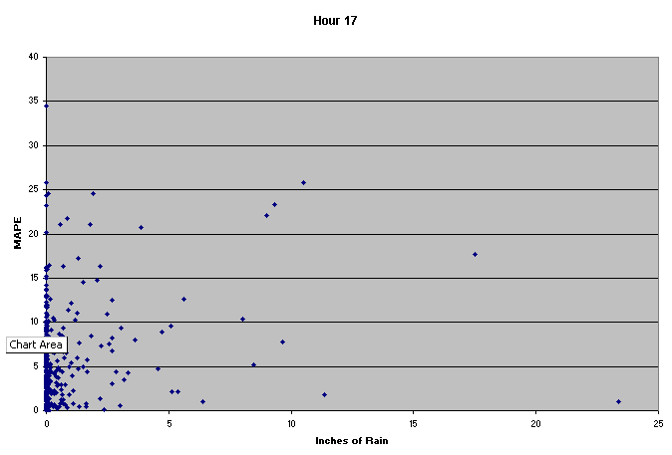

However, in file profiles_vs_res_avg.lst, using SAS Proc CORR, the Pearson Correlation Coefficient goes from .29 over all days of the year to .32 over the 251 days of the year with a trace of rain in at least one of the 6 area weather stations. The six weather stations used in this analysis were Galveston, Victoria, Houston Intercontinental, Houston Hobby, Houston Clover Field and Hooks.

Rainfall data is summarized in the following file, rain_rpt_byday_master.xls.

Visual inspection of load verses rain found in file, sample_vs_profile.pdf, shows that when it rains there appears to be more variance between the models and the sample. Proc CORR results support this directional variance. Samples of daily plots from the pdf file is as follows:

June 6 is a Sunday with no rain at any station. The normalized shapes of the sample, ResLoWr, ResHiWR or the combined RRI Residential shape are all fairly consistent.
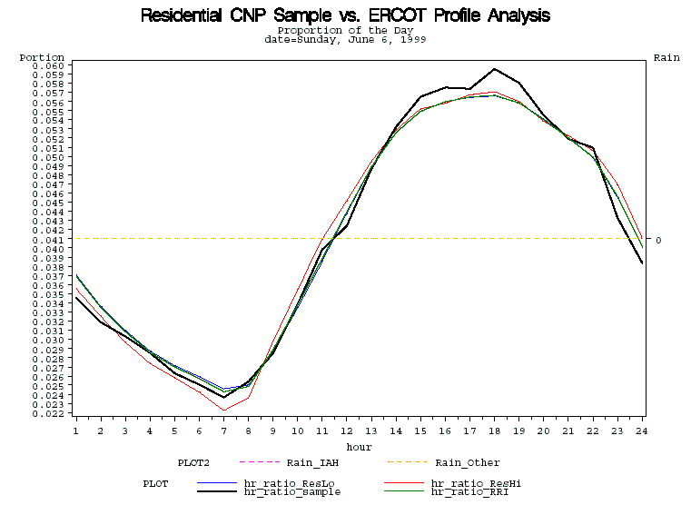

However the next day there is over .5 inches of rain at 5 of the stations in the area but none at Intercontinental Airport, which is the model input station.

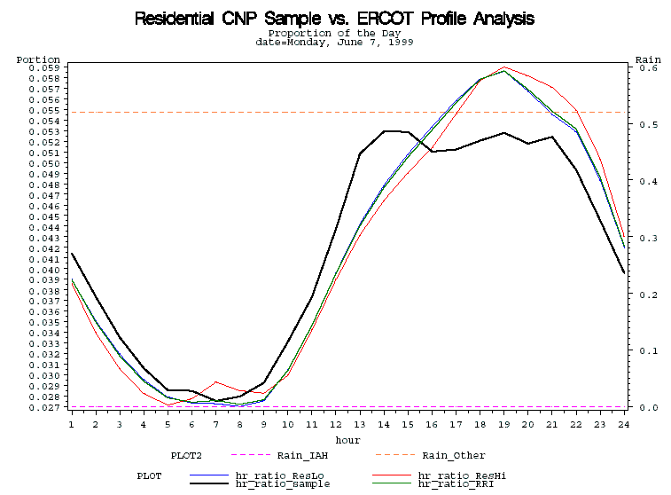

Visually this is more difficult to see in the winter than in summer.

