Market Application Guide

Introduction 3
Definitions 4
Reporting Requirements 5
What it to be reported? 5
Who is to report? 6
Who is to utilize the Market Notification process? 6
When should a Market Notifications be submitted? 7
Initial Market Notification 7
Status and Resolution Updates: 7
How should Market Notifications be routed? 8
Market Notification Web Form 8
Market Notification Email Form 8
Notification Categories 9
Business and Customer Facing 9
Technical 9
Process for Submitting 10
Web Form 10
Market Email Form 12
Appendix 13
Process Flow Diagram 14
Submittal and Notification 14
Status and Detail Update and Notification 15
Market Notification Form 16

Introduction

The testament to the success of any deregulated energy market is the growth of that market’s participant base. And along with growth comes the demand for information and consistent forms of communication.

Recognizing the need for a formalized market notification standard, Texas market participants set out to define the following Market Notification Procedures, with a focus to establish communication and notification consistency, structure and market documentation.

The following sections outline the Texas Market Notification processes and procedures as adopted by the market participants for the purpose of facilitating Market Notification within the Texas deregulated energy market.

Definitions

Market Notification Form Template used to imitate, update and communication pertinent information relating to an event or situation to market participants.

Situations of Consequence Generally any event or situations that does or has the potential to impact another market participant’s business operation, either technically or operationally.

Reporting Requirements

What it to be reported?

Generally any event or situations of consequence that does or has the potential to impact another market participant’s operation, either technically or operationally. Events or situations, which are unique to a trading partner for a specific business process, would not normally be subject to this process.

As an example:

A trading partner is missing a meter read and request an investigation and subsequent delivery of the missing transaction. Research indicates that a substantial number of meter reads were not being generated, submitted or delivered as thought. Market Notification process is initiated.

A trading partner is missing a meter read and request an investigation and subsequent delivery of the missing transaction. Research indicates that the read in question needs to be regenerated or released for delivery. Further investigation determines that this occurrence is unique to this one time event and trading partner. Market Notification is not warranted.

Example areas include but are not limited to:

- File Processing
- System Maintenance or Availability
- Mass or Significant Transaction Failures or Data Errors
- Customer Billing
- Emergency Notices

Who is to report?

Beneficially this would be the individual within the company who has first hand knowledge of the event or situation and is capable of addressing inquiries relating to the Market Notification being broadcast.

However, in cases where it is someone else generating the notification, the Market Notification should reflect the contact information of the individual who provided the details of the event and is capable of addressing inquiries relating to the information presented in the Market Notification.

Who is to utilize the Market Notification process?

Any market participant (e.g. REP’s, TDSP’s, ERCOT, Vendors / Service Providers, etc.) participating in the Texas deregulated energy market.

When should a Market Notifications be submitted?

Ultimately the decision to initiate and submit a Market Notification is driven by the event or situation itself followed by the availability of information detailing the event and proposed solution (s). The following should be used as the basis for submitting a Market Notification.

Initial Market Notification

Business and Customer Facing
- Transactional Emergencies – Within 1 hour of the event
- Billing Delays – Within 1 hour of the event.
- Invoice Delays – Within 1 hour of the event.
- Mass Cancel / Rebilling – 3 business days prior to the event.
- Mass Transactional Regeneration – 1 business day prior to the event.

Technical
  - Technical Emergency – Within 30 minutes of the event.
  - Production Processing Delays – Within 30 minutes of the event.
  - System Maintenance – 3 business days prior to event.

Status and Resolution Updates:

Business and Customer Facing
- Transactional Emergencies – Within 4 hours of the initial Market Notification
- Billing Delays – Within 4 hours of the initial Market Notification.
  - Invoice Delays – Within 4 hours of the initial Market Notification.
  - Mass Cancel / Rebilling – Daily if the event is being pushed otherwise upon completion of the event.
  - Mass Transactional Regeneration – Within 8 hours of the target date if the event is being pushed otherwise upon completion of the event.

When should a Market Notifications be submitted? (continued)

Technical
  - Technical Emergency – Hourly and upon completion of the event.
  - Production Processing Delays – Hourly and upon completion of the event.
  - System Maintenance – Daily if the event is being pushed otherwise upon completion of the event.

How should Market Notifications be routed?

Market Notification Web Form

Market Notifications should only be routed by selecting or highlighting the appropriate the list serve selection (s) as indicated on the Market Notification form. Once selected, the Market Notification, when submitted, will generate a summary message to the designated email recipients. The message recipient then will determine if the Market Notification subject matters warrant review or follow up of the actual Market Notification that has been retained for viewing on the Market Notification Bulletin Board.

Market Notification Email Form

During the interim, until the bulletin board and Market Notification Form is available to the market in a technical fashion, the market shall utilize the Excel version of the Market Notification form.

Users should access the Market Notification Form through the ERCOT web site copying down the current form version. Preparation and routing should then follow the process outlined within these guidelines. For this process email will continue to be the communication mechanism for submitting and routing.

Notification Categories

Market notifications are generally associated with specific areas of impact with further clarification or definition being communicated by assigning an associated category and status. This information is used to provide summary notification snap shots enabling quick user assessment, consistent Market Notification information, and minimal communication overhead. The following impact areas and related categories should be applied as appropriate and in relation to the definitions provided.

Business and Customer Facing

This area of impact encompasses

Emergency Event
Production Processing Delays
Meter Read Generation
Invoicing
Billing
ESI-ID Updates
Cancel / Rebill Billing
Error and Exception Processing

Technical

This area reflects those technical events

Emergency Event
Routine Maintenance Impacting Market Functions
GISB
FTP
Communication

Process for Submitting

Web Form

Market Notifications are initiated and updated through the Market Notification Form accessed through the bulletin board located through ERCOT’s web portal. To facilitate the process of submitting a Market Notification, the Market Notification Form, when initiated or accessed, is presented to the user with required data entry fields and selectable drop down values where applicable.

The following data elements are required when submitting a Market Notification Form and where applicable corresponding data values are provided for form completion.

Issue Number – Free form field for data entry. Unique over time for each Market Notification.
Date Submitted – Free form field for data entry.

Area of Impact
Business
Technical

Category
Business
Emergency Event
Production Processing Delays
Meter Read Generation
Invoicing
Billing
ESI-ID Updates
Cancel / Rebill Billing
Error and Exception Processing

Technical
Emergency Event
Routine Maintenance Impacting Market Functions
GISB
FTP
Communication

Process for Submitting (continued)

Web Form (continued)

Status
In Progress
Scheduled
Completed
Emergency

Process Flow
MP to ERCOT
ERCOT to MP
MP to MP
Issue Started – Free form field for data entry.
Issue Ended – Free form field for data entry.
Submitted By – Free form field for data entry.
Contact Email – Free form field for data entry.
Contact Phone – Free form field for data entry.

Transactions
All
MVI Series
MVO Series
SW Series
DRP Series
HIST Series
AND Individual Transaction Types (e.g. 814_01, 814_02…)
Short Description – Free form field for data entry.
Long Description – Free form field for data entry.
Proposed Solution – Free form field for data entry.
Final Resolution – Free form field for data entry. Required once final status update submitted to market

Selection Distribution List
RMS
WMS
ALL

Market Email Form

During the interim, until the bulletin board and Market Notification Form is available to the market in a technical fashion, the market shall utilize the Excel version of the Market Notification form.

Users should access the Market Notification Form through the ERCOT web site copying down the current form version. Preparation and routing should then follow the process outlined within these guidelines. For this process email will continue to be the communication mechanism for submitting and routing.

The following communication approach should be applied when initiation, updating and routing of an Excel Market Notification Form.

- Complete and attach the Excel Market Notification Form to an email for routing.
- In the subject line reflect
MARKET NOTIFICAITON - Area of Impact, Category, Status and Process Flow
- In the email body reflect
Short Description
- In the routing reflect
The appropriate list serve address for routing.

Appendix

Process Flow Diagram

Submittal and Notification

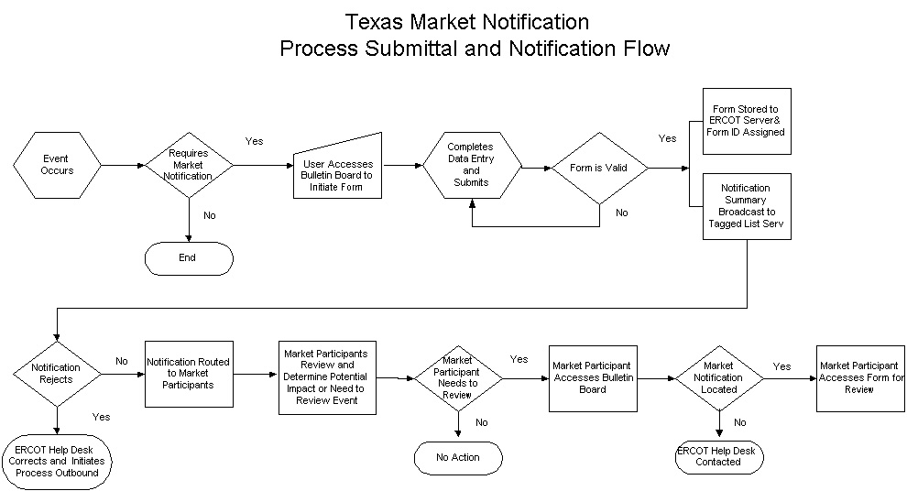

Status and Detail Update and Notification

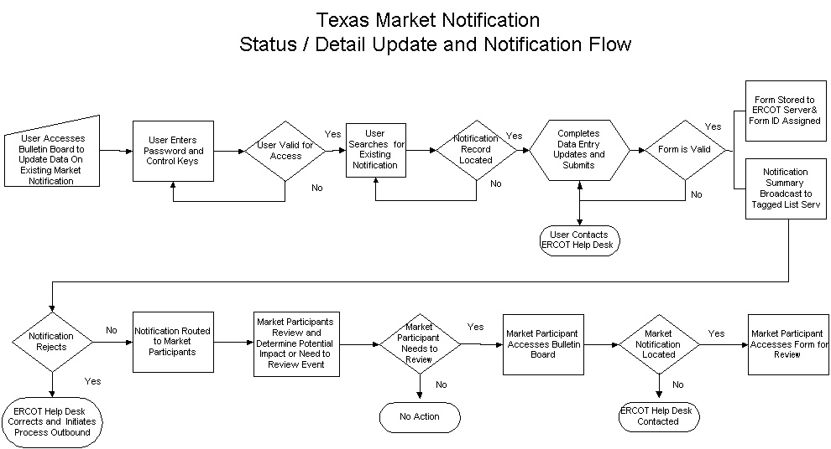

Market Notification Form

