ERCOT Report Voltage Collapse of Bryan/College Station Area
4/15/2003

Overview
At about 11:39 on April 15, 2003, Centerpoint Energy, switching for a planned outage, opened 345 kV Breakers J240 and J250 at Roans Prairie substation. This switch was part of a planned outage to remove the 345 kV circuit from Roans Prairie to Kuykendahl from service in order to support construction in the area.

Approximately 45 cycles after this action, fault recorders maintained by Centerpoint recorded the opening of the line from Roans Prairie to Gibbons Creek; and, a few cycles after that, observed a transfer trip signal from the Gibbons Creek station to open Breaker J230 at Roans Prairie.

Employees of Garland TSP state that, at about this time, it appeared that they received a trip signal for Breakers 5090 and 5080 at Gibbons creek. One, or both of these breakers appeared to fail to operate, and a breaker failure event was initiated on the Gibbons Creek bus.

Both the North and South buses of Gibbons Creek cleared. The Gibbons Creek Generating Unit remained in service connected only via a single breaker to Twin Oak Substation.

At about 11:45, the ERCOT Transmission & Security Desk received a call from Bryan Texas Utilities (BTU) informing ERCOT of severe under voltage conditions in the Bryan area. ERCOT checked telemetry data from BTU’s Dansby generating station and saw both low voltage and high reactive power output.

Gibbons Creek telemetry to ERCOT showed all breakers still in service and adequate voltage on both the 345 kV bus and the 138 kV bus. In reality, the Gibbons Creek substation was out of service at this time, and both autotransformers feeding the Bryan/College Station area were out of service.

ERCOT called Garland, the operator of Gibbons Creek, and asked if they could increase voltage on the 138 kV bus at Gibbons creek by tapping the transformers. Garland replied that they did not have tapping capability on these transformers.

Un-communicated to ERCOT was that Garland had seen all the breakers open at Gibbons creek, but believed that it was a false indication, due to a communication problem; since they had simultaneously lost contact with the RTU at Gibbons Creek. They later determined that, when the bus tripped, the modem to the RTU switched to dial up mode and communications were lost.

ERCOT, still unaware that the Gibbons Creek buses and autotransformers were out of service, called the Garland QSE and requested that they increase reactive power output on the Gibbons creek unit to increase voltage on the 345 kV and 138 kV buses. The operator directed ERCOT to call their TDSP.

During this period, both autotransformers feeding the Gibbons Creek 138 kV bus were out of service, and all three 138 kV lines from the Gibbons Creek substation feeding the Bryan/College Station area had no energy source. Only one transmission line remained feeding the area, the Hearne – Dansby 138 kV line.

At approximately 11:57, following loss of Dansby, which was the only generating unit providing reactive power in the area, voltage in the Bryan/College Station areas collapsed.

After confirming with BTU that a localized blackout was in progress, ERCOT recommended clearing the Dansby buses and beginning re-energization from Hearne.

Areas involved in the voltage collapse included the cities of Bryan and College Station, most of Brazos County, and some parts of Grimes and Burleson County. Approximately 212 MW of load and 68, 530 customers were affected.

Due to the loss of communications and telemetry at Gibbons Creek, restoration of the Gibbons Creek 345 kV station was slow; coordinated via telephone calls to operators at the site. The transmission system was restored and service restored to all load by approximately 1600.

An illustration of the areas involved is shown below.

Figure 1
Sequence of Events
1138 – Tripped 345kV breakers K890 @ KG & J240 @ RNS by SCADA control.

1139 –Tripped 345kV breaker J250 @ RNS by SCADA control. Some/all 345kV breakers @ XGC tripped (CenterPoint Energy has SCADA status monitoring of breakers 5080, 5090, 5110 and 5120 and these four breakers did indicate opening). 345kV breaker J230 @ RNS tripped. 345kV breakers F240 & F250 @ OB tripped. The following table of information extracted from the digital fault recorder located at the Roans Prairie substation provides details of these actions and observations:

Time | Description | Supporting Information
11:38:59.157 | Breaker J250 at Roans Prairie is opened by the CenterPoint Energy transmission dispatcher and the current on the circuit from Roans Prairie to Gibbons Creek changes from approximately 360 ampere to 1080 amperes. | See figure 2, image of information from the Roans Prairie substation Digital Fault Recorder.
11:38:59.370 | The current at Roans Prairie on circuit #75 to Gibbons Creek is approximately 1360 amperes. | See figure 2, image of information from the Roans Prairie substation Digital Fault Recorder.
11:38:59.829 | The current at Roans Prairie on circuit #75 to Gibbons Creek is approximately 1090 amperes. | See figure 3, image of information from the Roans Prairie substation Digital Fault Recorder
11:38:59.882 | Current Roans Prairie on the circuit to Gibbons Creek is interrupted by breakers opening at Gibbons Creek | See figure 3, image of information from the Roans Prairie substation Digital Fault Recorder
11:38:59.891 | Carrier transfer trip signal is received at Roans Prairie from Gibbons Creek. | See figure 3, image of information from the Roans Prairie substation Digital Fault Recorder
11:38:59.916 | Breaker J230 at Roans Prairie is opened by the carrier transfer trip signal received from Gibbons Creek. | See figure 3, image of information from the Roans Prairie substation Digital Fault Recorder
Also, during the above event, a carrier transfer trip signal was received at Obrien substation from Gibbons Creek which tripped breakers F240 and F250. This was concluded from the fact that the lockout relay that is operated by the receipt of carrier transfer trip from Gibbons Creek was found picked up. Also, there was no indication of the operation of a protective relay at Obrien that would trip these two breakers other than the lockout relay discussed above.

Figure2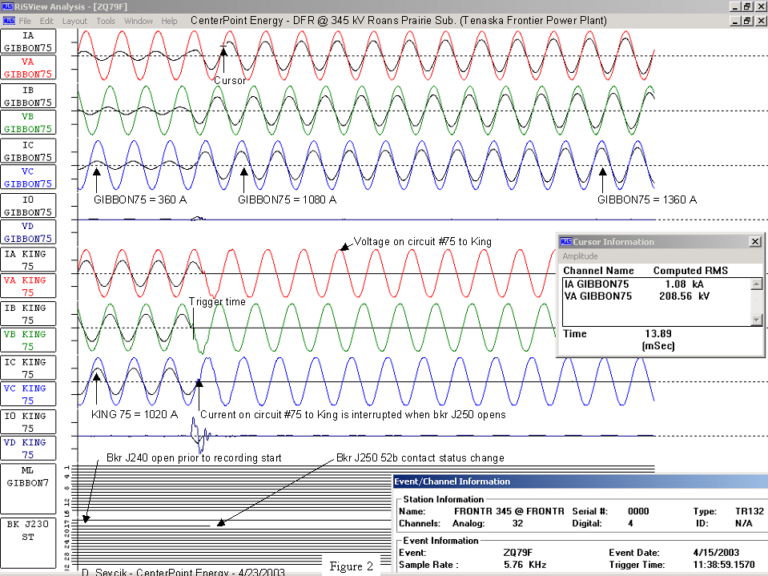

Figure 3

Problems that contributed to the cause of the outage
- Trip coil #2 on breaker 5120 at Gibbons Creek was found to be bad. It had shorted turns in the coil, but still had continuity through it. It did not short to ground. This was a problem that existed prior to the date of the outage.
- The shorted turns in trip coil #2 for breaker 5120 at Gibbons Creek allowed the current to increase through the trip circuit thus over-heating a 10 ohm, 100 watt resistor that is a part of the same trip circuit, until it failed. This resistor is physically located in the control cabinet on the breaker. The burned resistor, which is connected in parallel with a 500 microfarad capacitor, became open circuited, thus allowing the capacitor to charge up (by means of a red light circuit) and apply a DC voltage to the trip bus of the BF scheme for breaker 5120. This was a problem that existed prior to the date of the outage.
- Some of the CHC fault detector relays that are a part of the BF schemes were out of adjustment which allowed the contacts in those relays to stick closed once the relay picks up and closes its contacts. These relays are in the circuit that starts the BF timers. These relays normally close their contacts when the load exceeds a certain level. The load increase occurred when the line from Roans Prairie Substation (at Frontier Plant) to King Substation was switched out of service. This load increase caused the CHC fault detectors to pick up and close its contacts. Once the contacts were closed they stayed closed because of the adjustment problem. With these contacts stuck closed, the BF schemes timed out and tripped other breakers.

Figure 4 – Gibbons Creek 345 kV station
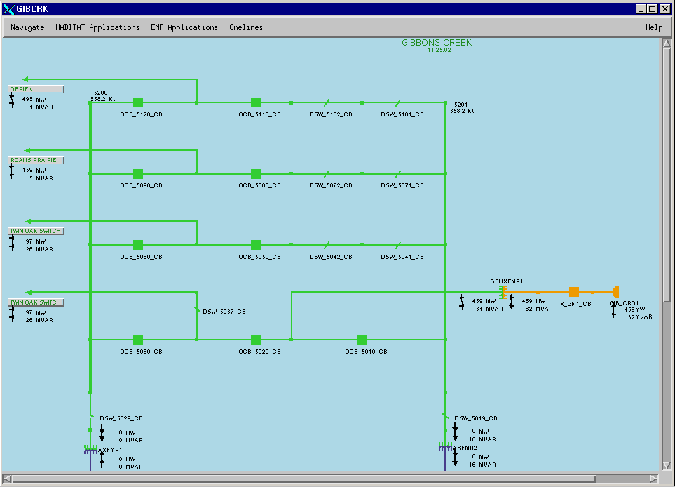
Since items #1 and #2 above had occurred beforehand, all that was needed was for item #3 to occur to start the tripping. Since item #3 occurred on at least three breakers (5120, 5090 and 5080), the problem cascaded from one to the other, thus tripping out breakers on both the north and south buses.

All three of these problems have been corrected. The trip coil and resistor have been replaced. The CHC fault detector relays have been adjusted and are working properly.

The delayed telemetry status received at ERCOT has not yet been resolved. ERCOT and Garland are working together to prevent a recurrence of this problem.

Summary
The voltage collapse at Bryan/Collage Station was caused by a series of failures of equipment in protection systems taking place at the Gibbons Creek substation. No switching errors have been identified.

ERCOT staff does not have expertise in system protection schemes but have formed the following opinions:

- The relaying scheme at Gibbons Creek uses older relaying techniques and is not as reliable as more modern methods.
- Some of the relaying equipment at Gibbons Creek may be undependable.
- The Transmission provider for the area is competent to correct these problems.

Recommendations
- This report should be reviewed by the ERCOT System Protection Working Group for accuracy and completeness.
- The relaying scheme at Gibbons Creek should be reviewed by the local transmission provider (TDSP) and system protection improvements recommended.
- The proposed revisions to the Gibbons Creek relaying scheme should be reviewed by the ERCOT System Protection Working Group and approved prior to implementation
Request:
- Investigation and report of all control operations and trip signals to or from Roans Prairie substation that might be associated with this disturbance

Response:
The following is the result of an investigation that was made by CenterPoint Energy (CNP) pertaining to the initial events that occurred on 4/15/2003 related to the bulk electric disturbance in the Bryan/College Station area. All times are approximate except those obtained from the digital fault recorder (satellite time synchronized). CenterPoint Energy was engaged in switching activities on a planned outage on 345kV line 75 KG – KDL – RNS for highway construction. SSO (Substation Operations) crews at RNS and KG.

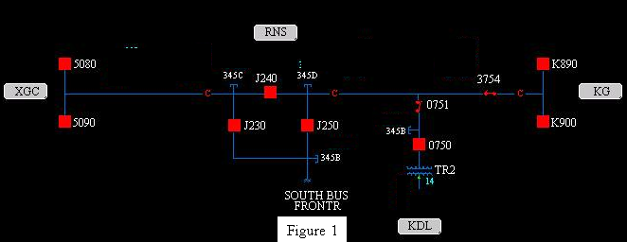

1138 – Tripped 345kV breakers K890 @ KG & J240 @ RNS by SCADA control.

1139 –Tripped 345kV breaker J250 @ RNS by SCADA control. Some/all 345kV breakers @ XGC tripped (CenterPoint Energy has SCADA status monitoring of breakers 5080, 5090, 5110 and 5120 and these four breakers did indicate opening). 345kV breaker J230 @ RNS tripped. 345kV breakers F240 & F250 @ OB tripped. The following table of information extracted from the digital fault recorder located at the Roans Prairie substation provides details of these actions and observations:

Time | Description | Supporting information
11:38:59.157 | Breaker J250 at Roans Prairie is opened by the CenterPoint Energy transmission dispatcher and the current on the circuit from Roans Prairie to Gibbons Creek changes from approximately 360 ampere to 1080 amperes. | See figure 2, image of information from the Roans Prairie substation Digital Fault Recorder.
11:38:59.370 | The current at Roans Prairie on circuit #75 to Gibbons Creek is approximately 1360 amperes. | See figure 2, image of information from the Roans Prairie substation Digital Fault Recorder.
11:38:59.829 | The current at Roans Prairie on circuit #75 to Gibbons Creek is approximately 1090 amperes. | See figure 3, image of information from the Roans Prairie substation Digital Fault Recorder
11:38:59.882 | Current Roans Prairie on the circuit to Gibbons Creek is interrupted by breakers opening at Gibbons Creek | See figure 3, image of information from the Roans Prairie substation Digital Fault Recorder
11:38:59.891 | Carrier transfer trip signal is received at Roans Prairie from Gibbons Creek. | See figure 3, image of information from the Roans Prairie substation Digital Fault Recorder
11:38:59.916 | Breaker J230 at Roans Prairie is opened by the carrier transfer trip signal received from Gibbons Creek. | See figure 3, image of information from the Roans Prairie substation Digital Fault Recorder
Also, during the above event, a carrier transfer trip signal was received at Obrien substation from Gibbons Creek which tripped breakers F240 and F250. This was concluded from the fact that the lockout relay that is operated by the receipt of carrier transfer trip from Gibbons Creek was found picked up. Also, there was no indication of the operation of a protective relay at Obrien that would trip these two breakers other than the lockout relay discussed above.
Additionally, there was no protective relay operation indication at Roans Prairie or Obrien that would indicate that carrier transfer trip was transmitted from either of these two substations to Gibbons Creek.

Request:
- Sequence of events at Roans Prairie during the event.

Response:
The following is a chronology of events that occurred on 4/15/2003. All times are approximate.

CenterPoint Energy was engaged in switching activities on an ERCOT approved planned outage on 345kV line 75 KG – KDL – RNS for highway construction. SSO crews @ RNS & KG.

Notes:
1. CenterPoint Energy scans the status of four 345kV breakers @ XGC; breakers 5080 & 5090 on 345kV line 75 to RNS & breakers 5110 & 5120 on 345kV line 99 to OB. CNP also scans the watt, volt/ampere & reactive power flow on these two 345kV lines. CNP has no control capability of any equipment at the XGC substation.
2. Mnemonics used; King (KG), Kuykendahl (KDL), Roans Prairie (RNS), Gibbons Creek (XGC) & Obrien (OB) substations. City of Garland (COG), CenterPoint Energy (CNP)
- Frontier power plant and RNS 345kV substation are physically located on the same site.
- Chronology is based on operator logs, SCADA data, and telephone tape recordings
- Unless otherwise identified all persons named are CenterPoint Energy personnel.

1138 – Reed tripped 345kV breaker K890 @ KG by SCADA control. He then tripped 345kV breaker J240 @ RNS by SCADA control.

1139 – Reed tripped 345kV breaker J250 @ RNS by SCADA control. Some/all 345kV breakers @ XGC tripped. 345kV breaker J230 @ RNS tripped. 345kV breakers F240 & F250 @ OB tripped. This locked out 345kV lines 75 RNS – XGC & 99 OB – XGC. Frontier generation tripped off line (approx. 700 MW’s). Line 75 KG – KDL - RNS remained energized from KG through 345kV breaker K900.

1140 – Reed contacted Frank @ Frontier generation. Reed asked if they were engaged in any switching activities. Frank replied no. Situation was also discussed with Frank Carelli supervisor @ Frontier. Reed asked for and received ok from Carelli to energize Frontier bus when possible.

1141 – Robison notified ERCOT (Diane) of loss of both lines. Notified ERCOT of attempt to contact City of Garland (COG) to discuss situation @ XGC. Unable to contact COG. Requested assistance in contacting COG.

1144 – Robison notified TMPA dispatcher (Troy) of situation. Troy reports he “doesn’t show anything either” @ XGC. Robison asks for XGC bus to be energized before CNP tries to energize line 99 from OB. Troy requests CNP contact COG.

1148 – ERCOT (Colleen) calls Reed with COG phone number. Confirms same number CNP has. Colleen reports COG very busy.

1154 – Reed made contact with COG(Ukulele). Requested status of XGC 345kV buses. Ukulele is unsure of situation. Ukulele reports problems with SCADA @ XGC. He believes XGC buses are still energized. COG has a SCADA crew en route to XGC.

1155 – Reed contacted Gillis @ RNS and asked for update. Gillis reports no relay flags other than an 86 lockout relay. Gillis reports that it appears a transfer trip came from XGC. A transfer trip from RNS to XGC should have a breaker failure relay flag @ RNS. There is no such flag found.

1158 – Reed contacted COG (Ukulele). Ukulele reports Tom Chambers @ XGC confirmed the 345kV buses are open. He still does not trust status on his system. Reports all 345kV breakers @ XGC are open. All 138kV is open.

1200 - ERCOT (Colleen)made request to Robison to restore lines 75 & 99 as quickly as possible. She reports “we’re collapsing, voltage is collapsing.”

1201 – Reed called COG (Ukulele) to notify COG of ERCOT request to restore as soon as possible. Ukulele reports they are working on it.

1205 – SSO (Gillis) reported nothing out of the ordinary other than lock out of breaker J230.

1208 – ERCOT (Colleen) reported to Robison “voltage collapse” in College Station. Colleen asks if CNP is trying to get the lines restored. Robison reports the hold up seems to be at XGC. College Station in the dark.

1210 – Reed called COG (Ukulele) & asks for status @ XGC.Ukulele reports they are still looking it over. Reed asks if COG aware of voltage problems in College Station area. Ukulele is not aware. Reed reports to Ukulele College Station in the dark and we need to restore ASAP. Ukulele to call them again.

1211 – Reed calls ERCOT (Colleen) and asks for assistance with COG. Reed reports CNP can close @ OB if XGC gets a hot bus.

1212 – Collier instructs Gillis @ RNS to put everything in manual and reset the lock out relay, then to stay in the clear. Gillis reports he is unable to reset the lock out relay. He suggests a transfer trip signal from XGC may still be applied. Gillis to get a meter to check on possible signal from XGC.

1219 – Tomball (TB) sub 345kV bus voltage @ 338kV.

1222 – Industrial & Large Commercial Accounts (Wheeler) called & was notified of situation.

1223 – Reed requested update on XGC from ERCOT (Colleen). Colleen reports COG is not going to energize those lines until they know what took them out. Jonte spoke with Colleen. Reports CNP ready to close from OB if XGC buses come hot. Colleen reports they are trying to start up Dansby. Colleen asks what happened. Jonte reports it looks like a transfer trip signal from XGC to RNS. Reed notifies Colleen there is still a trip signal being applied from XGC to RNS. Colleen reports breaker 5020 @ XGC only 345kV breaker closed. Jonte again says CNP is ready to close from OB as soon as COG is ready.

1228 – Howard Daniels called & received update.
Gillis calls from RNS & reports to Collier there definitely is a trip signal still coming from XGC.

1230 – ERCOT (Diane) called Robison to confirm lines 75 RNS – XGC & 99 OB – XGC opened @ 1140. She then asked if they tripped or did CNP open them. Robison answered they tripped.

1235 – Reed spoke with Frontier generation (Billingsley). Gave him update on situation. Reed informed him CNP may close 345kV breaker J250 @ RNS to be ready to tie to XGC. Instructed Billingsley not to bring generation on line until CNP ok’s it. The system is still unstable. SSO crew (Humberson) @ OB. Checking for relay flags. Reported no relay flags @ OB.

1238 – Reed contacted Gillis @ RNS & informed him he (Reed) would attempt to close 345kV breaker J250 @ RNS by SCADA. J250 failed to close due to hot line/dead bus condition. Note: This is correct under the current relay scheme for RNS.

1239 – Reed instructed SSO (Gillis) to close J250 @ RNS. Gillis closed J250 manually from panel which energized bus from RNS to Frontier generation.

1241 – Transmission Construction (R. Gordon) called for update.

1242 – ERCOT (Risinger) called Robison to ask if the 138kV line from XGC to Steep Hollow is CNP. Robison replied no. Risinger then asked “Whose is that, do you know?” Robison answered it probably was COG. Risinger said they were trying to get that line hot. Robison reported that line 75 was hot to RNS & the Frontier bus. CNP is waiting on COG. Risinger replied CNP was free to talk to COG directly. Risinger asked if it would hurt CNP if the 138kV line from Steep Hollow came hot to XGC. Robison replied no.

1243 – Requested update from ERCOT (Risinger) on situation @ XGC. COG unwilling to attempt to energize XGC. Notified ERCOT we were ready to try to energize from OB or RNS.

1244 – Reed closed 345kV breaker K890 @ KG on line 75 to RNS by SCADA control.

1245 – COG (Owens) reported “We show flags on 5090 & 5080 looking back at KG (RNS) on breaker failure on time our 62-5 TB/NB” @ XGC. Owens asked if CNP had a fault on line 75. Reed replied no, not to our knowledge. Reed went over events with Owens. Owens expresses they are having trouble @ XGC resetting their lock out relays. Reed requests they reset the signal from XGC to OB. Owens to call XGC. Owens asks CNP to close from other end. He doesn’t want to jeopardize the generating unit still on line @ XGC feeding through breaker 5020 to Twin Oaks. No other power @ XGC. Reed “That’s fine.” Reed suggests COG open a high side switch of one auto transformer. CNP could then energize & test that bus from OB. Owens to verify in field what’s open & call back.

1246 – COG reported they attempted to close 345kV breakers 5080 & 5090 @ XGC on line 75 to RNS. Unable to due to lock – out relay.

1250 – ERCOT(Risinger) called to confirm RNS to Frontier is back up. He then asks what is the status of KDL – Frontier. Robison replies that line is hot from KG – KDL - RNS. KDL tap is rolled off. Risinger asks if CNP is going to close the ring bus @ RNS, breaker J230. Robison says we are working on that.

1257 – Reed issued switching order # 83 to Gillis to clear up 345kV breaker J230 @ RNS. SSO to check for possible breaker trouble. Reed requested SSO breaker man be sent to RNS.

1306 – Reed agreed with COG (Owens) to energize XGC from OB on line 99. Reed confirmed with Owens switch 5019 @ XGC is open which isolates auto transformer 2 from the 354kV bus. Reed asks about auto re-closing @ XGC. Once a bus is energized he does not want breakers closing automatically. Owens to confirm status of manual/automatic @ XGC.

1306 – Collier calls OB & instructs Humberson to confirm F240 & F250 in manual & to stay in the house.

1309 - COG (Owens) calls Reed back & reports all auto re-closers are off. Reed confirms COG is ready for CNP to energize line 99 from OB to XGC. SCADA control fail on 345kV breaker F240 @ OB due to supervisory close inhibit (SCI).

NOTE: SCI prevents the closing of a breaker or motor operated switch by a System Controller through the energy management system (EMS). This action is initiated by automatic relay operation. The conditions under which this relay operation occurs are determined by substation relay engineering.

1311 – Reed asks Humberson to clear SCI @ OB.

1312 – Brockhan updated Public Affairs (Dixon).

1316 – Gillis @ RNS reports Ivey en route to RNS.

1319 – Gillis reports transfer trip signal from XGC cleared @ RNS.

1323 – John Houston called for update.

1327 – SCI @ OB cleared.

1331 – COG (Owens) reported XGC energized from both Twin Oaks lines. They are checking their 345/138kV autos. Owens sure they are good on both sides of the bus. Reed informs Owens CNP is ready to energize from OB.

1341 – Reed closed 345kV breaker F240 @ OB by SCADA energizing line 99 to XGC.

1342 – COG (Owens) closed 345kV breaker 5110 @ XGC restoring line 99 OB – XGC.

1344 – Robison notifies ERCOT (Risinger) that line 99 OB – XGC is in service. Robison informs Risinger there may be some closing/opening of breakers to get the auto transformer hot. Risinger asks “How far away from getting the autos hot?”. Robison replies “Just as soon as they’re able to.” Risinger asks CNP to notify him when the autos are hot.

1345 – Robison notifies ERCOT (Colleen) @ 1342 breaker 5110 @ XGC closed feeding 345B bus.

1349 - Closed 345kV breaker F250 @ OB by SCADA control.

1350 – Robison notified ERCOT (Risinger) XGC 345A bus energized. Robison asks if COG is making notification to ERCOT. Risinger says yes they are. Robison informs Risinger 5120 @ XGC is closed & COG will open 5110 to de-energize 345kV bus so switch 5019 can be closed.

1356 – COG closed 345kV breaker 5120 on line 99 to OB. COG de-energized the 345B bus to close switch 5019 on the high side of AT2. During this switching action to clear the 345B bus 345kV line 99 OB – XGC tripped at OB & XGC and the XGC 345A bus tripped & locked – out. Cause unknown.

1357 – Robison notified ERCOT (Risinger) of loss of line 99 OB - XGC.

1400 – Industrial & Large Commercial Accounts (R. Ferrell) @ ECDC.

1402 – RTO engineer Alford looking into next possible contingencies.

1406 – COG (Owens) reports when they tripped 5110 @ XGC “everything went out.” At Owens request Reed closed 345kV breaker F240 @ OB by SCADA control.

1406 – ERCOT (Risinger) asks Robison “Do you have a time … when the 345 bus, you lost it @ XGC?” Robison asks which time. Risinger replies the original time. Robison gives time of 1139. Risinger asks “You were still hot into there from Twin Oaks right?” Robison replies “That’s not our sub.” Risinger “Right, that’s TU’s right?” Robison “We don’t show status of everything up there.” Risinger “So you just know when you lost your two …?”

1407 – Alford discussed next contingency with J. Adams (ERCOT).

1410 – COG (Owens) reports they are unable to close XGC breakers on line 99 to OB. Requested CNP close breaker on line 75 RNS to XGC.

1412 – SCI @ RNS cleared.

1415 – J240 @ RNS closed by SCADA control.

1417 – Made request of generators to increase var output. Experiencing low voltage in Tomball area (328kV).

1418 – K. Morely to assist with voltage control.

1420 – RTO requested Oncor to raise voltage @ Jewitt to assist voltage @ Tomball.

1426 – 345kV breaker 5120 @ XGC closed restoring line 99 OB – XGC. Tomball improved to 343kV.

1429 – Tomball @ 346kV.

1430 – COG closed breakers 5110 & 5080 @ XGC. This restored line 75 RNS – XGC. Notified ERCOT (Colleen).

1433 – COG (Owens) reports cause of event unknown. Will continue to investigate.

1448 – ERCOT (Colleen) updated.

Request:
3. Description of the operating and control responsibility arrangement between Garland and CenterPoint Energy for the Roan’s Prairie 345 kV substation.

Response:
CenterPoint Energy has operational control and jurisdiction of the Roans Prairie 345 kV substation. Planned Outage requests are submitted to ERCOT for approval. CenterPoint Energy Outage Schedulers notify Garland Operations ahead of time whenever Planned Outages are scheduled for Roans Prairie substation or the associated transmission lines. Frontier Power Plant personnel are also notified.

ERCOT reviews and approves the Planned Outage requests to ensure that no conflicts or contingencies exist. For the two transmission lines connecting to Roan’s Prairie 345 kV substation the following will happen operationally:

Line 75 King to Kuykendahl to Roans Prairie
ERCOT, Garland, and Frontier Power Plant personnel will be notified of the planned switching. CenterPoint, upon approval from ERCOT, will switch first at Kuykendahl. The Roans Prairie substation end of the line will be opened next, followed by opening the line at King substation. All switches and equipment are then locked out and tagged.

Line 75 Roans Prairie to Gibbons Creek
ERCOT, Garland, and Frontier Power Plant personnel will be notified of the planned switching. This line requires personnel from both CenterPoint and Garland to do switching. The Roans Prairie end of line 75 is opened first, followed by opening the Gibbons Creek end of the line. All switches and equipment are then locked out and tagged.

Request:
4. A description of the relay and control scheme for the Roans Prairie – Gibbons Creek 345kV line.

Response:
At Roans Prairie the transmission line protective relaying for the circuit to Gibbons Creek consists of a directional comparison blocking scheme (pilot scheme) utilizing electromechanical phase distance and zero sequence voltage polarized ground directional overcurrent relays manufactured by ABB with a power-line carrier “ON/OFF” transceiver manufactured by Pulsar Technologies for the communications channel. Also, there is a non-pilot scheme utilizing electromechanical phase distance (two forward zones) and zero sequence voltage polarized ground directional instantaneous & time overcurrent relays manufactured by ABB. Each of these protective relay schemes is connected to separate current transformers associated with circuit breakers J240 & J230. The voltage source for both of these protective relay schemes are supplied from a common secondary winding of the line side connected coupling capacitor voltage transformers on this circuit. The DC supply for these protective relay schemes originates from separate branch circuits of a common battery DC system. In addition, each circuit breaker (J240 and J230) has breaker failure relaying associated with it, utilizing a solid state breaker failure relay manufactured by ABB with dual channel frequency shift power-line carrier direct transfer trip manufactured by ABB (Westinghouse).

Request:
- The procedure that would normally be used for switching the Roan’s Prairie to Gibbons Creek 345 kV line in or out of service.

Response:
In this instance CenterPoint was switching out the King to Roans Prairie 345 kV line. However, if the Gibbons Creek to Roans Prairie 345kV line was being switched out, the following procedure would be done:

- Call Frontier Power Plant to ensure that no conflicts with the date and
time of the planned switching exist.
- Enter a Planned Outage request with ERCOT.
- Upon approval from ERCOT, contact Garland to verify the time and date of the planned switching.
- On the day of the switching, the CenterPoint and Garland system operators coordinate the switching with the field personnel. Frontier Plant personnel are notified that the switching is to begin.
- The Roans Prairie end of the line is opened first, followed by opening up the Gibbons Creek end of the line.
- ERCOT is notified that the line is out of service.
- All switches and devices are then locked out and tagged.

Going back with the switching, following steps are done:

- All Clearances and Holds associated with the line are released by the field personnel.
- The system operators of Garland and CenterPoint coordinate the switching with field personnel. Frontier Plant personnel are notified that the switching is to begin.
- The line is energized from Gibbons Creek and then Roans Prairie is closed up.
- ERCOT and Frontier are notified that the line is back in service.

Note: If Line 75 Roans Prairie to King was being switched out, the same notifications take place with the exception that Gibbons Creek switching personnel are not required.

Ongoing Investigation Report to ERCOT
System Disturbance 4-15-03

As of Friday May 2, 2003 the investigation is continuing to determine the causes of the outage of Gibbons Creek Switchyard on 4-15-03. We are approximately 90% complete and have found, isolated, and corrected what we believe are the causes of the outage. A lot of success has been achieved in putting together a sequence of events which explains the order in which the relays and breakers operated as the outage occurred.

Relay Targets Recorded
The targets that were recorded after the outage occurred were associated with the breaker failure (BF) and bus lockout schemes. Three individual BF lockout relays operated along with the north bus lockout relays and the south bus lockout relays. The bus lockout relays trip not only the 345 kV but also the 138 kV buses by design, due to the configuration of the autotransformers.

Preliminary Observation
Typically there would be relay targets from a primary relay which would be the device that sensed a problem. These relays would normally initiate tripping to breakers and simultaneously start the timers for the BF schemes associated with those breakers. If the breakers open within the proper time, the BF schemes would stop and would not operate. If the breakers do not open within the proper time, the BF schemes would operate, thus tripping out all sources one level back from the affected breakers. The individual BF schemes also send direct transfer trip to the remote ends of the lines that are involved.

Since there were no targets associated with a primary relay that would have initiated tripping, there was no information to suggest what caused the BF schemes to operate.

Ongoing Investigation
Data and Information Collected
Data and information have been collected from the following sources:
- Event and settings information from the SEL-321 microprocessor relay which provides the primary protection for the 345 kV line to Frontier Plant.*
- Digital fault recorder information from CenterPoint Energy pertaining to their Roans Prairie Substation at Frontier Plant and at O’Brien Substation for the line from Gibbons Creek to O’Brien.
- Digital fault recorder information from Gibbons Creek Switchyard.
- Event log from Gibbons Creek Power Plant (1.0 second resolution).
- Sequence of events log from Gibbons Creek Power Plant (0.001 second resolution).
- SCADA event log from the Garland Dispatch Center.

*The primary protective relay on the 345 kV line to Frontier Plant is an SEL-321 relay system. We have interrogated it and have downloaded the information from it. We have retrieved an event related to under-voltage but there were no events related to a fault. This is consistent with proper operation because no fault targets were displayed on the front of the relay.

Our initial investigation focused on the relays (fault detectors, timers, and lockout relays) associated with the BF schemes for each of the breakers. Afterwards, we began testing other systems.

Problems that contributed to the cause of the outage:
- Trip coil #2 on breaker 5120 was found to be bad. It had shorted turns in the coil, but still had continuity through it. It did not short to ground. This was a problem that existed prior to the date of the outage.
- The shorted turns in trip coil #2 for breaker 5120 allowed the current to increase through the trip circuit thus over-heating a 10 ohm, 100 watt resistor that is a part of the same trip circuit, until it failed. This resistor is physically located in the control cabinet on the breaker. The burned resistor, which is connected in parallel with a 500 microfarad capacitor, became open circuited, thus allowing the capacitor to charge up (by means of a red light circuit) and apply a DC voltage to the trip bus of the BF scheme for breaker 5120. This was a problem that existed prior to the date of the outage.
- Some of the CHC fault detector relays that are a part of the BF schemes were out of adjustment which allowed the contacts in those relays to stick closed once the relay picks up and closes its contacts. These relays are in the circuit that starts the BF timers. These relays normally close their contacts when the load exceeds a certain level. The load increase occurred when the line from Roans Prairie Substation (at Frontier Plant) to King Substation was switched out of service. This load increase caused the CHC fault detectors to pick up and close its contacts. Once the contacts were closed they stayed closed because of the adjustment problem. With these contacts stuck closed, the BF schemes timed out and tripped other breakers.

Since items #1 and #2 above had occurred beforehand, all that was needed was for item #3 to occur to start the tripping. Since item #3 occurred on at least three breakers (5120, 5090 and 5080), the problem cascaded from one to the other, thus tripping out breakers on both the north and south buses.

All three of these problems have been corrected. The trip coil and resistor have been replaced. The CHC fault detector relays have been adjusted and are working properly.

Problems that were not a cause of the outage:
- Relay settings on the backup BF timers were not coordinated with the individual BF timers. These two backup BF timers (one for the north 345 kV and 138 kV bus and one for the south 345 kV and 138 kV bus) should have time delay settings longer than those of the individual BF schemes. These two timers function to trip the bus after the individual BF schemes operate. The individual BF schemes only re-trip the immediate breaker, trip the adjacent breaker in the branch, and send direct transfer trip (DTT) to the opposite end of a transmission line associated with the immediate breaker. The backup BF timers were incorrectly set with shorter times, which means that they would trip before the individual BF scheme, thus tripping all bus breakers rather than letting the individual BF scheme operate first. Given the other problems listed above, these schemes would have operated regardless of whether they were coordinated with each other. New settings are being issued for all of the individual BF timers and backup BF timers.
- A ground exists on the DC battery system. This battery bank should be a floating (non-grounded) system. This battery bank is the source for the breaker and relay controls. This is a problem that definitely needs to be corrected. However, it does not appear to be a cause of the outage. At this time we are working by process of elimination to try to locate the DC circuit(s) which are grounded.
- The modems associated with the RTUs stopped communicating at the time of the outage, when station service power was lost. This delayed the process of re-energizing the substation after the outage. Repairs have been made to correct this problem.

Other Testing and Troubleshooting
  - All SAM timers associated with the BF schemes have been tested and no problems were found.
  - The ratios for the CTs associated with the BF and line relaying schemes have been checked and verified.
  - The settings for the SEL-321 relay that protects the 345 kV line to Frontier Plant are being reviewed.
  - The substation battery bank has been tested by a contractor. Using an impedance test set, they tested all cells and the battery bank appears to be in good condition. This helps disprove the idea that there may have been low DC voltage which could have caused the breakers to operate slowly, thus causing the breaker failure schemes to operate.
  - Timing tests have been done on both trip coils for breakers 5120, 5110, 5090 and 5080. All of them tripped somewhere in the range of 0.9 to 1.4 cycles. The manufacturer’s specifications are 2 cycles.
  - All 345 kV breakers have been checked for an “open pole” condition. No problems were found.
  - Some of the alarms associated with the sequence of events recorder in the power plant are labeled with misleading terminology. We are working to trace these alarm points and then label them accurately.
  - We are also planning to re-configure the digital fault recorders to provide us with more meaningful information.

Rick Gurley
Transmission Manager
Texas Municipal Power Agency
5-2-03
Negative Sequence trips on circuit switchers and under frequency relay trips not SOE. Distribution transformer low voltage conditions not shown.

11:38:15 College Station Post Oak to College Station Switch Station 138 Line Volts low 120KV
11:38:18 College Station Switch Station to College Station Post Oak 138 Line Volts low 123KV
11:38:18 College Station Switch Station to College Station Greens Prairie 138 Line Volts low 123KV
11:38:18 College Station Switch Station to Bryan East 138 Line Volts low 123KV
11:38:18 College Station Switch Station Transformer Volts low 109KV
11:38:21 College Station Greens Prairie Transformer 1 Volts low 114KV
11:38:21 College Station Greens Prairie to College Station Switch Station 138 Line Volts low 125KV
11:38:29 College Station Post Oak Transformer 1 Volts low 114KV
11:38:29 College Station Post Oak Transformer 2 Volts low 114KV
11:38:29 College Station Post Oak Transformer 3 Volts low 113KV
11:38:29 College Station Post Oak to College Station Southwood 138 Line Volts low 125KV
11:38:32 College Station Southwood Transformer 1 Volts low 113KV
11:38:32 College Station Southwood Transformer 2 Volts low 113KV
11:38:32 College Station Southwood to College Station Post Oak 138 Line Volts low 126KV
11:38:57 College Station Greens Prairie Transformer 1 Volts low 119KV
At 11:38 on April 15, 2003 CSU Dispatch had low voltage alarms come in on the Electrical Scada System.
CSU Dispatch called City of Bryan at 11:40. BTU Dispatch said they were seeing the same thing we were and did not know what was causing the low voltage.
CSU Dispatch called ERCOT at 11:42. ERCOT said the Frontier power plant in Roans Prairie had went off line.
CSU Dispatch called Assistant Director of Public Utilities at 11:43 and informed him of the low voltage.
BTU Dispatch called at 11:50 and said they still have low voltage and don’t know how long they can hold the system up.
CSU Dispatch asked BTU Dispatch what the Dansby Power Plant was running at. He said it was running at 95 mw.
11:53:05 College Station Post Oak Circuit Switcher 2 S29TA2 Opened
11:53:08 College Station Southwood Circuit Switcher 2 S39TA2 Opened
11:53:23 College Station Post Oak Under Frequency Breakers B3,B10,B4 and B7 opened
11:53:23 No 138 Volts coming into College Station
11:53:26 College Station Southwood Under Frequency Breaker B4 opened
11:53:31 College Station Greens Prairie Under Frequency Breaker B4 opened
11:56:00 Dispatch Started to opening all Feeder Breakers
CSU Dispatch called Assistant Director of Public Utilities at 11:56 and informed him of no power coming into the city.
CSU Dispatch attempted to call Director of Public Utilities at 11:58 (Cell phones were going down.)
CSU Dispatch called City Mangers Office at 11:59 to inform them of the power outage.
CSU Dispatch called ERCOT at 12:08. ERCOT said all that they knew was there had been a schedule outage in the area and did not know what had happen. Also he did not know when the power would be back on.
12:07:35 Dispatch Opened College Station Switch Station OCB O10000 and OCB O16000
12:10 Director of Public Utilities contacted CSU Dispatch.
12:11:23 Dispatch Opened College Station Greens Prairie OCB O41001 and OCB O41002
CSU Dispatch called Assistant Director of Public Utilities at 12:13 and informed him of the conversation with ERCOT.
CSU Dispatch called City Manger at 12:14 and informed him of the status of the situation.
CSU Dispatch called City Manger at 12:14 and informed him of the status of the situation.
12:14:53 Dispatch Opened College Station Post Oak OCB O21000 and OCB O23000
12:22:56 Dispatch Opened College Station Southwood OCB O32000
13:00:00 Dispatch set LTC Positions on all Transformers to Neutral and locked down
13:42:55 City of Bryan BR8030 opened
13:43:25 City of Bryan BR8040 opened
13:56:27 SCADA went down.
14:06:11 SCADA back up
14:12:16 City of Bryan BR8050 and BR8060 opened
14:59:30 City of Bryan BR8030,BR8040,BR8050 and BR8060 closed
At 14:59 BTU Dispatch called and said we now have power coming into the City of College Station through Greens Prairie.
14:59:30 College Station Greens Prairie Transformer 1 Volts 137KV
At 15:00 BTU Dispatch called and said power is also coming in through Bryan East.
15:02:25 Dispatch Closed College Station Greens Prairie Pebble Creek Breaker
15:02:51 Dispatch Closed College Station Greens Prairie Industrial Breaker
15:03:10 Dispatch Closed College Station Greens Prairie Shenandoah Breaker
15:03:32 Dispatch Closed College Station Greens Prairie Rock Prairie Breaker
15:04:16 Dispatch Closed College Station Greens Prairie OCB O41001
15:05:20 Dispatch Closed College Station Greens Prairie OCB O41002
15:06:13 Dispatch Closed College Station Switch Station OCB O10000
15:06:13 College Station Switch Station Transformer Hot Windwood and Raintree Closed
15:06:38 Dispatch Closed College Station Switch Station OCB O16000
15:10:28 Dispatch Closed College Station Switch Station OCB O12000
15:10:33 Dispatch Closed College Station Switch Station OCB O14000
15:12:17 Dispatch Opened College Station Post Oak Transformer 3 Circuit Switcher S29TA3
15:12:49 Dispatch Closed College Station Post Oak OCB O21000
15:13:39 Dispatch Closed College Station Post Oak Transformer 3 Circuit Switcher S29TA3
15:16:06 Dispatch Closed College Station Post Oak Dartmouth Breaker
15:16:54 Dispatch Closed College Station Post Oak 2-F Breaker
15:17:06 Dispatch Closed College Station Post Oak East Bypass Breaker
15:18:14 Dispatch Closed College Station Post Oak OCB O23000
15:20:49 Dispatch Closed College Station Post Oak Transformer 2 Circuit Switcher S29TA2
15:21:37 Dispatch Closed College Station Southwood Longmire Breaker
15:21:42 Dispatch Closed College Station Southwood Emerald Forest Breaker
15:21:46 Dispatch Closed College Station Southwood Welch South Breaker
15:21:49 Dispatch Closed College Station Southwood Rio Grande Breaker
15:22:08 Dispatch Closed College Station Southwood OCB O32000
15:24:15 Dispatch Closed College Station Post Oak Post Oak Mall Breaker
15:24:38 Dispatch Closed College Station Post Oak Texas North Breaker
15:24:51 Dispatch Closed College Station Post Oak Southgate Breaker
15:25:21 Dispatch Closed College Station Post Oak Northgate Breaker
15:25:26 Sub Crew Closed College Station Southwood Transformer 2 Circuit Switcher S39TA2
15:25:49 Dispatch Closed College Station Post Oak Carters Grove Breaker
15:25:49 Dispatch Closed College Station Post Oak College Hills Breaker
15:26:08 Dispatch Closed College Station Post Oak Bee Creek Breaker
15:26:21 Dispatch Closed College Station Post Oak Holleman Breaker
15:26:36 Dispatch Closed College Station Southwood Langford Breaker
15:26:42 Dispatch Closed College Station Southwood Wellborn Breaker
15:26:49 Dispatch Closed College Station Southwood Welch North Breaker

Note – The BTU report was submitted via paper copy and is not included in electronic transmittals of this document.

