COMPLIANCE REPORT TO ROS
April 2, 2003

- Protocol-Based Compliance Enforcement: Pending minor issues, the document will be forwarded to ROS and market participants. ERCOT has already begun initial contacts with Market Participants; what is new is the tracking of issues and escalation.

- ERCOT Frequency Control Related Issues:
  - QSE AS reports are in preparation for March, and may be ready at the ROS meeting. Again, some Protocol revisions are needed to update exclusions from AS reporting.
  - Target posting date for the new NERC “Balancing” standards in draft is May 15, 2003. The comment period will be relatively short (30 days). CPS1 will be retained, CPS2 will be replaced by a 60 minute measure, DCS will be replaced by a measure that looks at more disturbances and melds recovery times for events into the CPS1 profile. Additional measures of severe frequency excursions, including the “reliability coordinator” actions to relieve the problem, are likely
  - Elimination of the 3 point smoothing algorithm effective March 19 appears to be having a beneficial effect on performance, details to be presented at the meeting.

- Transmission Security Issues:
  - NERC posted the draft standard for “Operating within Limits”. Ellis Rankin from Oncor is participating in this group. Comments WERE due on APRIL 2. All are encouraged to comment – even if just to concur with the proposed standard.
  - Related to the above, John Adams of ERCOT Operations has reviewed the contingency list and will discuss which situations have severe 1st contingency consequences – that is, system stability issues, cascading outages, or voltage collapse. ROS needs to review this proposal.
  - Possible violations will be presented at the ROS meeting, if there are any.

- NERC Compliance program for 2003
  - ERCOT Compliance will be audited by NERC on April 29 for 2002 program.
  - NERC compliance organization proposal was posted for comment in late March. Goal is to have a compliance stakeholder group reporting directly to the NERC Board outside of the NERC technical committees, as well as the Compliance Managers working through NERC’s compliance director.
  - Listing of status of NERC standards development is being included as a separate document.

- Control Center Backup plans are in review, per new Operating Guides requirement.

- 2003 Underfrequency load shed survey of TDSP’s will be April 23th at 9:00-10:00 am. Additional time has been granted to send the results to ERCOT Compliance.
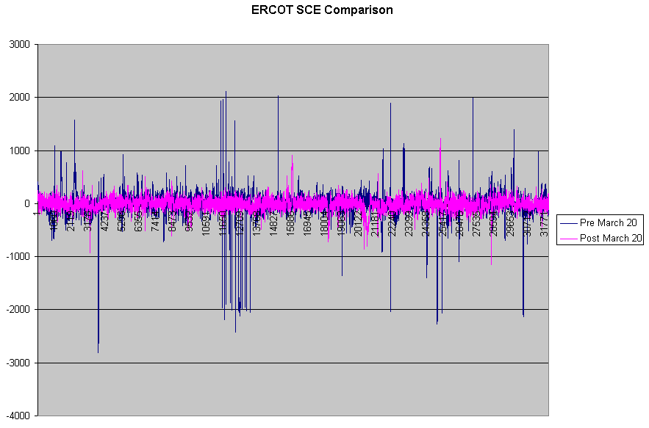
Mean SCE 2 Weeks Before March 20th = 10.01
Mean SCE After March 20th to April 2 = 4.66

