

Utilizing High-Set Load Shedding Schemes to Provide Responsive Reserve services
NovemBER 2002
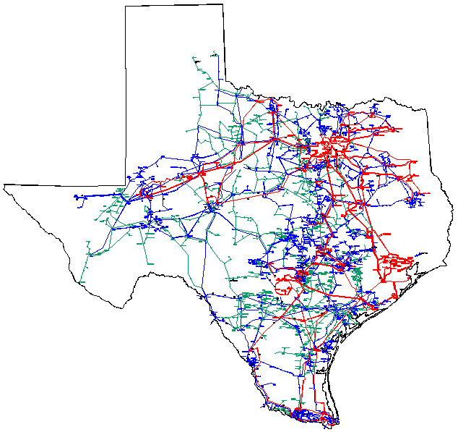

prEpared for ercot REliability Operations SUBCOMMITTEE
BY ERCOT DYNAMICS WORKING GROUP
Table of Contents
RESPONSIVE RESERVE STUDY GROUP | 3
DISCLAIMER | 4
EXECUTIVE SUMMARY | 5
STUDY OBJECTIVE | 7
Generation Spinning Reserves | 7
GENERATOR Governor | 8
gOVERNOR TUNING | 10
Model and Data | 15
Study Approach | 16
LOAD FREQUENCY MODELING | 18
ERCOT STATIC LOAD MODEL | 18
FREQUENCY SENSITIVE LOADS AND LOAD-DAMPING CONSTANT | 20
MODELING LOAD-FREQUENCY DEPENDENCE IN PSSE | 20
LOAD-FREQUENCY DAMPING | 21
Criteria for STUDY RESULTS Acceptance | 22
STUDY RESULTS | 23
Conclusions | 27
additional coNSIDERations | 28
REFERENCES | 29
APPENDIX A - excerpts from the ERCOT Protocols (Revision October 2002), and ERCOT Operating Guides | A
APPENDIX B - Results of Studies:  SPRING OFF-PEAK, 700 MW TRIP W/ UFLS (SERIES 3 only) | B
APPENDIX C – Results of Studies:  SPRING OFF-PEAK, 2500 MW TRIP W/ UFLS (Series 1 only) | C
APPENDIX D - STUDY SCOPE | D

Responsive Reserve Study Group
2002 Dynamics Working Group

Tom Bao | Lower Colorado River Authority
Vance Beauregard* | American Electric Power
Roy Boyer | Oncor
Jose Conto | ERCOT System Planning
Reza Ebrahimian | Austin Energy
Juan Santos | ERCOT System Planning
Wesley Woitt | Center Point Energy
John Moore | South Texas Electric Cooperative
Julius Moore | City Public Service

* Chair of DWG

Disclaimer

The Electric Reliability Council of Texas (ERCOT) Dynamics Working Group prepared this document. Conclusions reached in this report are a “snapshot in time” that can change with the addition (or elimination) of plans for new generation, transmission facilities, equipment, or loads.

ERCOT AND ITS CONTRIBUTING MEMBER COMPANIES DISCLAIM ANY WARRANTY, EXPRESS OR IMPLIED, INCLUDING ANY WARRANTY OF MERCHANTABILITY OR FITNESS FOR ANY PARTICULAR PURPOSE WHATSOEVER WITH RESPECT TO THE INFORMATION BEING PROVIDED IN THIS REPORT.

The use of this information in any manner constitutes an agreement to hold harmless and indemnify ERCOT, its Member Companies, employees and/or representatives from all claims of any damages. In no event shall ERCOT, its Member Companies, employees and/or representatives be liable for actual, indirect, special or consequential damages in connection with the use of this data. Users are advised to verify the accuracy of this information with the original source of the data.

ERCOT is the corporation that administers the state's power grid. ERCOT serves approximately 85 percent of the state's electric load and oversees the operation of approximately 70,000 megawatts of generation and over 37,000 miles of transmission lines. Its members include retail consumers, investor and municipally owned electric utilities, rural electric co-ops, river authorities, independent generators, power marketers, and retail electric providers.

ERCOT is one of ten regional reliability councils in North America operating under the reliability and safety standards set by the North American Electric Reliability Council (NERC). As a NERC member, ERCOT's primary responsibility is to facilitate reliable power grid operations in the ERCOT region by working with the area's electric utility industry organizations. The Public Utility Council of Texas (PUCT) has primary jurisdictional authority over ERCOT to ensure the adequacy and reliability of electricity across the state's main interconnected power grid. An independent Board of Directors comprised of electric utility Market Participants governs ERCOT.

Executive Summary

ERCOT Operating Guides allow for up to 25% of ERCOT’s response reserves to be provided by interruptible loads qualified to be bid in the market. Market participants have suggested this limit could be increased by initiating load tripping at 59.9 and 59.8 Hz.

In order to investigate how much the present 25% limit of high-set load tripping can be increased, a study group made up of members of the ERCOT Dynamics Working Group used Power System Simulation software and models to evaluate the response of the ERCOT system to loss-of-generation events. Dynamic simulations were done on the Spring 2002 Off-Peak and Summer 2002 On-Peak cases, to test system performance under off-peak and peak system conditions. Loss of 2500 MW and 700 MW of generation were studied consistent with ERCOT’s Protocols and Operating Guides for responsive reserve requirements.

Cases were studied with varying amounts of high-set under-frequency load shedding replacing responsive reserve: 0%, 25%, 50%, and 75%. Three stages of high-set under-frequency load shedding were studied: The location of the load shedding was distributed proportionally over the entire ERCOT system:
Load Block | Frequency
Stage 1 | 59.9 Hz
Stage 2 | 59.8 Hz
Stage 3 | 59.7 Hz

The study group also evaluated runs where the high-set load tripping was concentrated in a single area of the system, in order to test sensitivity to load tripping location. The areas studied for load sensitivity were: Houston Area (H), DFW Area (D), South Texas Area (S), and West Texas Area (W).

The study results did not reveal any problems with the 0%, 25%, and 50% level of high-set interruptible load replacing responsive reserve, for the conditions studied. Another way of stating this is that of the present 2300 MW Spinning Reserve requirement, up to 1150 MW can be replaced with load shedding. The 1150 MW load shedding can be at any of the three specified frequency blocks, or any combination of blocks. At the 75% level, it is necessary to restrict the amount of load shed in each frequency block, and limit the amount of load that can be tripped in any one geographic area, when the load sensitivity runs are considered. These limitations must be investigated in terms of their bidding and operational consequences. The 100% high-set interruptible load shedding (no generation responsive reserve) level was determined to be infeasible due to large frequency overshoot.

The study results summarized below are based on the Spring Off-Peak case and include the results of the load location sensitivity studies:
High set | Case 1 - 25%  575 MW | Case 2 -50%  1150MW | Case 3 -75%  1725 MW | Case 4 -100%  2300 MW
Level a:  59.7 | Any | Any | 60 %  (1380 MW) | N/A
Level b:  59.8 | Any | Any | 40 %  (920 MW) | N/A
Level c:  59.9 | Any | Any | 55 %  (1265 MW) | N/A

While study modeling was as detailed and accurate as possible, some assumptions inherent in that modeling have significant associated uncertainty, and some other important issues exist that could not be addressed using any available study tool. Because of these issues (more fully discussed on page 28), extreme caution should be exercised in relying upon the study results as the primary or sole consideration in proposing changes in policy.

The study results are dependent upon the generator frequency response performance produced by the turbine governor model used for all ERCOT generators. For all of the units supplying responsive reserve, the governor model used allowed the unit to pick up load at a minimum average rate of 6.25% of unit capacity per second, with overshoot no greater than 2.5 % of unit capacity.

Study Objective

The current ERCOT operating guides allow for up to 25% of the ERCOT 2300 MW Responsive Reserve Service, or 575 MW, to be served by market bid of interruptible load. The requirement calls for this load to be tripped at 59.7 Hz substitute for responsive spinning reserves.

The objective of this study is to investigate how much this limit can be increased without significant negative impacts on the ERCOT system. ROS assigned this study to the Dynamics Working Group to answer questions originally raised by the Retail Users Group.

The study includes each possible combination of high-set interruptible load, in increments of 5% in each of three different trip threshold categories (59.9, 59.8, and 59.7 Hz) that together with the spinning reserve in the base case add to a 2300 MW total responsive reserve service. The simulations conducted in this study are intended to determine whether ERCOT frequency would go outside an acceptable frequency band, not above 60.5 Hz and not below 59.3 Hz.

Generation Spinning Reserves

Spinning Reserve is defined as unloaded generation capacity that is synchronized and available to serve additional demand within ten minutes. Partially loaded generators usually supply this reserve.

Whenever generation is not in balance with the total demand, the electrical frequency of the entire interconnected system will deviate from frequency at which the system was designed to operate – 60 Hz. Of course, small load variations take place all the time, so frequency continuously deviates from 60 Hz. These smaller variations in frequency are covered by regulating reserve, which is a subset of spinning reserve and controlled by the automatic generation control (AGC) systems.

However, these normal frequency deviations are quite small compared to those that occur following large disturbances and are not a source of concern. System disturbances could trigger natural system oscillations in an interconnected system. The inertia of a system is directly related to the size (mass) of the generation units and the number of generators on line. This condition is magnified in a system that is lightly loaded with lower inertia.

Under Frequency Load Shedding (UFLS) schemes will help the system to arrest the frequency runaway during large disturbances. Appropriate combination of triggering under frequencies values and load shed levels are system dependent.

ERCOT uses the following UFLS scheme as the method of last resort to keep its system operating.
Frequency | Load Relief
59.3 Hz | 5% of ERCOT Load
58.9 Hz | 10% of ERCOT Load
58.5 Hz | 10% of ERCOT Load

Generator Governor

Governing is the process where a generating unit changes its power output in response to a change in frequency. Frequency control is primarily a function of governing. If the frequency drops below 60 Hz, governing will increase generation (power output) to bring the frequency back to 60 Hz. Governing is the automatic response of the governor to a (usually large) change in frequency. Secondary frequency control, or AGC, is automated dispatch of units to correct small frequency deviations.

For governing response to be effective, the following three elements must exist:
- The unit must have a governing margin. If the unit is operating at full load, it cannot increase its output in response to a loss of generation. Similarly, a unit operating at 90% of full load cannot respond with 20% of its capacity to a loss of generation.
- The unit’s controls must permit governing. “turbine follow” and “sliding pressure control” for conventional steam plants, and operating combustion turbines on temperature control can effectively block governing action.
- The unit must have a governor or speed input to the plant controls that is not blocked by intentional dead-bands or limiters [2].

Speed governing varies prime mover output (torque) automatically for changes in the system speed (frequency). Speed sensing deviations are typically reported by one of two types of devices: a fly ball assembly for mechanical-hydraulic governors or frequency transducers for electro-hydraulic governors. The output of the speed sensor passes through signal conditioning and amplification (provided by a combination of mechanical-hydraulic, electronic circuits, and/or software) and operates a control mechanism to adjust the prime mover output (torque) until the system frequency change is arrested. The governor action arrests the drop in frequency, but does not return the frequency to the pre-disturbance value of approximately 60 Hz in large interconnected systems. To return frequency to its normal operating range AGC (Automatic Generation Control) systems will respond following the governor arrest and adjust the prime movers output (release more steam from the boilers). The rate and magnitude of governor response to a speed change can be tuned for the characteristics of the generator that the governor controls and the power system to which it is connected.

Within the first few cycles (60 cycles = 1 sec) following a system disturbance that is due to loss of generation or a sudden increase in system load, a drop in frequency occurs which is proportional to the size of the imbalance and the amount of existing on-line generation and load. The inertia (physical size) of the generation on line will dictate the rate of frequency decline for a given disturbance. If the magnitude of the transient in the system is larger then the available inertia then the system will enter into a state of transient instability. Units will slip poles and system oscillations will cause a cascading outage.

Following the transient period, if the imbalance is significant in magnitude, governor control signals will enter dead-band status. Following a dead-band period, if frequency is still below its required acceptable level and there is spinning reserve available, then governors will respond and attempt to arrest the decline in frequency. Depending on speed droop and speed regulation settings system frequency will recover to its pre-disturbance conditions. Speed droop and speed regulation are defined in the following manner:

Speed Droop: The characteristic for a generator governor describing the relationship of change in speed with a corresponding change in generator power output. For example, a 5% droop means that a 5% frequency deviation causes a 100% change in generator power output. As system load is increased and system frequency drops, speed droop will indicate the governor’s ability to increase power output; thus helping the system frequency to recover.

Speed Regulation: A service used to control the power output of generators in response to a change in system frequency as to maintain the target system frequency within predetermined limits.

Observations of the Eastern Interconnection have shown a decrease in system response to frequency deviations over a five year period [3]. One utility determined that their response was 30% of expected response [2]. Similarly, the ERCOT response is not as expected [4]. This decline in governing response has been attributed to a quest for efficiency [3]. This quest for efficiency can manifest itself in such ways as changing unit operating modes from “boiler follow” to “sliding pressure”, operating at 100% output, and in the case of combustion turbines, operating on “temperature control” [2,4].

While this decline in response was not a concern for the large Eastern Interconnection (527 GW in 2001), it is a concern for a smaller system such as ERCOT (53.4 GW in 2001). This prompted discussions with operators from three “utilities” representing well over 60% of the installed capacity in ERCOT. The responses indicated that “most” to “almost all” conventional steam plant operating modes have been changed to a less responsive mode (turbine follow or sliding pressure, for example). Experience confirms these qualitative assessments [4]. It was determined that the nuclear plants are operated such that they will not respond to system frequency changes. Moreover, wind generation output is dependent upon the wind velocity, a quantity that is virtually uncontrollable. Thus, wind units are not expected to be responsive to frequency deviations or contribute to frequency restoration.

A review of the models, literature and data available for combined cycle turbines equipment resulted in several concerns. Combustion turbine output is dependent upon several factors. One of these factors is the power system frequency. Combustion turbine output rises when the frequency increases, and decreases when the frequency decreases [5,6]. An incident such as loss of a large generator or plant can cause a significant frequency decrease. A combustion turbine providing spinning reserve could have an output less than expected because of this frequency dependency. Thus, at the critical time when more power output is needed to arrest the frequency decline, it may not be available from the combustion turbine. After a loss of generation incident, there is the possibility of frequency overshoot (frequency greater than 60 Hz), especially when load shedding is part of the frequency recovery plan. If the frequency becomes greater than 60 Hz, the combustion turbine output may be greater than expected precisely when less generation is needed to bring the frequency back to 60 Hz. Even worse, the combustion turbine could trip off-line [7,8]. While these characteristics of combustion turbines do not preclude them from providing responsive reserve, it was clear that the frequency effects need to be accounted for in this study. Unfortunately, combustion turbine governor model available for this study do not properly model these combustion and frequency effects.

Combustion turbines also have exhaust temperature controls which can override the governor control [6,7,8]. Several combustion turbine models available to this study model the exhaust temperature controls. Judging from simulations using owner submitted data, most combustion turbines in ERCOT will be operated on their exhaust temperature limit. This situation is to be expected since many combustion turbines are part of combined-cycle plants. Operating at the exhaust temperature limit usually increases efficiency. It is possible to operate a combustion turbine at an exhaust temperature lower than its limit [6]. However, the turbine could reach its exhaust temperature limit while responding to frequency drop, thus affecting its response. For study purposes, the exhaust temperature controls pose a problem similar to that of conventional steam turbines: that is identifying and quantifying the actual controls and mode in use.

The previous ERCOT spinning reserve study (1988) used governor data as reported from generation owners and contained in the dynamics data file. Governor action was blocked for some units known to have little or no response during system frequency disturbances. At that time, deregulation had not occurred, most generation was from conventional steam boiler driven generators, and integrated utilities owned most of the generators. The models used to make the study assumed steam pressure would be 100% under all conditions for the governor to control [1]. That assumption can be approximately correct for conventional boilers operated in “boiler follow” control mode.

Several things have changed in the last 15 years. Deregulation in ERCOT has occurred. Large amounts of generation is owned and operated by independent power producers. Additionally, combined cycle plants now provide a significant part of the total generation in ERCOT when compared to 1988. Also generation from wind plants is increasing steadily. These changes prompted an evaluation of how the generator governors should be treated in this study.

Governor Tuning

Given the conditions mentioned above, it was clear to the DWG that the approach to governor modeling for this study needed careful consideration. Three alternatives were considered. First, an approach similar to that used in the 1988 study could be used. That approach generally used the governor models and data as they existed in the dynamics data base. Governor action was blocked for some units known to have little or no response during system frequency disturbances. For this current study, no comprehensive list of governors to be blocked was available. In addition, simply using the governor models and data as they exist in the dynamics data base would result in the simulated performance of conventional steam generators being substantially better than the actual performance for units where the operating point or control mode has changed [1]. Similarly, the lack of combustion turbines models that include combustion and speed effects would result in simulated performance being better than actual performance. Decisions based on overly optimistic performance could result in larger frequency swings and larger loss of load should a significant loss of generation actually occur in ERCOT. Given how important responsive reserve is to the reliability of the ERCOT system, this option was rejected.

A second option considered was to have all conventional steam plants tested in the mode they operate. From this testing new models could be chosen which more accurately represent their performance. However, testing would cost thousands of dollars per unit and take many months to complete. Furthermore, some owners might not be willing to participate. And, testing conventional steam units would do nothing to correct the deficiencies in the combustion turbine governor models. Efforts to obtain more accurate combustion turbine models have been underway for several years. Progress is being made. However, it was considered unlikely such models would be available for this study, and indeed that has been the case. So, while testing and model development would likely have produced the most accurate data and minimized the number of necessary assumptions, this option was considered infeasible.

The third option considered involves a significantly different approach to the study. The first two approaches essentially assume the models and related data accurately represent each individual unit. Different units have different response characteristics. Some units respond quickly, others slowly. Some units will pick up large amounts of load, while others will pick up little load. Simulations essentially “average” the response. An inherent problem with that approach is one does not know in advance which type of unit will be providing responsive reserve. It is possible that virtually all of the connected generation has poor response characteristics [7]. The approach used for this study was to define the minimum response for units providing responsive reserve. Advantages of this approach include:
- It is not necessary to know in advance which units are providing responsive reserve, or to
be overly conservative by modeling only “poorly” responding units.
- It is not necessary to know the operating mode of the conventional steam turbines.
- Highly accurate models and data for each unit are not required. Note that this statement does not apply to other types of studies.
- It is not necessary to resolve the deficiencies in the available combustion turbine models.
- Assuming there are no other failures, the minimum system response to loss of generation will be
well defined and understood.
- The minimum response characteristic is known. Units that do not meet the minimum response
can, within physical limits, be changed to meet the minimum response requirements if the
owners so choose.
- Because the only important parameter is the response characteristic, the specific model and data
used for simulations can be treated as a “black box”. (For a given input to the black box, the
output is known. Specific knowledge of the circuit or system in the box is not necessary.)

Defining the minimum response essentially involved choosing a governor model and tuning its parameters to obtain a desired response. For this study the IEESGO model within the PTI library was chosen. This is a fairly straight forward model originally developed for conventional steam turbines. An advantage of this model is sufficient, relatively simple parameters making the tuning process fairly easy. It also happens to be the most commonly used governor model in the ERCOT system.

If the response characteristic is too fast, some units may not be able to meet the minimum response requirements. If it is too slow, the system and customers could be unnecessarily affected should a significant loss of generation occur. The approach used was to tune the model parameters to match plots of actual loss of generation incidents. Specifically, the February 8, 2000 loss of Oklaunion 1 and the April 8, 2000 loss of Martin Lake 2 were used. With this approach, the minimum response characteristic is essentially the average of the individual responses at the time of these loss-of-generation events.

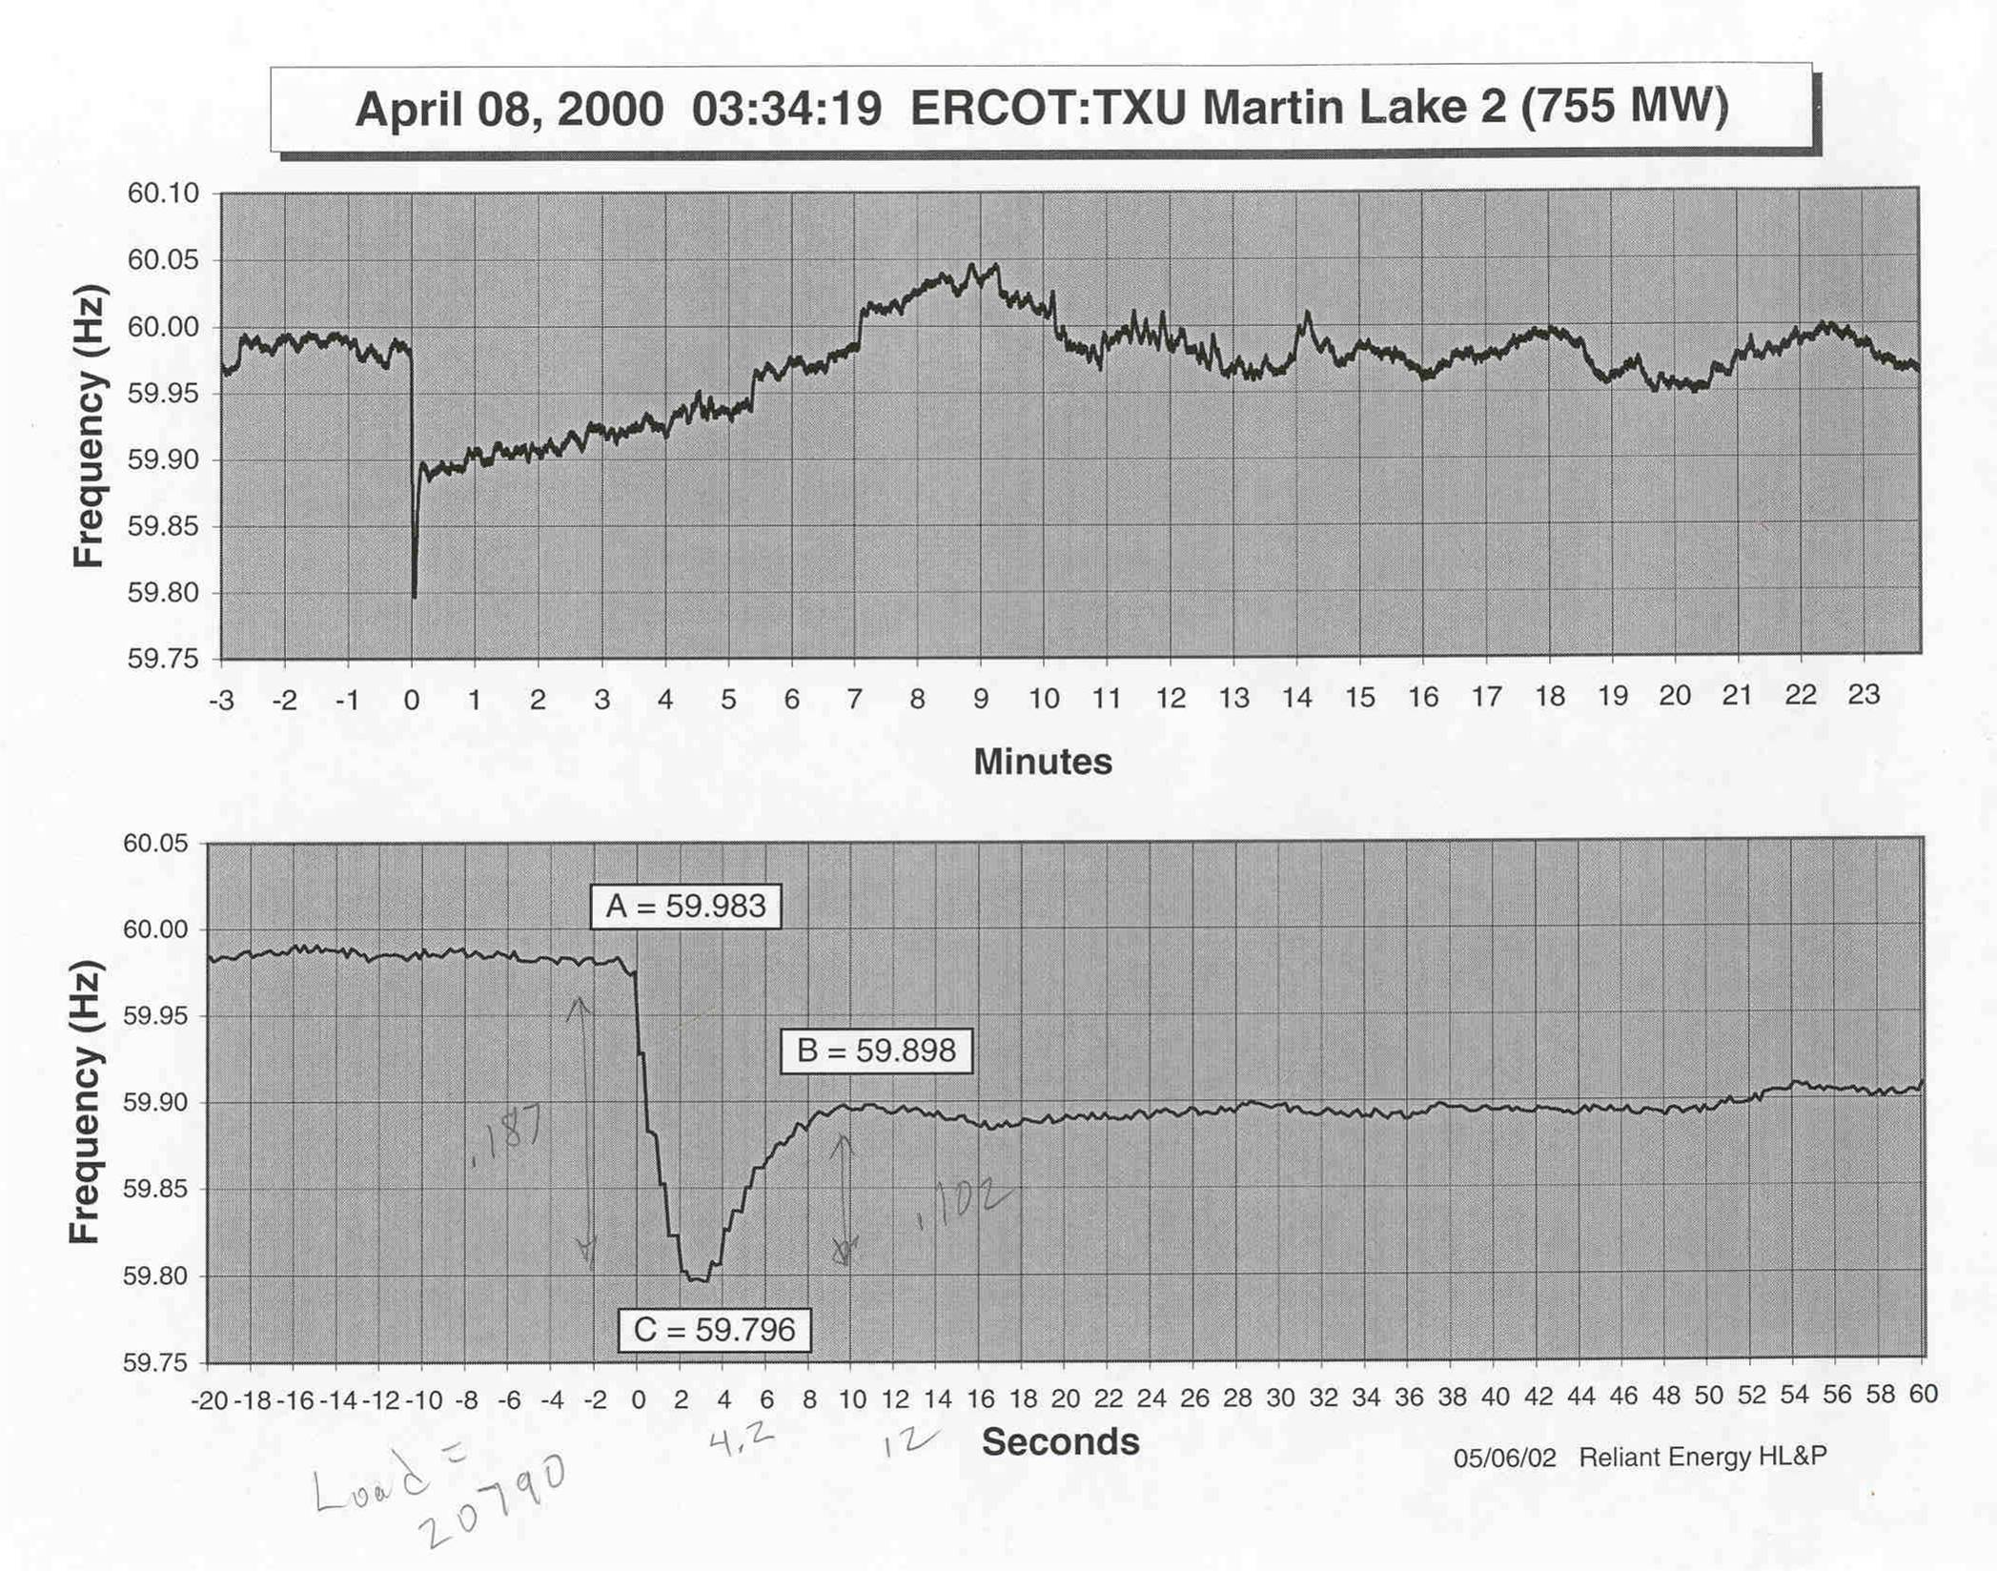

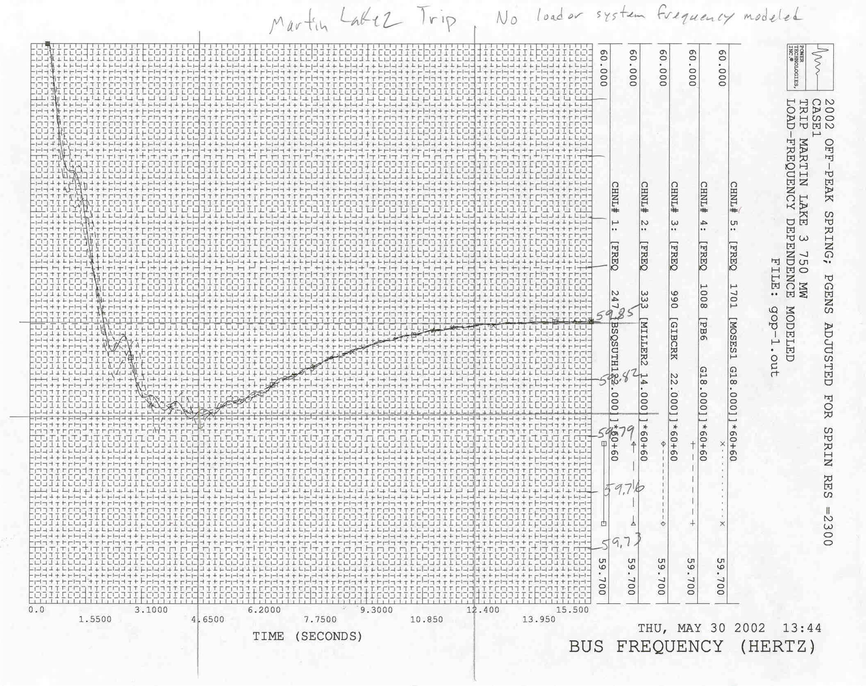

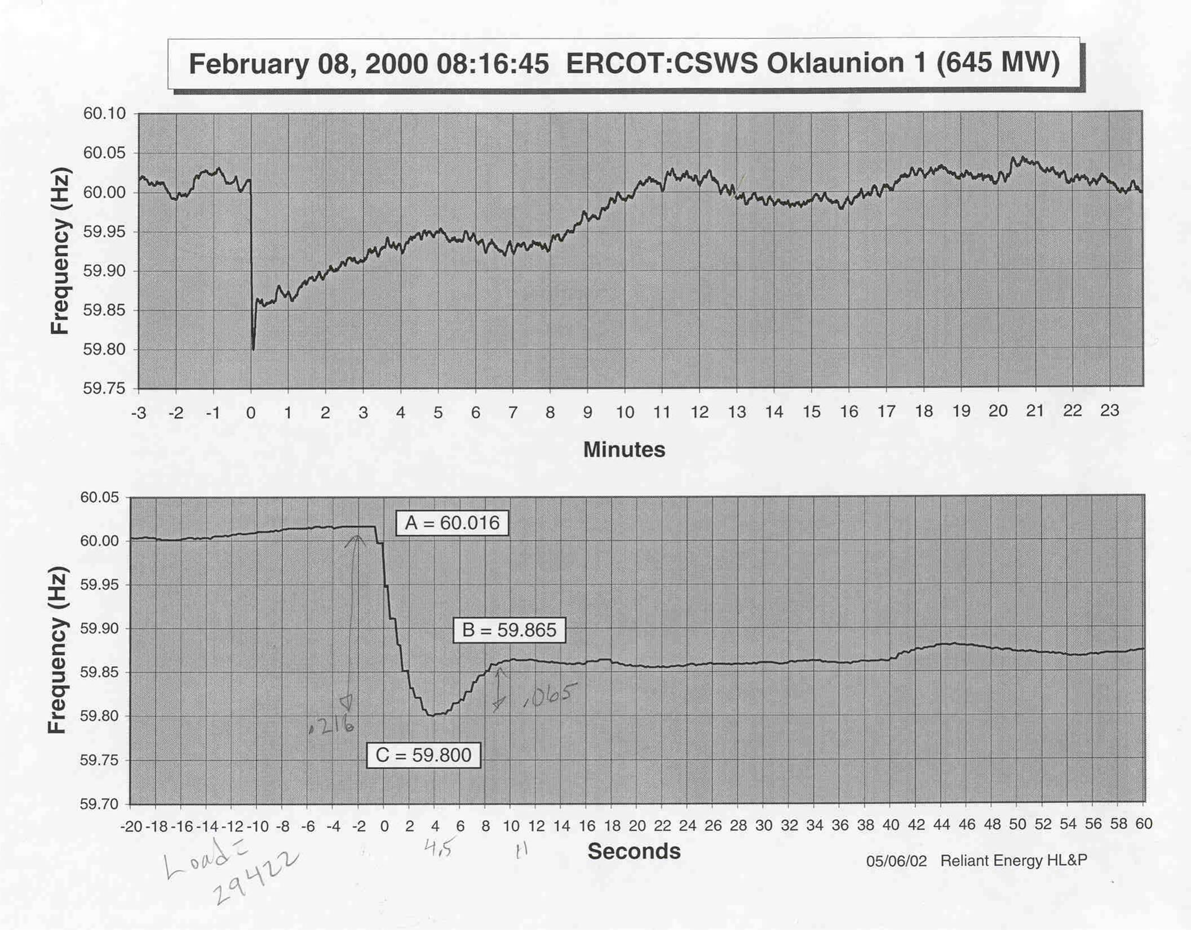

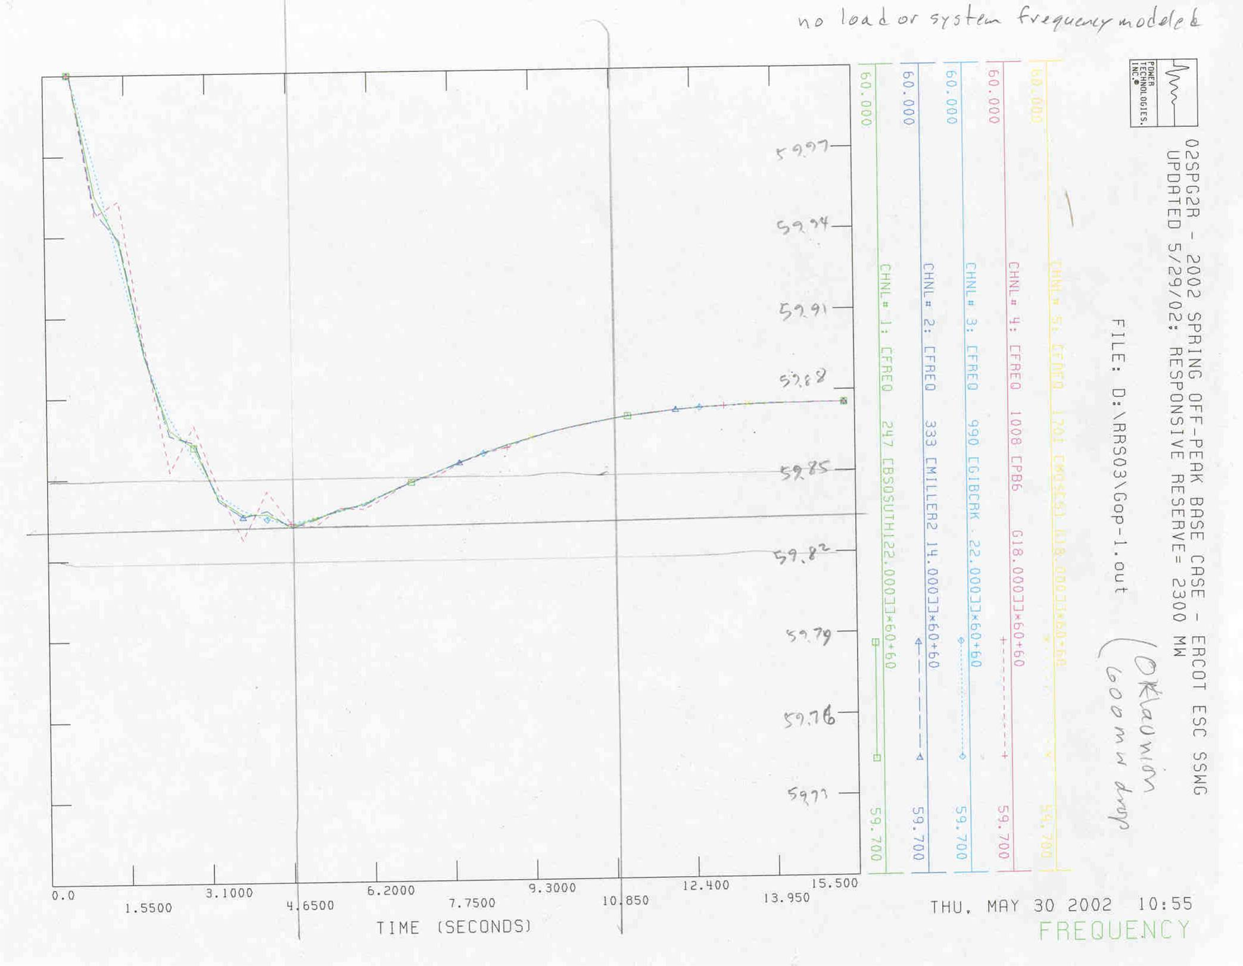

Model and Data

The study used PTI Power System Simulator for Engineering (PSS/e) software and models. The PTI models and data used by the DWG do not include models of the boiler. Therefore, the period of the simulation was limited to approximately 15 seconds. This time frame corresponds closely to the “A, B, C” time points in the Performance Disturbance Compliance Working Group (PDCWG) disturbance reports.

The study used the most recently available ERCOT Steady State working group (SSWG) load flow cases from 2002 Dataset A, for Spring and Summer 2002.

The Spring case used was:

SS02SPG2 - 2002 SPRING OFF-PEAK BASE CASE - ERCOT ESC SSWG FINAL - 08/01/2001 – ERCOT Case represents lowest load on same day as maximum load (Spring Season)

The Summer case used was:

SS02SUM1 - 2002 SUMMER ON-PEAK BASE CASE - ERCOT ESC SSWG FINAL - 08/01/2001 – ERCOT Case represents maximum expected load during Summer Season

The dynamics data used was the most recent DWG dynamics dataset.
The load model used in this study was constructed to include both voltage and frequency sensitive components. The voltage sensitivity load model was developed by UTA. The development of the frequency dependent load model will be discussed in a later section in this report.

Under Frequency Load Shedding relay operations models were included, responding at 59.3 Hz, 58.9 Hz and 58.5 Hz. The data was obtained from the Under Frequency Load Shedding Study completed by the ERCOT Dynamics Task Force in February of 2001. High-set load shedding data responding at 59.9 Hz, 59.8 Hz, and 59.7 Hz was selected in such a way as to spread the load shedding effects over the widest possible area.

Study Approach

This study compared the effects of replacing increasing amounts of responsive spinning reserve from generation with high-set interruptible loads set to trip by automatic relays with a time delay of not more than 20 cycles.

Performance was evaluated for the loss of 700 MW and 2500 MW of generation. In the initial phases of the study, frequency, bus voltage, rotor angles, speed, generator megawatts, generator mega-vars, generator terminal voltage, exciter field voltage, and out-of-step conditions were monitored. Solved load-flow cases were saved and examined for abnormal network conditions at the end of the dynamic simulation period. Since no abnormal conditions other than frequency and rotor angle drift occurred, and since a large number of simulations were performed, later studies monitored only the bus frequency at selected representative buses.

Task 1
A Flat Start was performed on the 2002 Summer On-Peak and the 2002 Spring Off-Peak base cases. The Spring Off-Peak case is the condition that causes the widest frequency deviations, since the amount of load damping and the generation inertia are smaller in the Spring case, compared to the amount of generation dropped. The Summer case was run to capture high circuit loadings, and for completeness.

Task 2
The governor models were removed from the base cases in order to bench mark the load response of the system.

Task 3
A custom governor model was constructed in order to obtain response similar to actual faults in the system, and so that the response of each unit would be known and predictable.

Task 4
The generation schedule in the SSWG cases were modified to model the current 2300 MW ERCOT Spinning Reserve rule, which allows up to 25% (575 MW), of the responsive requirement to be fulfilled by high-set interruptible load. The following cases were built with matching DYR files:

Base Case – 100% of spinning reserves.
Case 1 – Use High-Set Load Shedding Schemes (HSLSS) to replace 25% of the Spinning Reserve.
Case 2 – Use High-Set Load Shedding Schemes (HSLSS) to replace 50% of the Spinning Reserve.
Case 3 – Use High-Set Load Shedding Schemes (HSLSS) to replace 75% of Spinning Reserve.

Task 5
High-Set load models were added in the study for each scenario studied.
a. The Replacement Reserve Service (RRS) was modeled at the following trip levels:
i. Trip level set at 59.7 Hz for 20 cycles or 0.333 msec. at 60 Hz (Twenty cycles corresponds to the maximum time delay stated in the ERCOT Protocols.).
ii. Trip level set at 59.8 Hz for 20 cycles.
iii. Trip level set at 59.9 Hz for 20 cycles.
b. The load RRS was selected using an approach which spread the size and location of the RRS over the widest possible geographic area.
c. The load shedding requirement were determined for each case: 0 MW for the base case, 575 MW for Case 1, 1150 MW for Case 2, 1725 MW for Case 3.
The load shedding requirement was divided into blocks at 59.9 Hz, 59.8 Hz, and 59.7 Hz, in 5% increments, with all possible combinations considered that added up to the requirement.
Area sensitivity studies were run for the condition where all of the RRS is in one area.
a. Houston area - H
b. DFW area - D
c. South Texas area - S
d. West Texas area - W

Task 6
Perform scenario studies:
a. Spring 2002 Off-Peak Case
i. 700 MW trip, with geographically diverse high-set.
ii. 2500 MW trip, with geographically diverse high-set.
iii. 700 MW trip, with sensitivity runs for each area.
iv. 2500 MW trip, with sensitivity runs for each area.
b. Summer 2002 On-Peak Case
i. 700 MW trip, with geographically diverse high-set. .
ii. 2500 MW trip, with geographically diverse high-set.
c. Compile frequency data and number of relay operations.

Task 7
Write the report and recommendations.
Load Frequency Modeling

Load characteristics may have significant effects on the bus voltage magnitude and frequency. The power system load is composed of a large number of devices such as refrigerators, electric heaters, small and large motors, compressors, furnaces, incandescent and discharge lighting, etc. Since the composition of the load changes based on an hour of a day, a day of a season, weather conditions and even the state of the economy, it is difficult to accurately model the load in a dynamic stability simulation. Furthermore, the load can have dynamic characteristics such as response of discharge lamps to below a certain voltage, thermostatic loads cycling, motor stalling, transformer ULTC actions, etc.

These dynamic response of load are often expressed in orders of minutes; therefore, they are considered under mid-term stability studies. Most loads response to voltage and frequency changes is fast (for usual voltage and frequency changes), therefore the static load model is used for short-term dynamic simulations. The load governing frequency regulation, to which responsive reserve contributes, is generally accomplished within 3 to 5 seconds; this is also referred to as short-term or primary regulation. A secondary frequency regulation, in order of minutes using AGC is also employed, which is essentially automated dispatching to shift generation among available units, to achieve energy balancing while maintaining economic dispatch.

ERCOT Static Load Model

Active and reactive power flows in a transmission system are approximately independent of each other and are controlled by different control mechanisms. Frequency control is related to active power control, whereas voltage control is related to reactive power control. In the 1980’s, and a few decades before, research was conducted in the area of load voltage and frequency characteristics for inclusion in power system stability studies and published in a number of publications [9,10,11,12,13].

A study was conducted by the University of Texas at Arlington (UTA) in 1980’s to represent the ERCOT load-voltage characteristics. This model was presented based on the “ZIP” model that is composed of constant impedance (Z), constant current (I), and constant power (P) components. Table 1 shows the ERCOT’s load ZIP model composition. It can be written as:

$P=P_{0}\left(p_{1}{\left(\frac{V}{V_{0}}\right)}^{2}+p_{2}\left(\frac{V}{V_{0}}\right)+p_{3}\right)$ (1)

$Q=Q_{0}\left(q_{1}{\left(\frac{V}{V_{0}}\right)}^{2}+q_{2}\left(\frac{V}{V_{0}}\right)+q_{3}\right)$ (2)
and if the frequency dependency of the load is also considered then:

$P=P_{0}\left(p_{1}{\left(\frac{V}{V_{0}}\right)}^{2}+p_{2}\left(\frac{V}{V_{0}}\right)+p_{3}\right)∗(1+D_{p}Δf)$ (3)

$Q=Q_{0}\left(q_{1}{\left(\frac{V}{V_{0}}\right)}^{2}+q_{2}\left(\frac{V}{V_{0}}\right)+q_{3}\right)∗(1+D_{p}Δf)$ (4)

where:
P and Q are active and reactive components of the load,
V. is the bus voltage magnitude,
subscript ₀ denotes the variables at initial operating condition,
p₁ and q₁ are the factors of constant impedance,
p₂ and q₂ are the factors of constant current,
p₃ and q₃ are the factors of constant power,
D_{p} and D_{q} are the frequency sensitivity parameters, D_{p} ranges from 0 to 3 and D_{q} ranges from –2 to 0 depending upon the load components, and
Δf is the frequency deviation.

ERCOT Static Load Model

Company | Real Power Components |  | Reactive Power Components
Company | Constant  Current (p2) | Constant Impedance (p1) | Constant  Power (q3) | Constant Impedance (q1)
Oncor (TXU) | 44 | 56 | 50 | 50
Center Point (REI) | 50 | 50 | 50 | 50
CPS | 20 | 80 | 50 | 50
AEP (WTU) | 59 | 41 | 50 | 50
LCRA | 50 | 50 | 50 | 50
AE | 50 | 50 | 50 | 50
AEP (CPL) | 50 | 50 | 50 | 50
TMPP | 21 | 79 | 50 | 50
TNMP* | 50 | 50 | 50 | 50
STECMEC | 21 | 79 | 50 | 50

* The TNMP loads were not part of the UTA research project. Typical characteristics for the TNMP loads were used in the study.

Frequency Sensitive Loads and Load-Damping Constant

In the absence of detail load information, the most commonly accepted load model for representing active power is constant current, and for representing reactive power is constant impedance [11,8]. The frequency dependency of the load may be modeled in the following form:

$P−P_{0}={ΔP}_{n}+DΔω$ (5)

Where, D is the load-damping constant, and is similar to D_{p} described earlier, P_{n} is the load change that is not frequency sensitive. Considering the frequency sensitive portion of the load, we can write:

$P_{f}−P_{0,f}=DΔω$ (6)

$D=\frac{P_{f}−P_{0,f}}{ω−ω_{0}}$ (7)

This value is commonly given in MW/0.1 Hz, or in percent change in the connected load for percent change in frequency. For a power system, this value typically is in the range of 1 to 2. An average value used in dynamic simulations is D=1.5 (note, this is in per unit power / per unit frequency)[2]. A value of D=1.5 means that for 1% change in the frequency (i.e., frequency reduces from a 1.0 per unit to a 0.99 per unit), there will be a 1.5% change in the connected total load (i.e., total load reduces from a 1.0 per unit to 0.985 per unit).

Modeling Load-frequency Dependence in PSS/E

The PTI model LDFRAL represents the frequency sensitive load as follows:

$P_{f}=P_{0,f}{\left(\frac{ω}{ω_{0}}\right)}^{r}$ (8)

$r=\frac{\text{log}\left({P_{f}}/{P_{0,f}}\right)}{\text{log}\left(ω/{ω_{0}}\right)}$ (9)

Note: r is approximately equal to D divided by the fraction of the constant current real component of the total load. For the ERCOT 2002 spring off-peak case, the fraction of the constant current load is:

$\frac{\text{13034}\text{MW}}{\text{28752}\text{MW}}=0\text{.}\text{4533}$ (10)

For the purpose of this study we assume a conservative value of D = 1.0 This means for a 1% change in the frequency there will be a 1% change in the total load. We can calculate r as follows:

r1/0.4533 = 2.2 (11)

Alternatively, for the spring 2002 minimum case, 1% of the real power component of the total load is 288 MW. Since only the real power component of the constant current load is frequency sensitive, the 288 MW is about 2.2% of that load. For this reason we selected a 2% value for the real component of the constant current load change for 1% change in the frequency. Since log(0.98)/log(0.99) is approximately equal to 2.0, this will yield an approximate value of 2 for r in the equation (9) for the LDFRAL model. With r =2 the LDFRAL model record is as follows:

0,’LDFRAL’, ‘*’, 0,0,2.0,0

Note, although the results were developed for the spring off-peak case, since the on-peak summer case will yield similar value, it is used for that case as well.

Load-Frequency Damping

For the purpose of simulation of a particular disturbance within ERCOT a value of D=1.5% for the total real power load which will yield a value of r =3.3 for the real power component of the constant current load should be used.

In general, as the total load increases, the load- frequency damping effects will increase. ERCOT is the smallest interconnection in U.S. In other larger interconnections, the load damping effect is much larger, mainly due to the load magnitude. For example in the Eastern Interconnection the load is large enough such that for the loss of the largest unit, say 1300 MW, in an on-peak load level, governor response may not even be necessary for the frequency to recover to within an acceptable value.

As was described earlier, based on a five year measurements for the Eastern Interconnect, the combined load and governing response in the United States is gradually decreasing [9,17]. The governing system is known to be a contributor as a result of conversion of many steam units to sliding pressure control [9,10,18], as well as increase in combined cycle plants, however, it is not yet known whether and how much the load is also contributing to this decline [9]. The load damping effect is generally from the motor and compressor loads. The implementation of power electronics and variable speed drives may affect the load-frequency characteristics of these types of loads.
Criteria for Study Results Acceptance

Several criteria were considered in the interpretation of the results of this study.

The initial criteria stated:

- If any scenario studied fails to meet all of the following criteria, it will be considered unacceptable.

- No abnormal system conditions leading to cascading outages and system collapse.

- No firm load will be shed. To ensure this the minimum allowable frequency in the study will be shed for that stage. (Stages are 59. 7 Hz , 59.8 Hz and 59.9 Hz)

The study group also consulted ANSI/IEEE Standard C37.106-1987, which allows continuous operation in the 59.5 Hz – 60.5 Hz frequency band. The ERCOT Reliability and Operations Subcommittee proposed a band of 59.1 Hz – 60.5 Hz. A third criteria was also proposed: 59.3 Hz – 60.5 Hz.

It became apparent as the team reviewed the results from studies with a generation loss of 2500 MW, that any criteria that did not permit operation below 59.3 Hz, was not feasible under the present responsive reserve requirement of 2300 MW. A loss of 2500 MW of generation under Spring Off-Peak conditions will bring the frequency down below 59.3 Hz where the Stage 1 Under-Frequency load shedding is triggered. Clearly, a frequency decay to just below 59.3 Hz that exercises UFLS Stage 1 is acceptable, because it is the behavior of the system under the present rule. Also, the system does not approach 60.5 Hz under the present rule, so anything above 60.4 Hz was labeled as ‘marginal’, because it is a significant negative impact from the present ERCOT system.

Final Criteria

Any scenario failing to meet all of the following criteria, was considered unacceptable:

- No abnormal system conditions leading to cascading outages and system collapse.

- Minimum under-frequency deviation limit of 59.1 Hz. This limit allows for the use of UFLS stage 1 relays.

- Maximum over-frequency deviation limit of 60.4 Hz.

Study Results

All combinations of high-set interruptible tripping in increments of 5% that add up to a system total of 2300 MW of responsive reserve including the spinning reserve were studied for each, for a total of 224 15-second dynamics runs per series.

Overshoot Issue:

Preliminary analyses and spreadsheet models had predicted that certain level of high-set interruptible load shedding would produce an overshoot effect, where the tripping of blocks of load would cause the frequency to rise to high levels. An analysis was conducted to determine under what conditions overshoot could become a problem: The analysis concluded that:

- Overshoot does occur, but only for very high levels of high-set load trip.
- Overshoot is worst where the amount of load tripped by the relays is larger than the generation tripped, but isn't likely to violate ANSI/IEEE Standard C37.1987.
- The critical amount of generation to drop to cause overshoot is the minimum amount that causes the entire entire high-set load to trip. For the spring off-peak case, this is in the 650-700 MW range.
- Overshoot is worst with zero or very little responsive from generation. Larger amounts of responsive from generation will damp the overshoot.
- Zero responsive reserve causes the frequency to rise above the instantaneous trip level of 61.7 Hz of ANSI/IEEE Standard C37.106-1987, and is clearly unacceptable.
- There must be some level of responsive reserve in the system from generation – high-set cannot supply all of the responsive.

Cases simulated and analyzed:

Series 1: | Spring Off-Peak | 2500 MW trip, UFLS Included
Series 2: | Spring Off-Peak | 2500 MW trip, No UFLS
Series 3: | Spring Off-Peak | 700 MW trip, UFLS Included
Series 4: | Spring Off-Peak | 700 MW trip, No UFLS
Series 5: | Spring Off-Peak | West Texas Sensitivity, 700 MW trip
Series 6: | Spring Off-Peak | Houston Sensitivity, 700 MW trip
Series 7: | Spring Off-Peak | Dallas Sensitivity, 700 MW trip
Series 8: | Spring Off-Peak | South Texas Sensitivity, 700 MW trip
Series 9: | Spring Off-Peak | West Texas Sensitivity, 2500 MW trip
Series 10: | Spring Off-Peak | Houston Sensitivity, 2500 MW trip
Series 11: | Spring Off-Peak | Dallas Sensitivity, 2500 MW trip
Series 12: | Spring Off-Peak | South Texas Sensitivity, 2500 MW trip
Series 13: | Summer On-Peak | 2500 MW trip, UFLS Included
Series 14: | Summer On-Peak | 2500 MW trip, No UFLS
Series 15: | Summer On-Peak | 700 MW trip, UFLS Included
Series 16: | Summer On-Peak | 700 MW trip, No UFLS

Generation Responsive Reserve levels for each of the above cases:

a. 575 MW
b. 1150 MW
c. 1725 MW
d. 2300 MW

Series 1: Spring Off-Peak, 2500 MW trip, UFLS Included

In series 1, both STP units were tripped for a total of 2500 MW of generation loss, with the ERCOT Under-Frequency Load Shedding scheme included. Under Spring Off-Peak conditions, with no interruptible load, the frequency will decline to 59.3 Hz in about 4.5 seconds, at which time the UFLS Stage 1 will trip and restore frequency to around 59.7 Hz. Under the present rule of 25% high-set interruptible load, the high-set will trip and the frequency also declines to 59.3 Hz, but the UFLS is delayed until 5.5 seconds. The effect of adding increasing amounts of high-set interruptible delays the time that the UFLS Stage 1 tripping begins. For 75% high-set, UFLS begins at 10 seconds. For 50% high-set, UFLS begins at 8 seconds. In all of the cases, frequency recovers to the 59.7 Hz range. No frequencies below 59.2 Hz or above 60 Hz were observed.

Series 2: Spring Off-Peak, 2500 MW trip, No UFLS

Series 2 was run to see what the performance of the system was without the UFLS. With no high-set interruptible or UFLS, the frequency declines to 59.16 Hz at 10 seconds, and begins a slight recovery to 59.2 Hz at 15 seconds. Under the present 25% high-set interruptible load rule, the decline is to 59.2 Hz, with no noticeable recovery. The effect of adding increasing amounts of high-set interruptible changes the shape somewhat, but the frequency declines to the 59.2 Hz range in all of the cases. This series of cases shows that the UFLS scheme is necessary, even if high-set interruptible load shedding is added to the system.

Series 3: Spring Off-Peak, 700 MW trip, UFLS Included

Series 3 was run to test the performance of the system under a smaller amount of generation drop. A 700 MW drop under Spring Off-Peak conditions, causes all of the high-set interruptible to trip, without getting down to the 59.3 Hz range where UFLS relays trip. This is the condition where frequency overshoot above 60 Hz can occur. With no high-set interruptible, the frequency declines to 59.8 Hz at 5 seconds, and recovers to 59.84 Hz. Under the present 25% high-set interruptible load rule, the decline is to 59.86 Hz, and recovery is to 59.94 Hz. The effect of adding increasing amounts of high-set interruptible varies. In all of the 25% and 50% cases, and most of the 75% cases, the high-set arrests the frequency decline, and there is recovery to higher frequencies. In a few of the 75% cases, the frequency overshoots to the 60.4 Hz range. The overshoot is related to having too much of the high-set in the same frequency level.

The results are summarized below:

Limit of interruptible load that can be used to replace Responsive Reserve Based on Main Scenarios – Spring Off-Peak case

 | Case 1 - 25% | Case 2 -50% | Case 3 -75% | Case 4 -100%
Level a:  59.7 | Any | Any | 60% | N/A
Level b:  59.8 | Any | Any | 45% | N/A
Level c:  59.9 | Any | Any | 60% | N/A

Series 4: Spring Off-Peak, 700 MW trip, No UFLS

Series 4 was run to test the performance of the system under the 700 MW of generation drop, but without UFLS tripping. Since the frequency did not decay in Series 3 to 59.3 Hz or below where the UFLS Stage 1 begins to trip, the UFLS modeled in Series 3 was never called on to trip. Therefore, the results of Series 4 were identical to the results of Series 4.

Series 5: Spring Off-Peak, West Texas Sensitivity, 700 MW trip

Series 6: Spring Off-Peak, Houston Sensitivity, 700 MW trip
Series 7: Spring Off-Peak, Dallas Sensitivity, 700 MW trip
Series 8: Spring Off-Peak, South Texas Sensitivity, 700 MW trip

Series 5,6,7, and 8 were run to test the sensitivity of the results to the location of the high-set interruptible load tripping. In each of the sensitivity runs, the high-set was concentrated in the indicated area. The results varied by scenario, and indicated that concentration of high-set in a single area did make some difference, which served to further restrict the amount of high-set that could be tripped in any one level:

Limit of interruptible load that can be used to replace Responsive Reserve Results based on Sensitivity studies – Spring Off-Peak case

 | Case 1 – 25% | Case 2 -50% | Case 3 -75% | Case 4 -100%
Level a:  59.7 | Any | Any | 60 % | N/A
Level b:  59.8 | Any | Any | 40 % | N/A
Level c:  59.9 | Any | Any | 55 % | N/A

Series 9: Spring Off-Peak, West Texas Sensitivity, 2500 MW trip
Series 10: Spring Off-Peak, Houston Sensitivity, 2500 MW trip
Series 11: Spring Off-Peak, Dallas Sensitivity, 2500 MW trip
Series 12: Spring Off-Peak, South Texas Sensitivity, 2500 MW trip

Series 9,10,11, and 12 were run to test the sensitivity of the results to the location of the high-set interruptible load tripping under a 2500 MW generation loss. In each of the sensitivity runs, the high-set was again concentrated in a single area. All of the runs show frequency declines down to the UFLS Stage 1 level of 59.3 Hz, with frequency recovery to the 59.7 Hz range. No frequency overshoot was observed. There were no cases which required further restriction of the amount of high-set that could be tripped.

Summer On-Peak case

The Summer Series confirmed that the critical case was in the spring. Results indicated that during summer 2002 Summer On-Peak case there were no more additional concerns then those presented in the spring case. Moreover, since there is more generation on-line on the Summer On-Peak case, and more load damping and generation inertia. The effect of a 700 MW generation trip, and a 2500 MW generation trip respectively, did not produce as steep of a frequency decline as was produced in the Spring Off-Peak case. The additional inertia in the system prevented some of the frequency overshoot problems shown in the Spring Off-Peak case.
Conclusions

1. The current ERCOT rule allowing 25% of the ERCOT 2300 MW Responsive Reserve Service, or 575 MW, of interruptible load tripped at 59.7 Hz to be substituted for responsive spinning reserve, can be increased to 50% (1150 MW). The 1150 MW load shedding can be at any of the three specified frequency blocks (59.9 Hz, 59.8 Hz, or 59.7 Hz), or any combination of blocks. Generation responsive reserve requirement would then be 1150 MW.

2. The current ERCOT rule allowing 25% of the ERCOT 2300 MW Responsive Reserve Service, or 575 MW, of interruptible load tripped at 59.7 Hz to be substituted for responsive spinning reserve can be increased to 75% (1725 MW), if no more than 55% (1265 MW) of the requirement trips at 59.9 Hz, no more than 40% (920 MW) trips at 59.8 Hz, and no more than 60% (1380 MW) trips at 59.7 Hz. Generation responsive reserve requirement would then drop to 575 MW.

3. For 2500 MW of generation tripping under Spring Off-Peak conditions, Stage 1 of the Under-Frequency Load Shedding will be triggered, whether there is or is not high-set interruptible load shedding.

4. Frequency overshoot above 60 Hz can be an issue for circumstances where the amount of high-set load tripped is larger than the amount of generation loss. This can be avoided by limiting the amount of load in each of the frequency blocks.
Additional Considerations

There were several factors that were not considered in the study. Loss of load events will cause the ERCOT system frequency to rise. Governor action from generation units will respond to the frequency rise and help to return the frequency to normal. High-set interruptible will not respond at all to over-frequency conditions. This study also did not consider the issue of regulating reserve, which would require the use of extended-term simulations. Modeling of boiler controls, AGC systems, load-tap changing transformers, and switched shunts would be required in order to accurately run these extended-term simulations.

Several factors involved assumptions made by the Dynamics Working Group that argue for caution in the implementation of any recommendations from this report. The working group used a simplified governor model with a defined minimum response in order to quantify the results from our runs. In many cases, real generation may exhibit different response from the simplified model. Recent indications are that many units in ERCOT run in modes that may limit response to frequency. The results of this study and any recommendations drawn from them are dependent upon generators meeting the minimum performance of our model. For this reason, it will be necessary to address generator governor response issues before fully implementing increased use of high-set interruptible. The working group used conservative values for the effects of load-frequency dependence, based on the best information available. Variations from the damping values assumed could affect results.

The working group also assumed (in our main runs) that loads participating in high-set interruptible were widely dispersed geographically. Information was not available to model individual large loads that might possibly participate in high-set interruptible load shedding. The tripping of large loads in one geographic location could possibly cause local over-voltage conditions, and impose undesirable impacts on nearby generators. Although sensitivity runs were performed that placed all of the high-set interruptible in one geographic region, even these runs did not model the sudden tripping of large concentrated loads.

Due to these other factors not modeled, it will be necessary to phase-in the increase in the amount of high-set interruptible load shedding used for responsive reserve service, in order to verify that these other factors do not have a material bearing on system response.

References

[1] James W. Feltes, Johnny R. Willis, “Boiler Effects on Steam Turbine Response”, Power Technologies, Inc.
[2] R. P. Schulz, “Modeling of Governing Response in the Eastern interconnection”, IEEE Winter Power Meeting, Symposium on Frequency Control Requirements, Trends and Challenges in the New Utility Environment, 1999.
[3] Jim Ingleson- New York Power Pool, Makarand Nagle- Entergy Services, Inc., “Decline of Eastern Interconnection Frequency Response”
[4] S. Niemeyer, “Frequency Control” Nineteenth Annual ERCOT Operations Training Seminar, Austin Texas, U.S.A., April 2002.
[5] K. Kunitomi, A. Kurita, H. Okamoto, Y. Tada, S. Ihara, P. Pourbeik, W. W. Price, A. B. Lierbukt, J. J. Sanchez-Gasca, “Modeling Frequency Dependency of Gas Turbine Output”, 2001 IEEE Winter Power Meeting
[6] CIGRE 38.02.14 final report “Analysis and Modeling Needs of Power Systems Under Major Frequency Disturbances”.
[7] Mike Connolly, CenterPoint, February 19, 2002 Email to DWG,
[8] Draft CIGRE 38.02.25. “Modeling of Gas Turbines and Steam Turbines in Combined-Cycle Power Plants”
[9] C. Concordia and S. Ihara, “Load Representation in Power System Stability Studies”, IEEE Transactions on Power Apparatus and System, PAS-101, pp. 969-977, 1982
[10] S.A.Y Sabir and D.C. Lee, “Dynamic Load Models Derived from Data Acquired during System Transients”, IEEE Transactions on Power Apparatus and System, Vol. PAS-101, pp 3365-3372, September 1982.
[11] T. Ohyama, A. Watanabe, K. Nishimura, and S. Tsuruta, “Voltage Dependence of Composite Loads in Power Systems”, IEEE Transactions on Power Apparatus and Systems, Vol. PAS-104, pp. 3064-3073, November 1985.
[12] K. Srinivasan, C.T. Nguyen, Y. Robichaud, A. St. Jacques, and G.J. Rogers, “Load Response Coefficients Monitoring System: Theory and Field Experinece”, IEEE Transactions on Power Apparatus and Systems, Vol. PAS-100, pp.3818-3827, August 1981.
[13] R. J. Frowd, R. Podmore, and M. Waldron, “Synthesis of Dynamic Load Models for Stability Studies”,IEEE Transactions on Power Apparatus and Systems, Vol. PAS-101, PP. 127-135, January 1982.

ROS: Reliability and Operations Subcommittee of the ERCOT Technical Advisory Committee

