

DRAFT REQUEST FOR PROPOSAL:
GUIDELINES FOR RFP SUBMITTALS TO DEVELOP ERCOT WIND GENERATION MODELS AND MODEL VALIDATION.
April 3, 2002
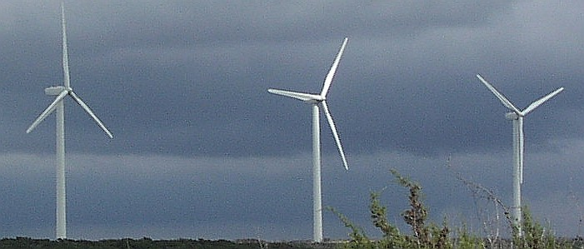
Key Dates:
- April 10, 2002, RFP released.
- No later than April 24, 2002, questions for clarification must be submitted by email.
- No later than May 8, 2002, answers to questions will be sent to all bidders by email.
- No later than May 15, 2002, proposals must be submitted and received.
- May 30 and 31, 2002, tentative meeting and presentation by possible bidders in Austin.
- No later than June 7, 2002, bidder selected.

Table of Contents

1.0 Introduction and Scope
2.0 Modeling Requirements
2.1 Aggregated Model Requirements
2.2 Block Diagrams Representing Control Systems
2.3 FORTRAN Code
2.4 Incorporated into the PTI Software
3.0 Validation Via Simulation and measurement Testing
3.1 Large Signal Performance
3.2 Small Signal Performance
3.3 Flexibility
4.0 Account for Real and Reactive Power
4.1 Electro-mechanical Interaction Between Turbines
4.2 Effects of a Weak Transmission System
5.0 Training
6.0 required elements for PROPOSED schedule
7.0 Outline of Key Elements Required in Submitter’s Proposal

8.0 GENERAL INFORMATION AND REQUIREMENTS

9.0 DISCLOSURE OF CONFLICT INTEREST

1.0 Introduction and scope

Due to increased popularity and environmental concerns, wind generation in the ERCOT system is increasing rapidly. By the year 2004 it is estimated that there will be over 1000 MW of generation capability. In the past, wind turbines were not considered for bulk transmission system voltage and frequency concerns. If a disturbance occurred, the wind turbine was disconnected and reconnected following the disturbance. This was permissible for low penetration levels of wind turbines. As wind farms become a larger part of the total generation of the system and the penetration levels increase, issues related to integration, transient effects, and voltage impacts become increasingly important. Moreover, the integration of wind devices into the bulk system is significantly different due to the stochastic nature of wind. That is, generation output is directly related to the strength and duration of wind.

Compared to other more conventional devices, wind generation is relatively uncontrollable, somewhat unpredictable, and varies with local weather conditions. Furthermore, for the most part, ERCOT system operators have limited experience dealing with large intermittent resources. This concern is heightened due to the fact that new wind resources are principally located in the west area of the ERCOT grid, which is relatively a weaker system. An added concern is that in the ERCOT system high-set relays normally set to offset responsive reserve may be taken off line, increasing the requirement for active reserve. Reserve requirement for ERCOT is 2300 MW.

Finally, an accurate and appropriate model that can be used to study the effects of integration of large wind devices for transients is currently not available. There is a growing concern that inaccurate models can lead to limiting the amount of wind generation that can be accommodated by the present ERCOT system without decreasing system reliability.

The purpose of this document is to outline modeling criteria, definitions, and test objectives to develop a series of wind generation models. The primary purpose of such models is to accurately simulate the dynamic performance of wind farms and the impact they have on power systems.

New wind turbine models should be applicable for the following studies (see figure 1):

- Steady state (load flow)
- Transient dynamics (large disturbances)
- Small signal stability (small disturbances)
- Stability studies including short and long term dynamics (angular, frequency, and voltage stability)

Small Signal Stability
Power System Stability
Angle Stability
Frequency Stability
Voltage Stability
Transient Stability
Large Disturbance
Voltage Stability
Small Disturbance
Voltage Stability
Short Term
Short Term
Long Term
Long Term
Small Signal Stability
Small Signal
Stability
Power System Stability
Power System Stability
Angle Stability
Angle Stability
Frequency Stability
Frequency Stability
Voltage Stability
Voltage Stability
Transient Stability
Transient Stability
Large Disturbance
Voltage Stability
Large Disturbance
Voltage Stability
Small Disturbance
Voltage Stability
Small Disturbance
Voltage Stability
Short Term
Short Term
Short Term
Short Term
Long Term
Long Term
Long Term
Long Term

Figure 1: Outline of planning studies.

In addition, matching actual disturbance data with model simulations requires that both large and small signal performance criteria be considered during design specification and acceptance testing of any model developed for use by ERCOT Staff and stakeholders.
2.0 Modeling Requirements

Due to the large number of turbines within one wind farm, ERCOT needs an aggregated model that can be used to model an entire wind farm at the substation interconnection point. Most wind farms have a large number of wind turbines therefore making it excessively time consuming to attempt to model each turbine.

Figure 2: Aggregated Model

An aggregated model denotes one or more equivalent wind turbine generators represented by an equivalent mathematical model interconnected to a collector bus (See figure: 2). For wind farms with very large number of turbines, e.g. several hundred, the wind farms may be modeled by a set of several equivalent generators, as the model of a single model may not be sufficiently accurate. Use of multiple equivalent models to represent a large farm should be considered if the performance of a single model is poor. The model developer should provide ERCOT and its stakeholders with user-friendly tools in order to aggregate the dynamics of the set of equivalent generators. The modeling sets should be designed for use with Power Technologies Incorporated Power System Simulator for Engineers (PTI PSS/E).

One or more collector buses can be interconnected to the same substation bus.
Model should account for both variable speed and constant speed control turbines. However, the problems related to electro-mechanical interactions, problems with weak grids and with resynchronizing following disturbances are almost non-existent with variable speed wind turbines. Variable speed wind turbines do not resynchronize because their speed is controlled by the converter and not the grid.

Depending on the type of turbine (variable or constant speed) the appropriate subsystems should be included in the aggregated modeled:

- Wind speed model
- Rotor model
- Rotor speed controller
- Pitch angle controller
- Voltage at terminal of equivalent model
- Power electronics

Additional requirements are:
- Block diagrams representing controls systems
- FORTRAN code
- Incorporation into the PTI PSSE software
- Validation via testing
- Flexibility–ability to incorporate seasonal factors as required by users and to account for stochastic nature of wind. It must be possible to specify a single signal for wind speed at the individual wind parks from which the speed of individual turbines can be derived.
- It must be possible to specify the following parameters for the wind speed model: initial wind speed, wind direction, gust start and stop times, gust amplitude, ramp start and stop times and ramp amplitude.
- It is not a requirement to account for wind turbulence.
- Account for real and reactive power
- The method for converting wind speed to mechanical should be described and suitable for the aggregated model.
- Account for electro-mechanical interaction between turbines
- Account for effects of a weak transmission system (low short-circuit-ratio - SCR)
- A list of all assumptions and simplifications made in developing the aggregated models should be provided along with a brief justification.
- The level of achieved accuracy for dynamic simulations to study the different stability phenomena must be reviewed and accepted by ERCOT
- The methodology/procedure for aggregating the wind turbines should be described, valid and repeatable.
- The mathematical representation of the dynamics of the aggregated model(s) should be made available for future model development work.
- Load flow analysis should ensure that the correct equilibrium point for the operating point is achieved for the steady state conditions with the aggregated model and the detailed wind plant model.

The three foremost wind turbine technologies used in the ERCOT system are 1) squirrel-cage induction generator 2) double-fed induction generator 3) direct-drive synchronous generator.

The squirrel-cage induction generator can be most closely approximated by PTI’s CIMTR3 Induction Motor (Machine) Model. This model takes into account the rotor flux dynamics but neglects the stator derivative term. This assumption would not cause excessive errors in analysis of induction machines for on-line operation when the network frequency stays close to nominal and the rotor slip is small but may not work properly for all study scenarios such as large system disturbances that cause major system frequency and voltage swings. Under severe disturbances this simplified model could result in poor modeling. In regards to the double-fed induction generator, a power converter promptly responds to rotor speed and terminal voltage deviations. The former action is physically different from typical generator governor response. The latter action could be significantly different from the interaction between a synchronous machine and its excitation system because of the physics of the wound rotor field and the controls. The main difference is that in a doubly-fed induction generator, both reactive power and torque can be controlled by changing the rotor current.
In a synchronous generator, only the reactive power can be controlled by the rotor current, and the active power must be controlled by the relatively slow governor. These physics should be taken into account to reach the desired level of modeling credibility. Additionally, there are concerns about the capability of existing models to accurately capture the electro-mechanical interactions between wind turbines. It is therefore deemed necessary to develop from the required control block diagrams and not develop models based on PTI PSSE’s existing CIMTR3 Induction Motor (Machine) Model.

ERCOT requires models for all generators connected to the system. The following wind turbine technologies are acknowledged to be either planned for or connected to the system.

- Squirrel-cage induction generator (see figure 3)
The squirrel-cage induction generator is coupled to the rotor via a gearbox. The purpose of the gearbox is to provide optimal power output for varying speed ranges. Since the generator is connected directly to the grid, rotor speed variations are small. The changes in mechanical power resulting from wind speed variations lead to changes in the rotor slip. With relatively low rotation speeds the induction generator operates in a narrow speed range around the synchronous speed (slip), with the maximum speed (and slip) occurring at maximum power output. Also, rotor speed along with output power is limited by the design of the rotors’ geometry. The aerodynamic properties of the rotors become less efficient at high wind speeds. This property is called stalling. Stalling prevents the squirrel-cage wind turbine from becoming overloaded due to high wind speed.

Induction generators require reactive power from the grid for excitation, and therefore operate at lagging power factor. This type of generator does not provide voltage support and requires reactive power from the grid. Shunt capacitors are typically used to compensate for some of the reactive power requirements of the generator. Typically, reactive power is provided by an added capacitor at the point of interconnection for power correction.
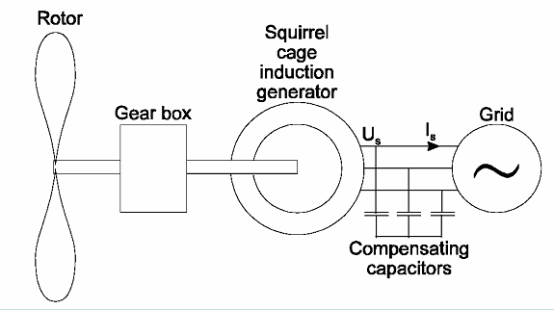
Figure 3: Squirrel-cage induction generator (Source: J.G. Slootweg, Delft University of Technologies )

- Double-fed induction generator (see figure 4)
Similar to the squirrel-cage generator the double-fed wound rotor induction generator requires a gearbox to compensate for speed difference between the rotor and generator. For the double-fed generator the stator is linked to the grid and the rotor is coupled to a back-to-back converter. By means of this converter, it is possible to provide voltage support and it decouples the transmission grid system frequency and the mechanical frequency of the rotor. Changing the rotor current accordingly normally provides voltage support. The grid side of the converter is normally operated at unity power factor and does therefore not take part in the reactive power interchange.
This converter provides voltage support and allows the device to be decoupled from transmission grid system frequency and the mechanical frequency of the rotor. The generator and converter are prevented from being overloaded in high wind speeds by controlling the machine field voltage supplied by a power converter. Additionally, rotor speed is also controlled by varying pitch of the rotor blades to reduce the efficiency of extracting energy from the wind and thus the speed. This method of regulation is called pitch control.

In a double-fed induction generator, rotor circuits are connected to external terminals via slip rings, as with the armature winding of a DC machine. The external connection makes it possible to alter the rotor circuit electrical characteristics and therefore the overall behavior of the machine. Series connection of external resistors to each of the three rotor circuits, for example, alters the torque speed characteristic of the machine. In this case, a semi-variable speed wind turbine results, which still consumes reactive power and is not able to support the grid voltage. More sophisticated external rotor circuit controls, such as electronic power converters, offer a wider range of speed and torque control possibilities, as well as better overall conversion efficiency and reactive power control capabilities.

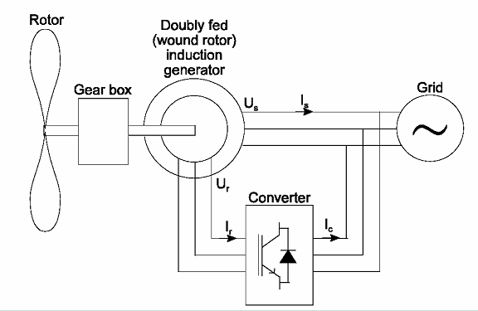

Figure 4: Double-fed induction generator (Source: J.G. Slootweg, Delft University of Technologies )

- Direct-drive synchronous generator (see figure 5)
In the direct-drive synchronous machine the rotor is directly coupled to the generator and no gearbox is required. Due to the low mechanical frequency of the rotor, a synchronous generator with a large number of poles is utilized. The stator of this device is connected to the grid via either a voltage source converter or a back-to-back diode/thyristor converter. Varying the stator current can control generator torque. When using a voltage source converter, no additional capacitors for voltage support are required. Similar to the double-fed turbine this device employs pitch control to regulate mechanical power due to high wind speeds. The major difference is that the direct-drive turbine operates at variable speed, and the electrical frequency of the terminal voltages and currents varies with turbine rotor speed. The output is rectified by a diode bridge, then converted to fixed frequency AC and interfaced to the grid. Consequently, the dynamic behavior of the turbine is mostly dictated by the characteristics of the power conversion system.

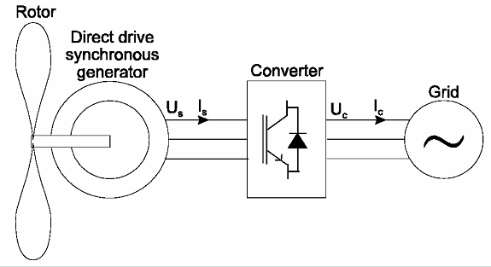

Figure 5: Direct-drive synchronous generator (Source: J.G. Slootweg, Delft University of Technologies )

2.1 Aggregated Model Requirements

An aggregated model should be able to accurately combine wind farm characteristic into a single substation representation. The motivation for a substation approach is threefold 1) reduce error by automating data input into models and 2) reduce the time required to implement models, and reduce computational time. Typically, wind farms comprise large numbers of wind turbines that are interconnected. A considerable amount of time and effort is necessary to model all of the turbines interconnected in a wind farm distribution system. Furthermore, to model this amount of detail, the wind farms will have to provide this information and the chance of modeling errors is increased. Wind turbines can be connected individually to the grid or clustered in wind farms. A wind farm may comprise a large number of individual units that are interconnected with one another in a radial, parallel, or mixed arrangement. When studying the impact of a wind farm on the system, it is reasonable to make an equivalent model of the wind farm comprising a limited number of equivalent units connected to the network. Each of these units is assumed to be electrically identical (i.e., equal ratings). Similar to conventional turbines, the step-up transformer of the equivalent model is explicitly modeled between the substation bus and the generator bus.

2.2 Block Diagrams Representing Control Systems

One of the first steps in modeling any device in a numerical program is comprehension of the physics of the equipment to be modeled. To aid in understanding the physics, (see figure 6) block diagrams are used to represent the equipment, using differential and algebraic equations. These block diagrams can be reduced using calculus and block diagram algebra to transform the system equations to form a manageable model. Transitions between block functions and feedback require different time intervals. These transitions should be clearly marked in the provided diagrams.

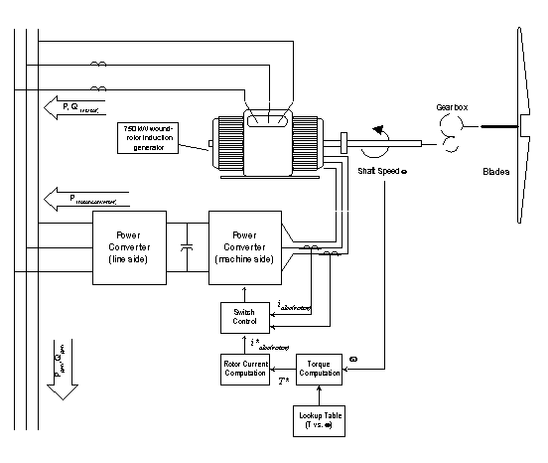

Figure 6: Mechanical layout of typical wind turbine.

2.3 FOrTRAN Code

Source code is required for all models developed for use by ERCOT Staff and stakeholders. By providing this code, ERCOT is assured that future upgrades to the models and modifications can be made. Furthermore, having the source code available will make the translation of models into other power system simulators more readily available.

2.4 Incorporated into the PTI PSSE Software

ERCOT Staff and stakeholders use the PTI PSS/E as its standard software tool. The PTI PSS/E is a package of programs for studies of power system transmission network and generation performance in both steady-state and dynamic conditions. PTI PSS/E handles power flow, fault analysis (balanced and unbalanced), network equivalent construction, and dynamic simulation. PTI PSS/E is not set up to solve any specific problem. Rather, it is a carefully optimized data structure associated with a comprehensive array of computational tools that are directed by the user in an interactive manner. To import models into the PTI PSS/E platform, control block diagrams are translated into FORTRAN statements and compiled during the initialization of the dynamics data.

3.0 Validation Via simulation and measurement Testing

The performance and degree of accuracy between the aggregated model and a detailed model of the study system should be validated as follows:
- Simulation using an dynamics base case to be provided by ERCOT.
- Measurement by applying a disturbance to a system (subsystem) within ERCOT to which a large wind farm is connected. The measurements will be coordinated by ERCOT in collaboration with a wind farm developer.
- Large and small signal stability validation will be carried out as specified by ERCOT.
- Time and frequency response results for the multi-turbine wind plant and aggregated wind plant model should be presented

3.1 Large Signal Performance

Large signal performance is the response to signals that are large enough that nonlinearities are significant. The purpose of large signal performance criteria is to provide a means of evaluating the system performance for severe transients affecting system transient stability. The criteria must reflect the effects of operation under realistic power system disturbances. With respect to performance testing, it is often impractical to adequately duplicate these effects. In cases where tests can only be made on individual components and only at partial load or open-circuit, analytical means may be used to predict performance under actual operating conditions.

3.2 Small Signal Performance.

Small signal performance is the response to signals that are small enough that nonlinearities are insignificant. Small signal performance of a wind turbine control system or its components can be assessed from time responses, frequency responses, or by eigen value analysis. Small signal performance criteria provide a means of evaluating the response of systems for incremental load changes, incremental voltage changes, and the incremental changes in synchronous machine rotor speed associated with the initial stages of dynamic instability (where oscillations are small enough that nonlinearities are insignificant). Small signal performance data provide a means for determining or verifying model parameters for system studies.

3.3 Flexibility

Models to be developed should have the ability to incorporate seasonal factors as required by users and to account for the stochastic nature of wind. As wind increases or decreases, power output for the wind turbine will increase proportionally. This may not have significant results for transient stability studies but will have considerable impact for frequency and voltage stability studies. As penetration levels of wind generation increases, the ability to predict system swings due to wind will have an increased benefit. Simpler models are important for connecting large numbers (thousands) of wind turbines and calculations with a rather slow time variation, up to 10 Hz. The more advanced models are used when there is a need for calculations with a short time constant, less then 100 ms. Of course, the computer calculation time is much longer for the advanced model.

4.0 Account for Real and Reactive Power

In large-scale electrical power systems, synchronous generators interconnected to the grid provide power and voltage support. Voltage support maintains grid voltage close to a nominal value by injecting or absorbing VARs in the system. The voltage profile task is very important and in some cases may be one of the leading causes for system constraints. Voltage limitations are intensified the farther away the source is from the load. For example, there is an increased need for voltage support as power is transmitted over longer distances. The longer line causes a voltage drop and a phase shift when current flows through it caused by an increased line resistance and reactance. The increased line reactance requires additional VARs. The farther away the source is from the supply the more VARs will be required at the sending end of a heavily loaded transmission line. Typically in the past wind generation has not been considered for providing voltage support. In a deregulated market where all generation is considered equal, wind generation must account for the same performance as other generators in the system or make provisions to be comparable.

Voltage profile and reactive requirements must be considered in developing a wind turbine model and when measuring system performance. Other reactive compensation, such as collector line or interconnection substation capacitor banks on voltage or current controlled switches, must also be incorporated into the wind plant model. A relatively detailed representation of the Enron DVAR system will also be necessary.

4.1 Electro-Mechanical Interaction Between Turbines

One increasing concern is what happens when a large wind farm is equipped with turbines having different mechanical parameters. This question is related to inter-area local mode oscillation and small signal variations. Oscillations between turbines with different mechanical parameters following a disturbance may be a risk. If the wind turbines’ mechanical parameters are different, the wind turbine’s natural frequencies due to shaft tensional modes will also be different. This concern is magnified when compared to regional small signal oscillations between farms and other interconnected devices. Studying electro-mechanical oscillations between turbines in the same wind plant will most likely require a model with much more detail than would be necessary for analysis of transmission system events where there would be a higher degree of coherence among all turbines in a single plant. It has been suggested that a modular modeling approach, where successively more detail can be incorporated by increasing the number of turbine “groups” that are explicitly modeled, may provide the best approach to capture this phenomenon. This is only important for constant-speed wind turbines and not for variable-speed wind turbines because for those the electrical and mechanical behaviors are decoupled.

  - Effects of a Weak Transmission System (low short circuit ratio- SCR)

System strength can be considered for both the nominal intact AC system and for contingency situations. The most severe line or synchronous machine contingency is usually the critical condition for system design. However, degraded performance or diminished power transfer capability is determined to be acceptable, within bounds, for the most severe contingencies and some intermediate system condition may be limiting for some design conditions depending on system relative strength. The definition of system strength is commonly specified in terms of three-phase fault or short-circuits capacity (SCC), which is calculated as:

SCC = √¯(3 *Vacn* Isc)

Where Vacn = the nominal AC bus line-line voltage
Isc = three-phase short-circuit current

The short-circuit ratio is developed using the SCC and comparing it with the size of the inverter (in this case the wind turbine) device

SCR = SCC
Pn

Where Pn is the size of the device in MW

In a weak system, similar to West Texas, voltage stability becomes more of a factor as wind generation penetration increases. Studies indicate that for a weak system there an increased number of “discrepancies” between what is mathematical simulated and actual fault recorded. The reason for these discrepancies is partly due to the presence of DC offset current in the induction stator following a disturbance and partly due to the induction machine shaft system. This shaft of wind turbine generator rotor is light and considered soft. This discrepancy increases the need for more accurate wind turbine models.

5.0 TRAINING

The vendor is asked to provide a separate bid for training ERCOT and its stake- holders in the techniques and algorithms used to generate aggregated models.

Training should include the following:
- Data preparation
- Interpretation of results
- Specific training on the modeling software and the conversion of block diagrams
- PTI PSS/E User Model Writing and integration information:

  - Dynamic Analysis Tools
    - Differential Equations
    - Laplace Transforms
    - Transfer Functions
    - Block Diagrams
    - Feedback Control System Concepts

  - Review of PTI PSS/E Dynamic Activities
    - Dynamic Simulation
    - Basic Simulation Set-up Procedures
    - Documenting, Checking and Altering Data
    - Exciter and Governor Response Tests
    - Applying Disturbances
    - Assigning Output Channels and Plotting Results

  - PTI PSS/E Model Writing
    - FORTRAN
    - Compiling and Linking CONEC and CONET
    - PTI PSS/E Program and Data Structure
    - PTI PSS/E Program Flags and Indexing
    - PTI PSS/E Dynamic Simulation
    - Model Writing - Calling Sequence
  - Model Writing - Initialization and Run Modes
  - Model Writing - Basics & Data Input
  - Advanced Uses of CONEC & CONET
  - Class Examples & Exercises
  - Course Review & Discussion

The purpose of this course is to provide the users of the wind models the ability to change, update, and modify models as required. This course should be appropriate for a small group of 15 to 25 attendees, with three days of instruction and two days of hands-on work. Vendor should be able to describe in detail all aspects associated with PTI PSSE user model development.

6.0 REQUIRED ELEMENTS FOR PROPOSED SCHEDULE

Task 1: Collect field data from measurements taken in wind parks to validate models.¹
Task 2: Aggregated Models for Plants with Constant-Speed Turbines.
This task requires validation in ERCOT base case simulations and through field measurements.²
Task 3: Aggregated Models for Plants with Variable-Speed Turbines.
This task requires validation in ERCOT base case simulations and through field measurements.²
Task 4: Training in utilization of wind aggregated models for plants for both types of turbine.

ERCOT anticipates that in the future models used in different studies will involve a mix of different types of wind turbines. However, a task approach as proposed above will ensure the proper knowledge transfer throughout the entire project as well as testing and validation of the developed models. Furthermore, the fundamental differences in the operating principles of constant-speed wind turbines and of variable-speed wind turbines have implications for the model aggregation. Hence, the phase approach allows for both to be treated separately when developing an aggregated model of the wind power plant.

Note:
- Additional requirements for task 1 will be define in a separate document depending on model requirements.
- Validation will require small signal, large signal, and voltage stability studies to validate the accuracy of the models.

7.0 Outline of Key Elements Required in Submitter’s Proposal
If appropriate, bidder can submit individual bids for single or multiple tasks of the project as outlined in section six. Preference will be given to single source bids for the entire project.

- Qualifications
  - Description for basis of investigation
  - Previous clients with contact information (ERCOT reserves the right to contact any previous client, whether or not listed.)
  - The proposed study team and their qualifications
  - Overall benefit to ERCOT
  - Industry experiences, practices and requirements
  - Summary of bidder’s background and resources available
  - Information regarding any relationships between your organization (or any of its clients) and ERCOT that would impair your objectivity or independence, in fact or by appearance.
  - Full disclosure of any lawsuits or other legal disputes involving services provided by your organization.

- Procedure for RFP
  - Theoretical review of analysis and approach
  - A description of development process
  - Statement of analytical tools used
  - Overview of development methodologies including existing models that have already been developed.
  - Comparison methods and other analytical tools

- Estimate of timeline with benchmarks
  - Deliverable and dates FOR EACH TASK
  - Timeline for overall development and benchmark dates
  - Submit study scope to ERCOT for approval
  - Scope modification dates
  - Gather and prepare data dates
  - Completed study date
  - Post study period for committee review
  - Distribute study report to ERCOT
  - Report presentations
  - Presentation dates
  - Milestone dates
NOTE: Schedule is tentative and will be revised as necessary and appropriate by ERCOT.

- Detailed description of data required and format
  - Data that ERCOT will provide
  - Latest base cases for model development
  - What media will be used to transfer data
  - Dynamics data requirements
  - Distribution data requirements
  - Real-time data requirements
  - Shunt capacitor and reactor installations
  - Specific dates for submittal of data, to be adjusted on availability
  - The final list of events to be studied in detail.

- Estimate of funds required
  - Policy for timely deliverables
  - Costs and payment details
  - Additional terms and conditions

- Draft delivery methods and project stages

- Final Report (Documentation)
All documentation for studies will be supplied in both printed and electronic form and will meet the following criteria:
  - Electronic documents must be compatible with Microsoft Office 2000
  - An electronic version of the study and all related data, including power-flow cases, dynamics data, and the final report, are to be provided on CD-ROM.
  - Color documents should be designed so that they can be legibly printed on a black-and-white laser printer.
  - Executive summary containing a brief description of project development and approach.
  - Final report will include a presentation to ERCOT members to review study findings at an "Open House" for ERCOT stakeholders and PUCT Staff. This presentation will be held in the Austin area.
  - All wind models developed in this process and associated information to include “programming code” that is provided to ERCOT will be made public for the use of all ERCOT stakeholders and their affiliates.

8.0 GENERAL INFORMATION AND REQUIREMENTS

The key dates for the Request for Proposals (RFP) process are as follows:

- Questions for clarification must be submitted by email to Juan S. Santos (jsantos@ercot.com ) no later than April 24, 2002.
- Answers to questions will be sent to all bidders by email no later than May 8, 2002.
- Proposals must be submitted and received by May 15, 2002.
- Tentative meeting and presentation by possible bidders is planned for May 30 and/or 31 in Austin. ERCOT will select bidders for this meeting. Not all bidders may be selected for this meeting and presentation.

No work shall commence, no data will be provided nor shall any invoices be paid until the contractor has signed a consulting agreement with ERCOT. This agreement will require the confidentiality of ERCOT information. ERCOT will provide a copy of its standard consulting agreement to the selected bidder. A bidder will be selected by June 7, 2002.

ERCOT requests the bidder to provide as much information as possible when responding to each point in this RFP. The bidder must identify any specific requirements with which it is unwilling or unable to comply.

ERCOT reserves the right to amend this RFP at any time before the specified due date for proposals. After the proposal due date, amendments to the Study Request shall be sent only to bidders who submitted a proposal.

All those submitting proposals shall keep their proposals open for acceptance by ERCOT for a period of 120 days.

Any cost incurred by the bidder in the preparation of the proposal will be borne by the bidder and the proposal will become the property of ERCOT.

No oral or written statements made by ERCOT personnel shall be considered addenda to this RFP unless the statement is confirmed in writing and identified as a written addendum to this RFP. During the evaluation process, it will be assumed that respondents received all amendments and addenda for this RFP.

ERCOT reserves the right to seek proposal clarification from any bidder to assist in making decisions. A meeting and presentation by selected bidders may be called by ERCOT and held in Austin to assist in final decisions. Any cost incurred by the bidder for the meeting and presentation to ERCOT will be borne by the bidder and the presentation will become the property of ERCOT.

RFP and scope of work may be submitted via email but should be followed up with hard copies and must be received by May 15, 2002. Three (3) copies of the proposal are required. If appendices or other supportive documents are required, then it is requested that three sets be submitted with your proposal.

No data, results, reports, technical papers or documentation of any kind will be released by the selected bidder outside of ERCOT staff without written authorization of ERCOT.

ERCOT will evaluate all proposals and consider cost, reliability, and quality of service in the selection of the organization it believes will provide the best overall value to ERCOT. It is understood that ERCOT reserves the right to reject any and/or all bids and to waive irregularities and informalities as deemed necessary.

All information submitted in response to this RFP is public after the Notice of Award has been issued. The bidder should not include as part of the response to the RFP any information, which the bidder believes to be a trade secret or other privileged or confidential data. Any information submitted by bidders may be shared with any ERCOT stakeholders (e.g. market participants in the ERCOT region electric market) involved in the study.

9.0 DISCLOSURE OF INTEREST

All bidders shall make full disclosure in writing at the time of the proposal of any of the following existing business relationships with ERCOT personnel:
- If the bidder is a private company, detail or ownership of shares by any ERCOT personnel. If the bidder is a public company, ownership of shares in excess of 5% of total shares by any ERCOT personnel.
- Detail of any directorships of any ERCOT personnel.
- Affiliation to any known market participant in the ERCOT region.
By submission of a proposal, the bidder certifies (and in the case of a joint proposal, each party certifies) that:
- No relationship exists or will exist during the contract period between the bidder and ERCOT that interferes with fair competition or is a conflict of interest.
- The proposal has been developed independently without consultation, communication or agreement with any employee or consultant of ERCOT who has worked on the development of this RFP, or with any person serving as an evaluator of the proposals submitted in response to this Study Request.
- Bidder is not an ERCOT member or affiliated with an ERCOT member.
If a bidder fails to disclose an interest, ERCOT reserves the right to terminate or cancel a contract, into which ERCOT may have entered with that bidder.

Submit hard bid copies in triplicate and electronic copies in MS word format by May 15, 2002. Documents will be distributed via email to members of the Wind Model Development Task Force.

Juan S. Santos MSEE
Senior Consultant, System Planning
Technical Operations
ERCOT
2705 West Lake Drive
Taylor, Texas 76574-2136
(512) 248-3139, Fax: (512) 248-3082
Email: jsantos@ercot.com

Responsive reserve is on line generation that can respond to system emergencies such as generation outages and line trips.
FORTRAN – This term is refers to computer programming language that is outlined in ANSI X3J3./96-007 and International Standards ISO/IEC 1539:1991
The latest version of Power Technologies Incorporated Power System Simulator for Engineers (PTI PSSE) software has been adopted by ERCOT as its standard.
This does not imply a completely separate dimension for the model, but only that the temporal behavior of wind plants can be incorporated as the user requires.
J.G. Slootweg, S.W.H. de Haan, H. Polinder and W.L. Kling. ”Aggregated Modeling of Wind Parks with Variable Turbines in Power System Dynamics Simulations” Submitted to PSCC, June 2001, Seville Spain.
Although production of the direct-drive electro-mechanical coupling has decreased, ERCOT considers this as a viable technology.
Yuriy Kazachkov – PTI Presentation at ERCOT Aug 15, 2001
J.G. Slootweg, S.W.H. de Haan, H. Polinder, W.L. Kling Modeling Wind Turbines in Power System Dynamics Simulations Delft University of Technologies
J.G. Slootweg, S.W.H. de Haan, H. Polinder, W.L. Kling Modeling Wind Turbines in Power System Dynamics Simulations Delft University of Technologies
same as 5
Source code refers to original code needed to implement model.
V. Akhmatov ,H.Knudsen,A. Nielsen, J.Pedersen, N.Poulsen Modeling and Transient Stability of Large Wind Farms, Royal Institute of Technology. Stockholm, Sweden
D. Wilhelm High -Voltage Direct Current Handbook Electric Power Research Institute EPRI TR-104166s
Vladislav Akhmatov, Modeling of Windmill Induction Generators in Dynamic Simulation Programs. IEEE paper BPT99-243-12

