DPC Dashboard
Transmission Operator User Guide
Submitting Temporary DPCs & Monitoring Your Dashboard

Document Version | Version 3.0
Audience | Transmission Operators (TOs)
Scope | DPC Submission Form and TO Dashboard View only
Classification | ERCOT Public

Table of Contents
Contents
Table of Contents 2
Requesting Access for DPC Dashboard 4
DPC Dashboard Roles 4
How Do I Know If I Have the Role on My Certificate? 5
1. Introduction 6
1.1 Purpose of This Guide 6
1.2 What Is a DPC? 6
1.3 Determining Whether You Need a Temporary DPC 7
1.4 Temporary DPC Types Available to TOs 9
2. Accessing the DPC Dashboard 10
2.1 Launching from the Outage Scheduler 10
3. The DPC Dashboard 11
3.1 Dashboard Layout 11
3.2 Dashboard Columns 11
3.3 DPC Queue vs Archive 12
3.4 DPC Status Reference 12
4. Submitting a DPC 14
4.1 Starting a New Submission 14
4.2 General Information Section 15
4.3 DPC Data Section 15
4.4 Submitting a Static Line/Transformers Rating DPC 16
4.4.1 Line Rating Submission 16
4.4.2 Transformer Rating Submission 17
4.5 Submitting a Contingencies Enable/Disable DPC 18
4.6 Notes and Attachments 19
4.7 Submitting the Form 20
5. After Submission – Monitoring and Actions 21
5.1 Tracking Your DPC 21
5.2 Modifying the Effective End Date 21
5.3 Withdrawing a DPC 23
5.4 Adding Comments to a DPC 24
5.5 Cloning a Closed DPC 24
6. Quick Reference 26
6.1 Submission Checklist 26
6.2 Where to Find Things 26
6.3 Key Contacts 26
Appendix: Glossary 27

Requesting Access for DPC Dashboard
All Market Participants have established a User Security Administrator (USA) with ERCOT to receive digital certificates and manage user access through the Market Participant Identity Management (MPIM) system.

If you are new to MPIM or need to establish a USA for your organization, please refer to the following guide on ercot.com:

MPIM Digital Certificate User Guide

DPC Dashboard Roles
- Once you have a USA established with ERCOT, you can add a DPC Dashboard role to your existing roles.
- The DPC Dashboard is available for TSPs (Transmission Service Providers) to access via a role in the format DPC_M_<permission>, which can be found under MPIM Digital Certificate Roles:

https://www.ercot.com/mp/data-products/data-product-details?id=dcug-01-m

These roles are available on MPIM for you to select, add to your existing roles, and request a new or updated digital certificate through your USA.

Role | Description | Organization Type
DPC_M_OPERATOR | - View the DPC TO Dashboard.  - Submit new DPC requests.  - Modify and resubmit DPCs based on rejection feedback.  - Withdraw a DPC in Submitted status.  - Modify the Effective End Date of a Temporary DPC.  - Add comments to a DPC.  - Clone a closed Temporary DPC to start a new submission. | TSP
DPC_M_VIEW | View the DPC TO Dashboard with read-only access. No ability to submit, modify, or withdraw DPCs. | TSP

How Do I Know If I Have the Role on My Certificate?
Before you try to access the DPC Dashboard, you can confirm the role is on your certificate directly on the ERCOT Market Information System (MIS) site:
- Go to https://mis.ercot.com/secure/profile (Production) and log in with your existing credentials.
- On the User Profile page, look at the “My Assigned Roles” panel on the right.
- If your certificate has been granted access, you’ll see DPC_M_OPERATOR or DPC_M_VIEW listed there.

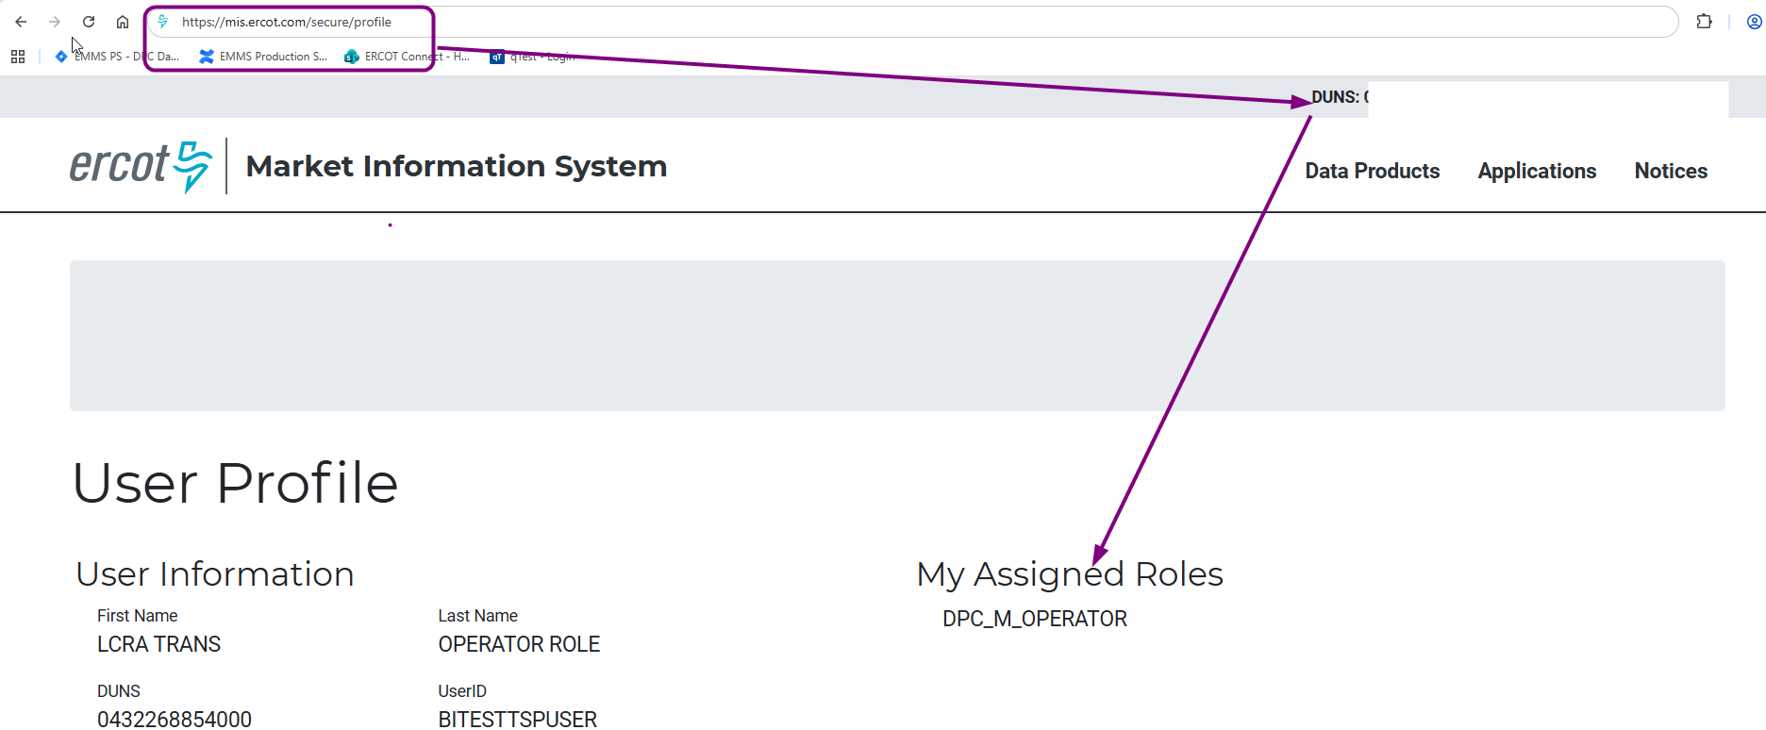

Note: If you don’t see either role listed, you don’t yet have DPC Dashboard access. Work with your USA to request the role through MPIM before your effective date (MOTE: 7/13/2026; Production: 8/28/2026).

1. Introduction

1.1 Purpose of This Guide
This guide explains how Transmission Operators (TOs) use the DPC Dashboard to:
- Submit temporary Downstream Production Change (DPC) requests to ERCOT.
- Track the status of submitted DPCs through the TO Dashboard.

1.2 What Is a DPC?
A Downstream Production Change (DPC) is a request to make a specific change to the ERCOT network model between the regular weekly model loads. TOs submit DPCs when field conditions require a temporary update to model data — for example, when thermal limits on a line need to be temporarily reduced, or a contingency needs to be disabled during field work.

Scope: This tool handles Temporary DPCs submitted by TOs only. Permanent DPCs continue to be submitted through the NMMS MAGE system as before.

How DPC Timing Works —: The Effective Start and End dates you enter are planned dates. ERCOT Shift Engineers use them for internal visibility and dashboard filtering (for example, a look-ahead filter for the next 12 hours or next 2 days) — they do not, by themselves, trigger implementation or reversion. The actual switching, at both the start and the end of a Temporary DPC, still happens only when your TSP Operator calls the ERCOT Operator Desk to coordinate it, exactly as it does today.

Because Temporary DPCs are driven by field conditions, ERCOT still relies on a phone call — not the clock — to know when to act. Here is how the two work together:
a. You submit the Temporary DPC with your planned start and end date/time.
b. ERCOT Shift Engineers see it on their dashboard based on their own filters (for example, DPCs planned to start in the next 1–2 days). They can widen their filters to see all DPCs in Submitted status if needed.
c. ERCOT Shift Engineers Approve or Revert a Temporary DPC only once your TSP Operator calls the ERCOT Operator Desk — not automatically at the planned date/time — since field timing often shifts from what was originally planned.
Bottom line: submitting a DPC does not replace the call. Keep calling the ERCOT Operator Desk at the start and at the end of your work, exactly as you do today.

1.3 Determining Whether You Need a Temporary DPC
Before choosing a DPC type, determine whether your need is Permanent or Temporary:
- Permanent — your desired status will not change again within approximately 21 days, and the need is not driven by an outage or switch-cycle.
- Temporary — the need is driven by an upcoming outage or switch-cycle, and the status will be toggled again on a known near-term date.
Important: Any change to a contingency's definition — adding a new contingency, or modifying an existing one — must always be submitted to NMMS MAGE via a NOMCR, regardless of category. The DPC Dashboard can only change a contingency's status; it cannot author or edit a definition.

If your need is Permanent: submit a NOMCR to NMMS MAGE and set the desired status directly in that submission. No DPC Dashboard submission is needed.
If your need is Temporary:
- If the contingency already exists and is correctly defined, submit only a Temporary DPC on this Dashboard to change its status — no NOMCR is required.
- If the contingency is new, submit a NOMCR to NMMS MAGE first (it will default to Disabled), then submit a separate Temporary DPC on this Dashboard to enable it.
- If an existing contingency's definition needs to change, submit a NOMCR to NMMS MAGE retaining its current status, then submit a separate Temporary DPC on this Dashboard for the status change.
Sequencing: When both a NOMCR and a Temporary DPC are needed, note in the Temporary DPC's comments that the NOMCR must be implemented in production before the Temporary DPC's effective date.

The table and diagram below summarize this decision process:

Category | Definition change needed? | NOMCR to NMMS MAGE? | Status set in submission in NMMS MAGE | Separate Temporary DPC?  DPC Submission Form from Dashboard
Permanent | Always to NMMS MAGE | Yes | Set directly to desired state | No
Temporary — no definition change | No | No | No | Yes — sole submission, toggles status
Temporary — modifying existing | Yes | Yes | Retain previous status (unchanged) | Yes  Just add a comment in temporary submission form- “Implement NOMCR# before this”
Temporary — brand-new contingency | Yes (new contingency requires a new definition) | Yes | Disabled (default) | Yes  Just add a comment in temporary submission form- “Implement NOMCR# before this”
Table 1.3 – NMMS MAGE vs. DPC Submission form decision table
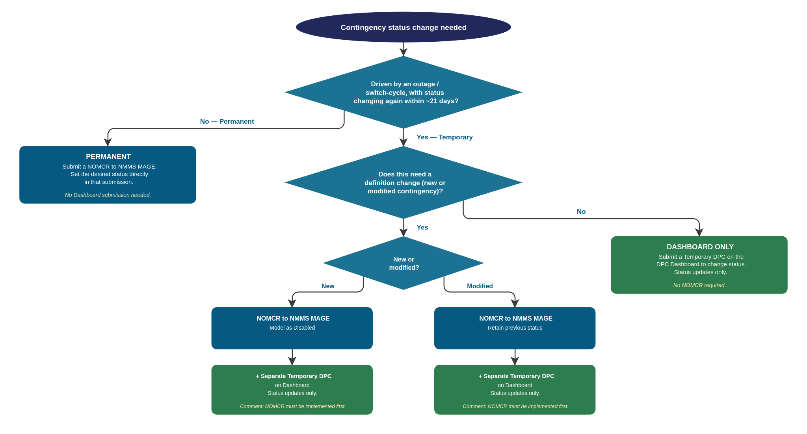
Figure 1.3 – NMMS MAGE vs. DPC Submission form- decision tree

1.4 Temporary DPC Types Available to TOs

DPC Type | Description
Static Line/Transformers Ratings | Temporarily update Normal, Emergency, LoadShed, or Relay Loadability (RLR) limits for one or more lines, transformers, or ZBRs.
Contingencies Enable/Disable | Temporarily enable or disable one or more contingencies in the network model.

2. Accessing the DPC Dashboard

2.1 Launching from the Outage Scheduler
The DPC Dashboard is accessed directly from the Outage Scheduler — the same portal you already use for outage submissions. No separate login is required.

- Log in to the ERCOT Market Portal using your existing credentials.
MOTE URL - https://testmis.ercot.com/osrui/osrui/Summary.action
PROD URL- https://mis.ercot.com/osrui/osrui/Summary.action
- Open the Outage Scheduler application.
- In the top-right corner of the Outage Scheduler, click the DPC Dashboard button.

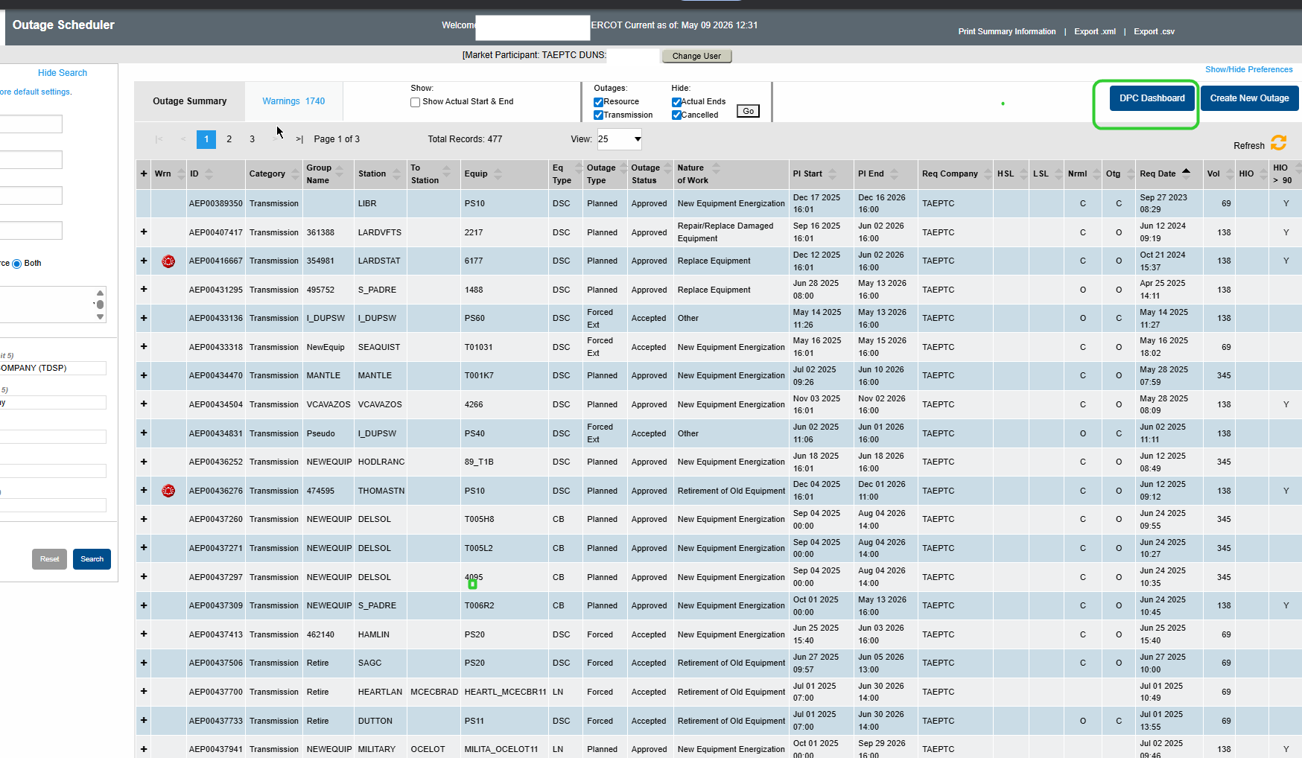
Figure 1 – The DPC Dashboard button (top-right) in the Outage Scheduler
Note: Your current Market Participant and DUNS number are displayed at the top of the Outage Scheduler page. The DPC Dashboard will use the same company context automatically.

3. The DPC Dashboard

3.1 Dashboard Layout
Clicking DPC Dashboard opens the DPC Queue view. The screen is divided into two areas:

- Left panel – Navigation: DPC Queue (active submissions), Archive (historical records), and the + New DPC button to start a new submission.
- Main grid – A table listing all your DPC records with columns for key details and current status.

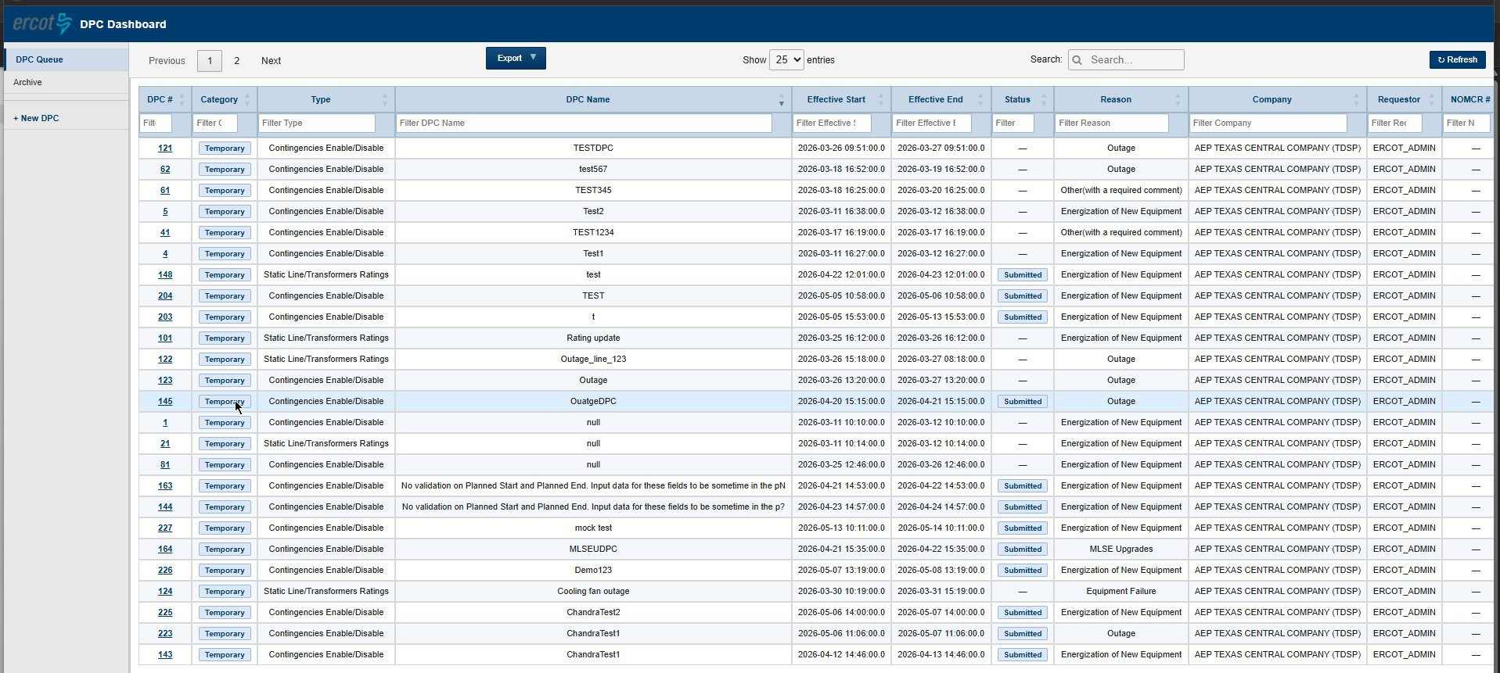
Figure 2 – DPC Dashboard showing the DPC Queue with submitted records

3.2 Dashboard Columns

Column | Description
DPC ID | Unique identifier assigned to each DPC. Click the number to open the full DPC detail view.
Category | Temporary – for DPCs submitted through this portal. Permanent – for DPCs submitted from NMMS MAGE.
DPC Type | Static Line/Transformers Ratings or Contingencies Enable/Disable.
DPC Name | The name you entered for the DPC at submission.
Effective Start | The effective start date and time of the DPC.
Effective End | The effective end date and time of the DPC.
Status | Current processing status. See Section 3.4 for full definitions.
Reason | The reason category selected at submission (e.g., Outage, Equipment Failure).
Company | Your requesting company name.
Requestor | The user ID that submitted the DPC.
NOMCR # | Applicable only for Permanent DPCs from MAGE. This field will be blank for Temporary DPCs submitted from this portal.

3.3 DPC Queue vs Archive

View | What it shows
DPC Queue | Your active and recently submitted DPCs. This is the default view when you open the dashboard.
Archive | Historical DPCs that have completed the full lifecycle: Closed, Rejected, or Withdrawn.

3.4 DPC Status Reference
The Status column shows a color-coded badge reflecting where the DPC is in the review and implementation process.

Status | DPC Category | What it means for you | Action needed?
Submitted | Temporary | For Temporary DPCs — submitted from this portal and awaiting approval by ERCOT Shift Engineers for production implementation. | Call ERCOT Operator Desk when you’re ready to implement
DPC Received | Permanent | For Permanent DPCs — ERCOT Network Model Coordinators have accepted and reviewed your submission. | Monitor
Validated | Permanent | For Permanent DPCs – ERCOT Network Modeling Engineers have modeled and validated the DPC and ready for ERCOT Shift engineers approval. | Monitor
Approved for Implementation | Temporary/Permanent | Shift Engineers have approved the DPC for production implementation.  This is short intermittent state as Shift engineer Approves- Implementation happens in next few minutes. (< 10 mins) | Monitor
Implemented | Temporary/Permanent | Your DPC has been implemented in ERCOT’s EMS and MMS systems. | Monitor
Verified | Temporary/Permanent | ERCOT has confirmed the DPC was implemented correctly in EMS and MMS. | Monitor
Pending Reversion | Temporary | The DPC’s effective end date/time has passed, but it has not yet been reverted in EMS/MMS — ERCOT is typically waiting on your end-of-work call to the Operator Desk (for example, if field work is running longer than planned). See Section 5.1. | Call ERCOT Operator Desk when you’re ready to revert
Reverted | Temporary | Your Temporary DPC has been reverted in EMS and MMS back to the original model state/values. | No
Rejected | Temporary/Permanent | The DPC did not meet requirements. A reason is provided. You may modify and resubmit. | Optional – modify & resubmit
Withdrawn | Temporary | You have withdrawn this DPC. | Optional – modify & resubmit
Closed | Temporary/Permanent | The DPC lifecycle is complete. No further action required. | No

4. Submitting a DPC

4.1 Starting a New Submission
From the DPC Dashboard, click + New DPC in the left panel.

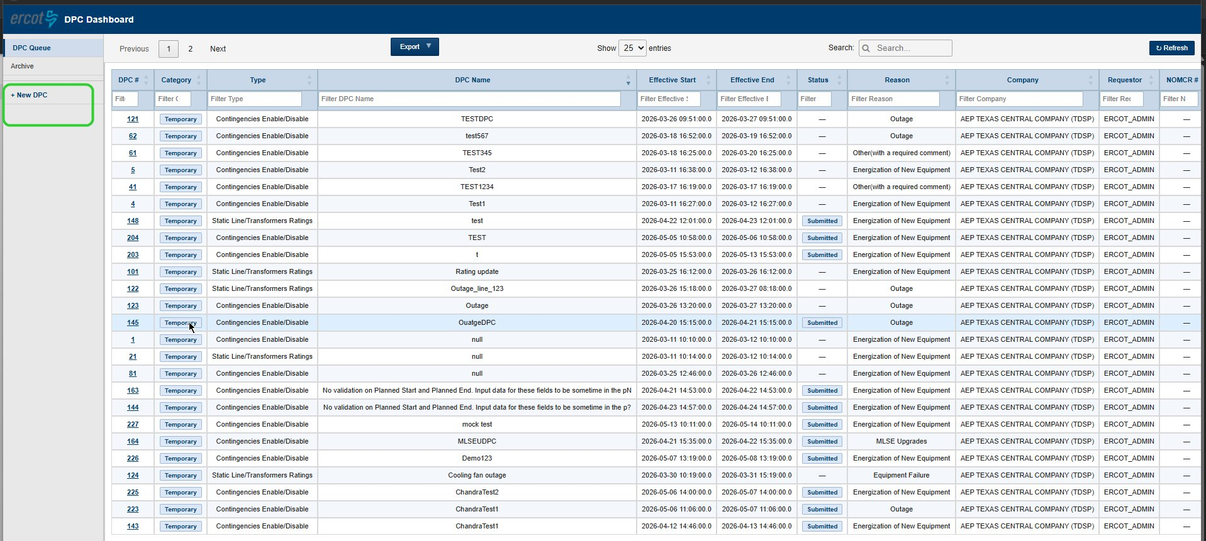
Figure 3 – The + New DPC button in the left navigation panel
The Create Downstream Production Changes Request form opens. The first screen asks you to select your DPC type.

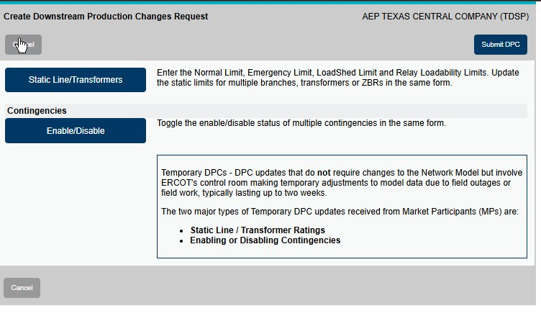
Figure 4 – DPC type selection screen
Select the appropriate type:
- Click Static Line/Transformers to submit a temporary rating change for a line, transformer, or ZBR.
- Click Enable/Disable under Contingencies to temporarily enable or disable contingencies.

Note: The information panel on the right of this screen confirms that Temporary DPCs do not require changes to the Network Model, but involve ERCOT’s control room making temporary adjustments to model data due to field outages or field work, typically lasting up to two weeks.

4.2 General Information Section
After selecting a DPC type, the submission form opens. The General Information section at the top is automatically populated from your account and cannot be edited:

- Request Date – today’s date and time (auto-filled).
- Requestor – your ERCOT user ID (auto-filled).
- Requesting Company – your company name (auto-filled).
- Primary Phone and Secondary Phone – contact numbers from your account profile.

4.3 DPC Data Section
Fill in the following fields in the DPC Data section:
Field | What to enter | Notes
Category | Automatically set to Temporary DPC. | Read-only.
Request Type | Automatically set based on your type selection. | Read-only.
DPC Effective Date – Start | Click the calendar icon to select the date and time the change should take effect. | Required.
DPC Effective Date – End | Click the calendar icon to select the date and time the change should end. | Required. Must be within the maximum allowed duration.
Reason for DPC | Select from dropdown: Outage, Equipment Failure, Energization of New Equipment, As-build Corrections, MLSE Upgrades, Other (with required comment). | Required.
DPC Name | Enter a short descriptive name (e.g., “Line 17T522 rating update”). | Required. Identifies the DPC in the dashboard.

4.4 Submitting a Static Line/Transformers Rating DPC
Use this type when field conditions require a temporary change to thermal limits on a line, transformer, or ZBR.

4.4.1 Line Rating Submission
After completing the DPC Data section, the equipment selection area appears:

- The Equipment Type field shows LN (Line). Type the equipment name in the Equipment field to search for your asset.
- Once selected, the asset appears in the Selected Equipment table with editable rating columns:
  - Normal Rating – enter the new value. Current value is shown below in grey.
  - Emergency Rating – enter the new value. Current value is shown below in grey.
  - LoadShed Rating – enter the new value. Current value is shown below in grey.
  - RLR Rating (Relay Loadability) – enter the new value. Current value is shown below in grey.
- You can add multiple lines to the same submission — each appears as a new row.
- To remove an item, click the red ✖ button in the Remove column.

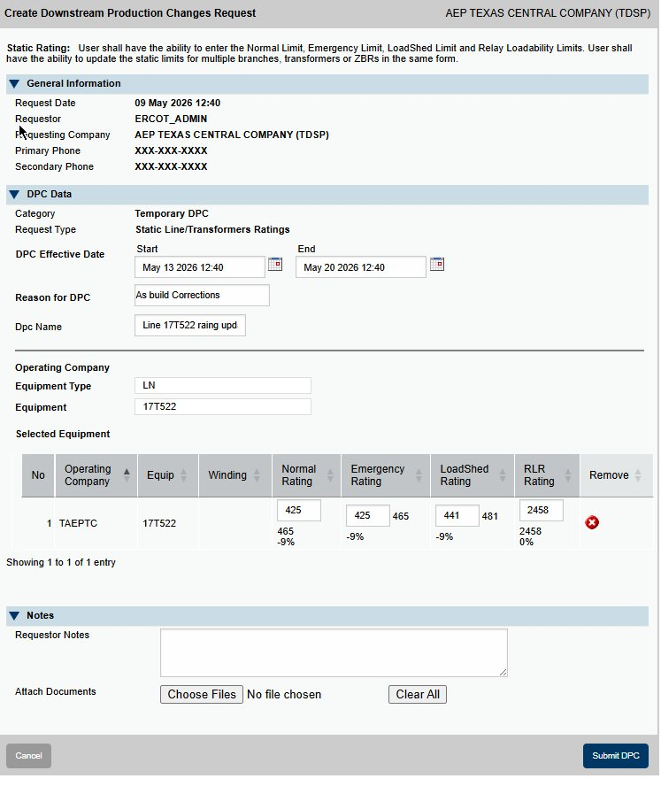
Figure 5 – Static Rating form for a line (LN) showing new and current (grey) limit values
Validation rule: Normal Rating ≤ Emergency Rating ≤ LoadShed Rating ≤ RLR Rating. If this rule is violated when you click Submit DPC, an error will be shown. Correct the values before resubmitting.

If the change in any rating exceeds a system-configured threshold, a popup will appear comparing old and new values before the submission is processed. Review and confirm or adjust before proceeding.

4.4.2 Transformer Rating Submission
The transformer rating form works the same as the line form, with one additional field: Winding Name.

- Set Equipment Type to XF (Transformer).
- Enter the Equipment name (e.g., GILLCR_AT1L).
- Enter the new rating values in the Selected Equipment table as described above.

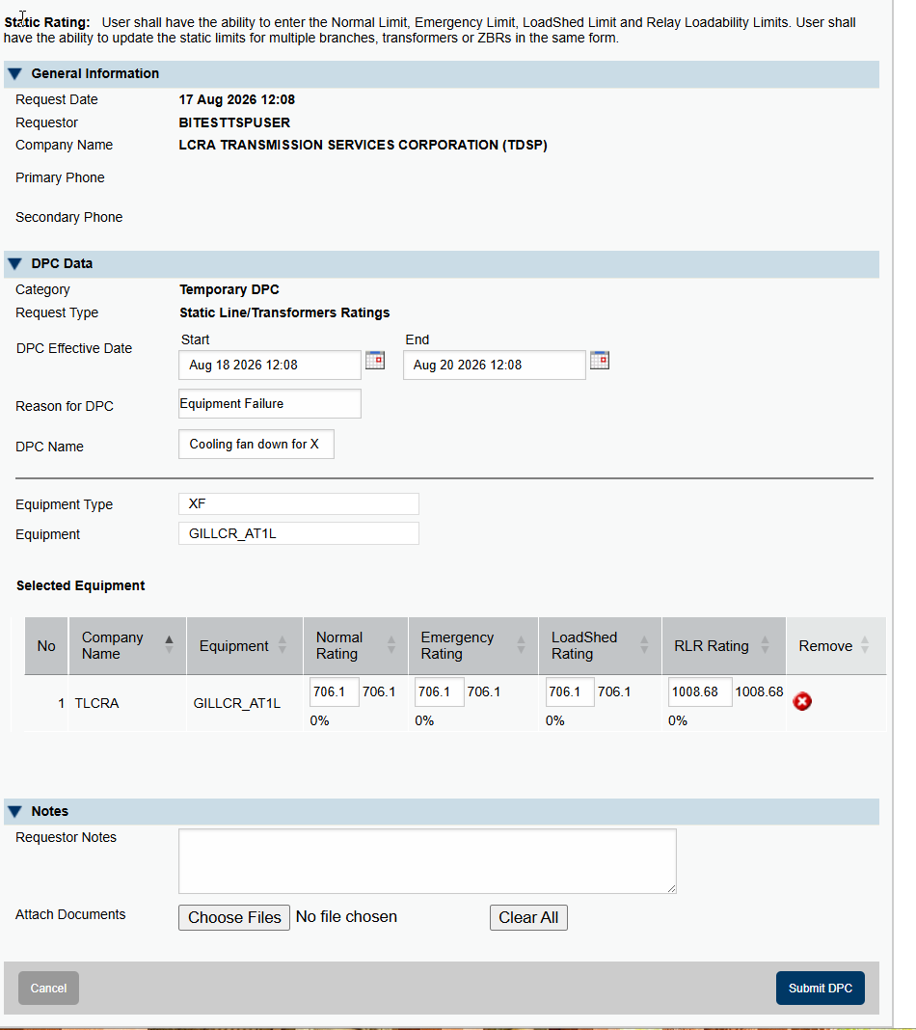
Figure 6 – Static Rating form for a transformer (XF) showing the Winding Name field

4.5 Submitting a Contingencies Enable/Disable DPC
Use this type when field conditions require you to temporarily enable or disable one or more contingencies.

- Complete the DPC Data section (dates, reason, DPC name) as described in Section 4.3.
- In the Operating Company field, confirm your company name is selected.
- In the Contingency field, type the contingency name and select it from the list.
- The selected contingency appears in the Selected Contingency table showing:
  - Contingency ID – the contingency identifier.
  - Current State – the existing status in the model (Enabled or Disabled).
  - Future State – the new status after the DPC is applied. This is always the inverse of the current state as per the model.
  - Assoc Equip – click View to see associated equipment details.
Note: This form assumes the contingency already exists and is correctly defined. If you still need to add or modify a contingency's definition, see Section 1.3 for the required NOMCR and sequencing steps before submitting this Temporary DPC.

- Repeat to add multiple contingencies to the same submission.
- To remove a contingency, click the red ✖ button.

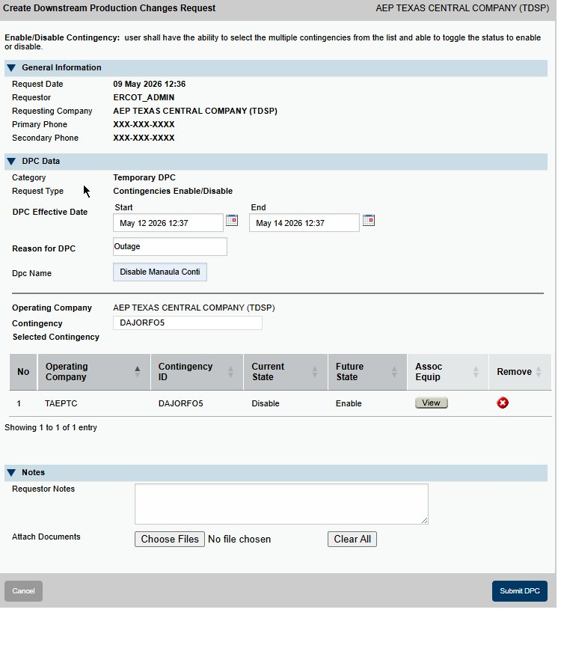
Figure 7 – Enable/Disable Contingency form showing a selected contingency with Current State (Disable) and Future State (Enable)

4.6 Notes and Attachments
At the bottom of both form types is a Notes section:

- Requestor Notes – Enter any additional context or instructions for ERCOT reviewers. Free-text, no character limit.
- Attach Documents – Click Choose Files to attach supporting documents. Multiple files can be attached. Click Clear All to remove all attachments.

Important: Attaching a document is optional — attach supporting documentation (e.g., field orders, engineering justifications) only if it would help ERCOT review and approve the change.
This feature is currently disabled and is expected to be enabled in an upcoming release (targeted for October). Until then, during parallel submissions, NMMS MAGE submissions remain the primary reference.

4.7 Submitting the Form
- Review all entries in the form.
- Verify that your Effective Start and End dates are correct.
- Confirm any needed documents are attached (optional).
- Click Submit DPC (blue button, bottom-right of the form).

If any validation errors are found, they will be displayed and must be corrected before the submission is accepted.

On successful submission:
- A unique DPC # is assigned to your record.
- The DPC appears in your DPC Queue on the dashboard.

To cancel without submitting: Click the Cancel button at the bottom-left of the form at any time to discard the entry and return to the dashboard.

5. After Submission – Monitoring and Actions

5.1 Tracking Your DPC
After submitting, your DPC will appear in the DPC Queue. The Status column updates automatically as ERCOT processes the request. You will receive automatic email and in-dashboard notifications when the status changes to any of the following:

Notification trigger | What it means
Validated | ERCOT Network Model Coordinators have accepted and completed testing and sent the permanent DPC for ERCOT control room approval/implementation.
Rejected | Your DPC was rejected. A reason is provided in the notification and DPC detail view.
Implemented | Your DPC has been successfully implemented in production. No further action needed.
Verified | ERCOT has confirmed your DPC was implemented correctly in EMS and MMS.
Pending Reversion | Your DPC’s effective end date/time has passed, but it has not yet been reverted. ERCOT is typically waiting on your end-of-work call to the Operator Desk.
Reverted | Your Temporary DPC has been reverted in EMS and MMS back to its original model state/values.
Closed | The DPC lifecycle is complete.
Withdrawn | Your DPC has been withdrawn.

5.2 Modifying the Effective End Date
To support changes in workplan based on field conditions as work can finish ahead of schedule or be delayed due to unforeseen circumstances. The Modify End Date function lets you adjust the Effective End Date of a submitted DPC without withdrawing and resubmitting.

This matters because the Effective End Date is what makes the DPC eligible for reversion. Reaching the end date does not revert the model automatically — the DPC moves to Pending Reversion status and stays there until your TSP Operator calls the ERCOT Operator Desk to confirm the work is complete. Once that call is made, ERCOT reverts the model to its previous state:

DPC Type | What reverts when the end date is reached
Contingencies Enable/Disable | The contingency reverts to its original state as per the model. For example, if you Disabled a contingency via DPC, it becomes Enabled again once ERCOT reverts the DPC, following your end-of-work call to the Operator Desk.
Static Line/Transformers Ratings | The thermal limits (Normal, Emergency, LoadShed, RLR) revert to the original model values once ERCOT reverts the DPC. Equipment returns to its pre-DPC rating.

- If work finishes early — move the end date forward, then call the ERCOT Operator Desk when you're ready so the model can revert sooner, rather than waiting until the original end date.
- If work is delayed — extend the end date to keep the DPC in Implemented status and avoid it moving into Pending Reversion while your outage or field work is still underway.

Important: Always keep the Effective End Date aligned with your actual field conditions. Reaching the end date does not revert the model on its own — it moves the DPC to Pending Reversion, where it stays until you call the ERCOT Operator Desk to confirm your work is complete and request the revert. Because Modify End Date locks 180 minutes before the end date (see below), make sure your planned end date reflects your best estimate before that window closes.

Important: Once a Temporary DPC has been Implemented and Verified by ERCOT, Modify End Date is locked starting 180 minutes (3 hours) before the Effective End Date/Time. Plan any end-date changes before that 180-minute window opens — once it starts, the end date can no longer be changed. However, the actual revert is still only performed once the ERCOT Operator Desk receives a call from the TSP requesting it. The lock-in window exists purely so ERCOT has visibility and time to prepare — it does not, by itself, trigger the revert.

5.2.1 How to Modify the End Date
- In the DPC Queue, click the DPC # hyperlink to open the DPC Detail popup.
- At the top-right of the popup, click Modify End Date.
- The Edit Effective End Date panel expands at the top of the popup.
- Enter the new date and time using the date/time picker. The system will accept any date that is in the future and after the Effective Start date (unless you're already inside the 180-minute lock-in window described above, in which case Modify End Date will not be available).
- Click Save End Date to confirm, or Cancel to discard the change.

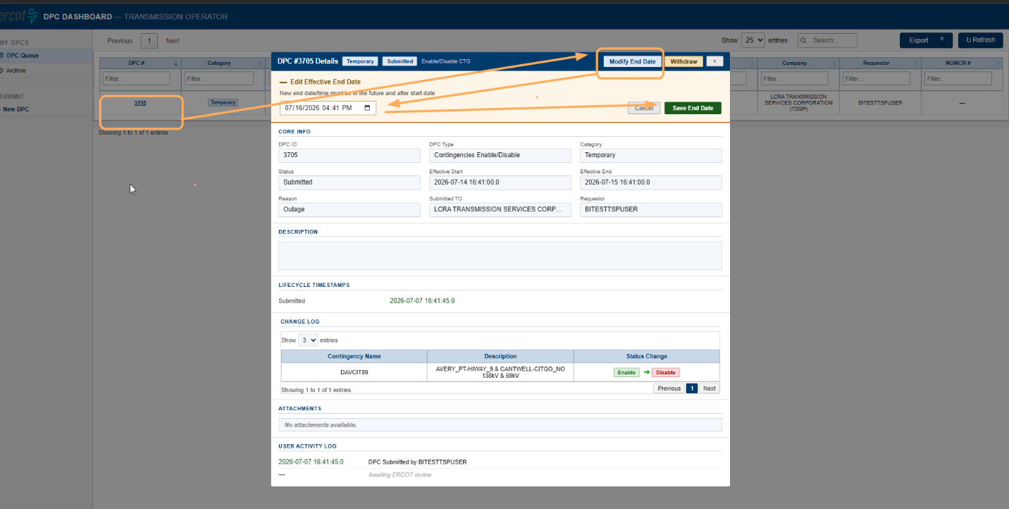
Figure 8 – DPC Detail popup showing the Modify End Date and Withdraw action buttons, with the Edit Effective End Date panel expanded

5.3 Withdrawing a DPC
You can withdraw a DPC yourself if it is still with Submitted status. This is applicable only to temporary DPCs submitted from the new UI, permanent DPCs would follow the procedures on NMMS MAGE system from where they were submitted.

- Click the DPC # hyperlink in the dashboard to open the DPC detail view.
- Click Withdraw.
- Confirm when prompted.
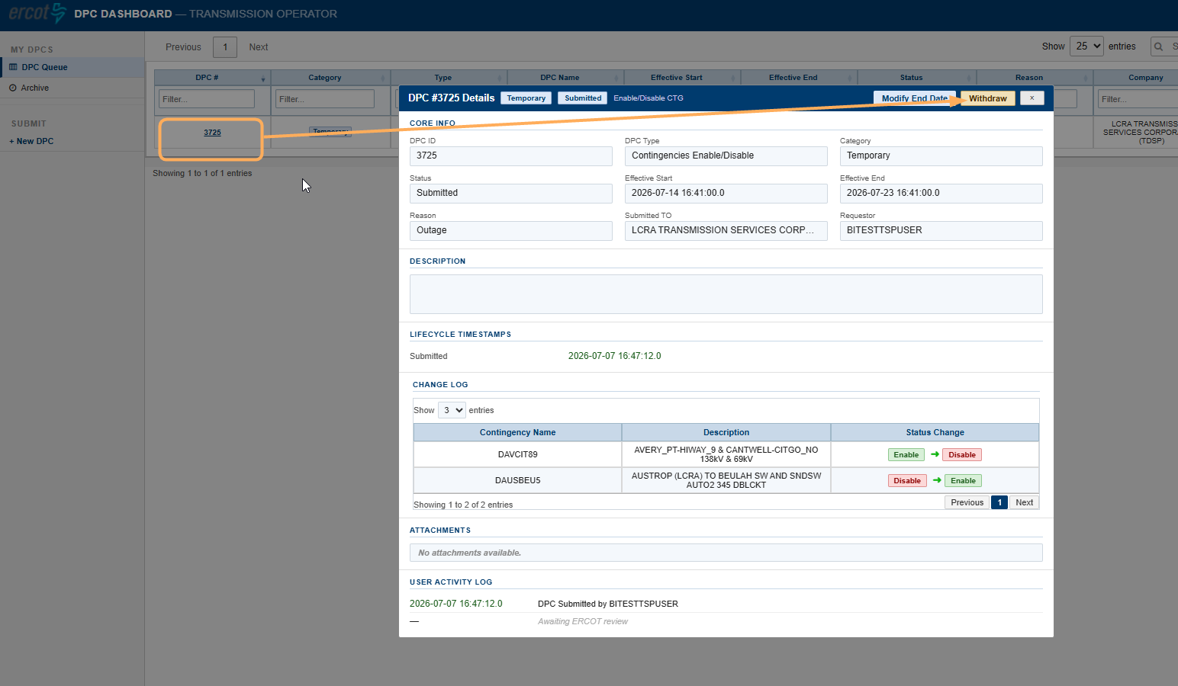
The status will update to Withdrawn on your dashboard immediately.

Note: You cannot withdraw a DPC that has already been Approved for Implementation or Implemented in Production. Contact ERCOT Operations if changes are needed at that stage.

5.4 Adding Comments to a DPC
Every DPC's Details popup includes an Add Comment button.
Use it to communicate directly about the DPC — for example, to give ERCOT reviewers additional context on field conditions, or to note a timing update. Comments are attached to the DPC record and stay with it for the life of the DPC.

5.5 Cloning a Closed DPC
If you need to resubmit a recently closed Temporary DPC — for example, the same rating or contingency change is needed again — you don't have to re-enter everything from scratch.
This is applicable only to Temporary DPCs.
- In the left navigation panel, click Archive.
- Click the DPC # of the closed DPC you want to reuse to open its Details popup.
- Click Clone (top-right of the popup, next to Add Comment).
- A new submission form opens, pre-filled with that DPC's information. Update the effective start/end dates and any other details as needed.
- Click Submit DPC.
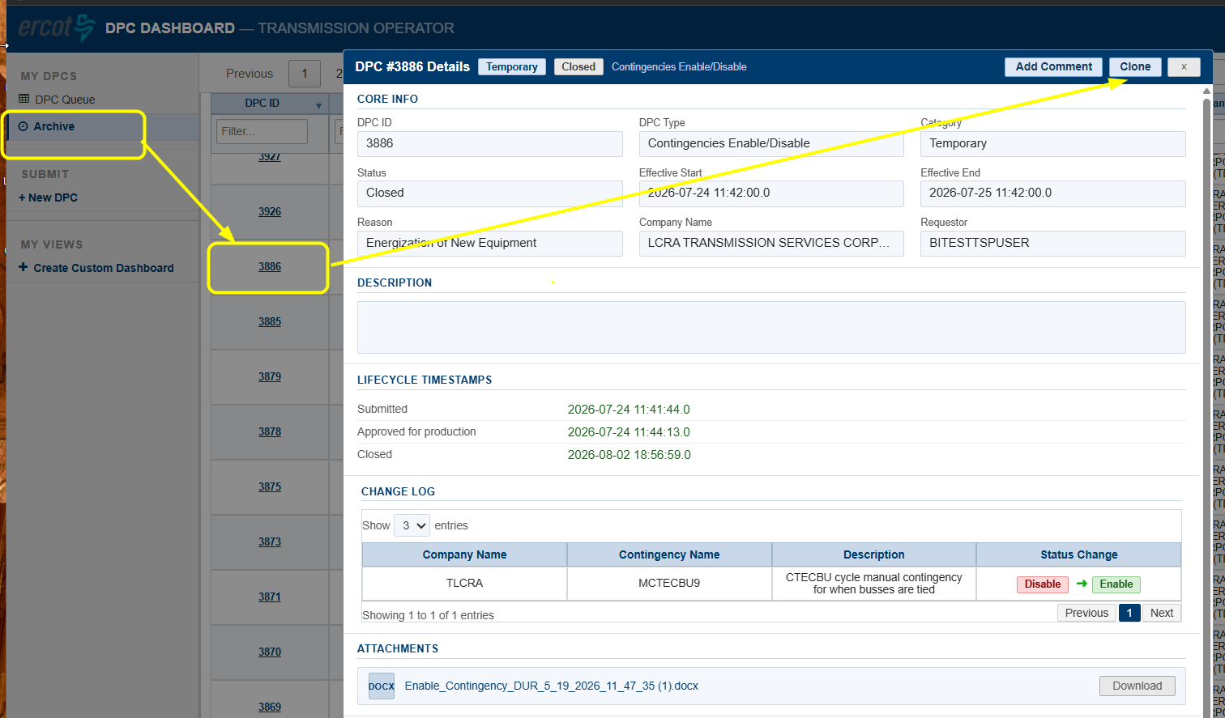
Figure 9 – DPC Details popup for a closed DPC, showing the Clone button (top-right) used to start a new pre-filled submission
Note: Cloning creates a brand-new DPC with its own new DPC ID — it does not reopen or edit the original closed DPC.

6. Quick Reference

6.1 Submission Checklist
 | Before clicking Submit DPC
☐ | DPC type selected: Static Line/Transformers Ratings or Contingencies Enable/Disable.
☐ | DPC Effective Start and End dates entered and within the maximum allowed duration.
☐ | Reason for DPC selected from dropdown.
☐ | DPC Name entered.
☐ | For Static Ratings: equipment selected and new limit values entered. Normal ≤ Emergency ≤ LoadShed ≤ RLR.
☐ | For Contingencies: contingencies selected and Future State confirmed (always the inverse of Current State).
☐ | Any supporting documents attached via Choose Files.

6.2 Where to Find Things

I want to… | Do this
Open the DPC Dashboard | Outage Scheduler → DPC Dashboard button (top-right).
Submit a new DPC | DPC Dashboard → + New DPC (left panel).
See all my active DPCs | DPC Dashboard → DPC Queue (left panel).
See completed/closed DPCs | DPC Dashboard → Archive (left panel).
Find a specific DPC | Use the Search bar (top-right of grid) or type in any column’s filter row.
Resubmit a recent closed DPC | Archive → open the DPC → Clone (top-right of Details popup) → update dates → Submit DPC. Temporary DPCs only.

6.3 Key Contacts

This email alias could be used for communication.
ERCOT DPC Support ERCOTDPCSupport@ercot.com;

Appendix: Glossary

Term | Definition
DPC | Downstream Production Change. A specific data modification applied to the ERCOT network model between weekly model loads.
Temporary DPC | A DPC that applies a short-term change (up to approximately two weeks). Does not require a Network Model update. Submitted through this DPC Dashboard.
Permanent DPC | A DPC that will be incorporated into the permanent network model. Submitted through NMMS MAGE (not this tool).
TO | Transmission Operator. The entity responsible for operating transmission facilities and submitting DPC requests.
NOMCR | Network Operations Model Change Request. The associated model change record in NMMS.
Static Rating | Thermal limit ratings for a line, transformer, or ZBR: Normal, Emergency, LoadShed, and Relay Loadability (RLR).
RLR | Relay Loadability Rating. The maximum thermal limit for relay protection purposes.
ZBR | Zero-impedance Branch. A special equipment classification in the ERCOT network model.
LN | Line. Equipment type code used in the submission form.
XF | Transformer. Equipment type code used in the submission form.
EMS | Energy Management System. ERCOT’s real-time system for grid operations.
MMS | Market Management System. ERCOT’s system for market operations.
Verified | A DPC status confirming ERCOT has checked that the DPC was implemented correctly in EMS and MMS.
Reverted | A DPC status indicating a Temporary DPC has been reverted in EMS and MMS back to its original model state/values, following the effective end date and the TSP’s end-of-work call.
Pending Reversion | A DPC status indicating the effective end date/time has passed but the DPC has not yet been reverted — typically because ERCOT is still waiting on the TSP’s end-of-work call.
Clone | An action available on a closed Temporary DPC that opens a new, pre-filled submission form based on that DPC. Submitting it creates a brand-new DPC with its own DPC ID.

