
RTOC: Instruction to Launch and User Guide for RTOC Communications Application
External User Guide
Version 1
Key Takeaway:
External guide detailing basic functionality of RTOC communication page.

Document Revisions
Date | Version | Description | Author(s)
06/22/2026 | 0 | First draft | Christopher Morton
06/22/2026 | 1 | Added SOL Violations Monitor | Subhan Shaik

Sign-Off
Title | Name | Date

Title | Name | Date

Table of Contents
1. External User Guide 1
2. New Message, Reply, and Export 3
3. SOL Violations Monitor 5

External User Guide
Login and landing page
- Market users will first login to MIS RTOC with their MIS certificate
- https://mis.ercot.com/rtocweb/logon.do
- They will be prompted with a window to select their certificate, choose the appropriate one
- Please use a Google Chrome browser for functionality

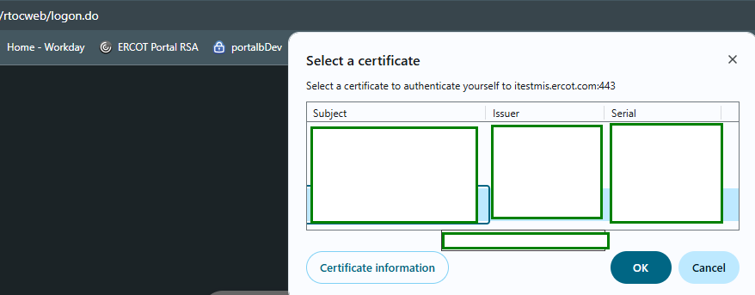
- When logged in, users will see this landing page.
- https://mis.ercot.com/rtocweb/logon.do
- We are aware that currently the logout functionality is not working for MPs, the workaround is to close browser and relaunch
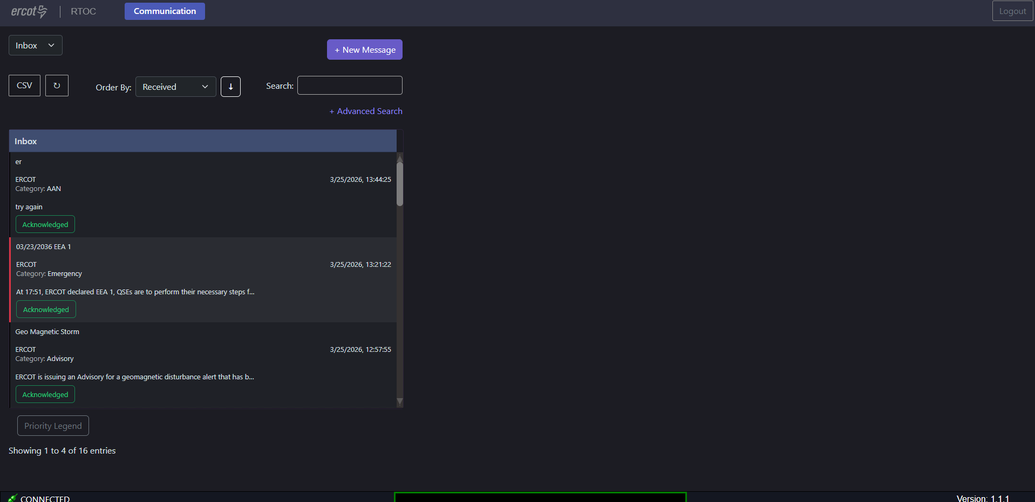
- On this page you can view past messages in your inbox, switch to your sent message inbox, and of course send a new message.
  - In your inbox, you will see notifications for new messages as well as the amount. The count of new messages will clear when the messages are read/acknowledged.
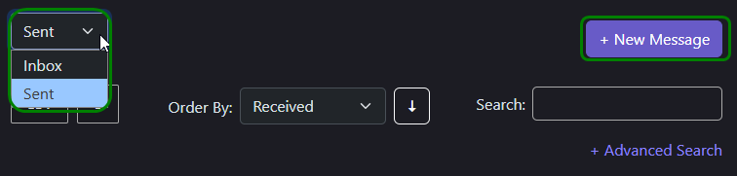

New Message, Reply, and Export
- To send a new message, you simply click on the new message button and fill out the message box as you would an email.
  - When sending a new message, you can use freeform or a template message
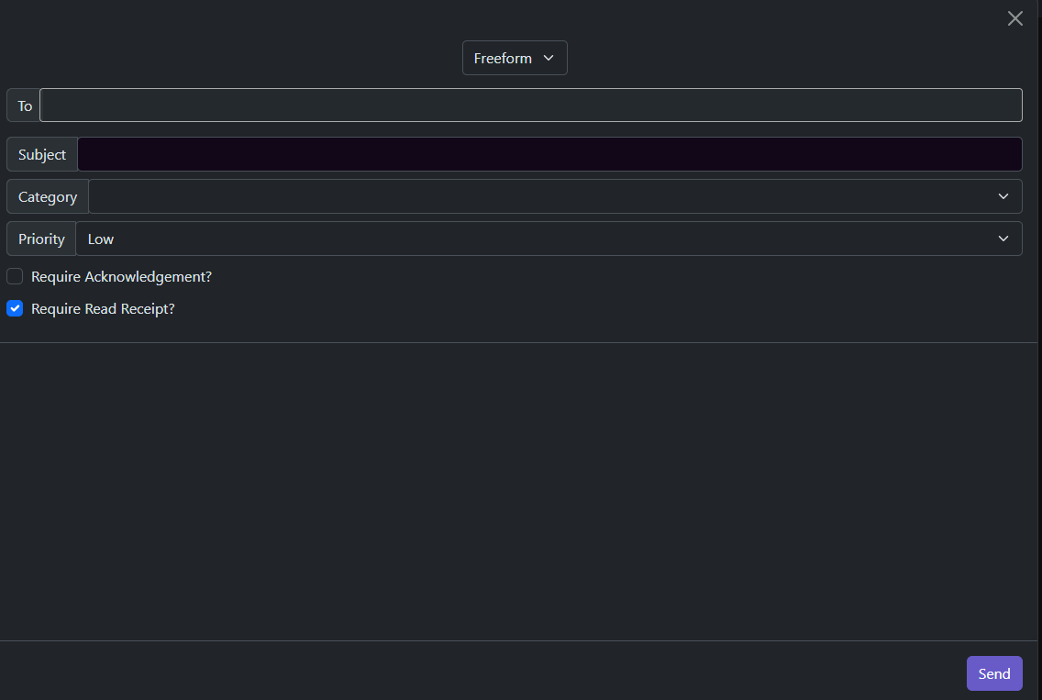
  - We are aware of an issue that allows you to type an infinite amount of characters into the inbox, but it will fail if you go past 2000 characters

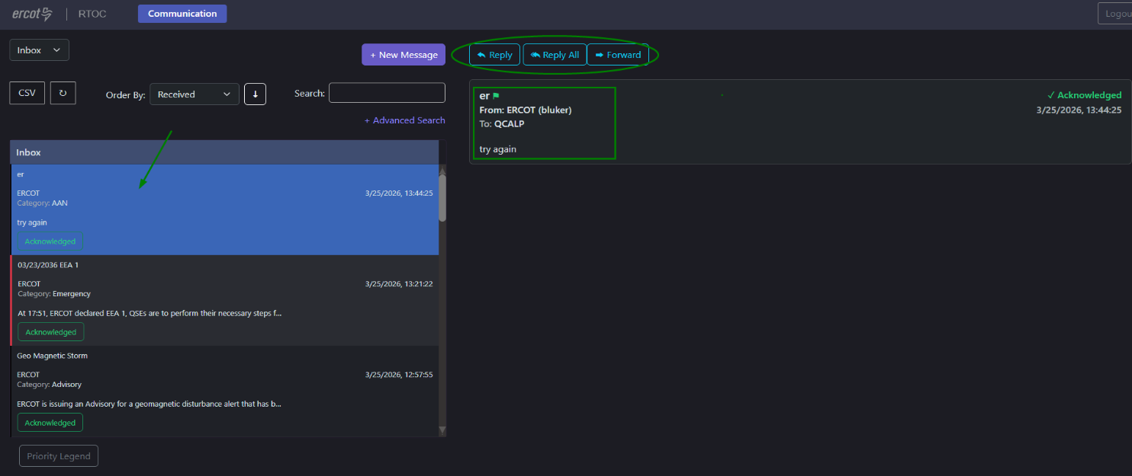
- In addition to sending new messages, you can reply to messages in your inbox by simply clicking on the reply to options when the message is selected.

- Finally, you can export your inbox by clicking on the CSV button below. In addition, you can narrow down the results in your inbox by using the search and advanced search tool.
  - We are aware of an issue currently impacting CSV exporting for MPs
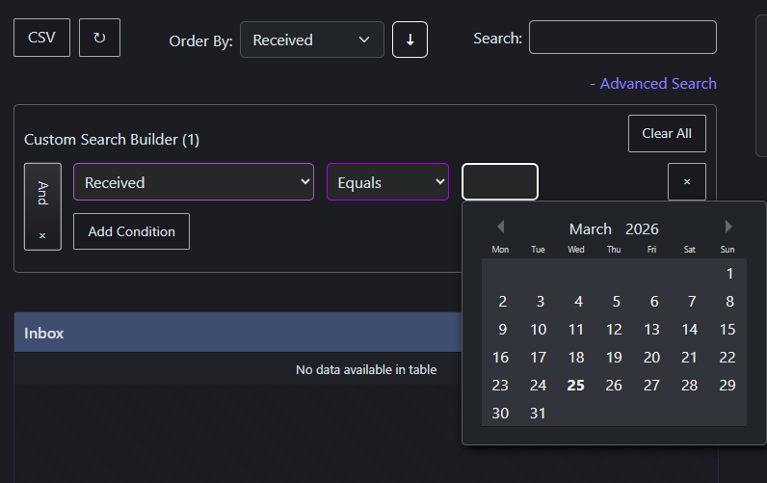
  - In addition we are aware of the advanced search tool not working for ‘ACK Required’ filter

SOL Violations Monitor
- Click on the RTCA tab on the top of the display to navigate to SOL Violation Monitor display
- In Default view, current SOL violations from the latest RTCA run, are listed in 4 tabs namely Branch Exceedances, Voltage Exceedances, Phase Angle limitations and GTL Exceedances.
- Each tab contains all the details of violations with search, sort, column visibility selection and export capabilities.
- History view is in development phase.
