DPC Dashboard
Transmission Operator User Guide
Submitting Temporary DPCs & Monitoring Your Dashboard

Document Version | Draft 1.0
Audience | Transmission Operators (TOs)
Scope | DPC Submission Form and TO Dashboard View only
Classification | ERCOT Public

Table of Contents
Table of Contents 2
1. Introduction 3
1.1 Purpose of This Guide 3
1.2 What Is a DPC? 3
1.3 Temporary DPC Types Available to TOs 3
2. Accessing the DPC Dashboard 4
2.1 Launching from the Outage Scheduler 4
3. The DPC Dashboard 5
3.1 Dashboard Layout 5
3.2 Dashboard Columns 5
3.3 DPC Queue vs Archive 6
3.4 DPC Status Reference 6
4. Submitting a DPC 7
4.1 Starting a New Submission 7
4.2 General Information Section 8
4.3 DPC Data Section 8
4.4 Submitting a Static Line/Transformers Rating DPC 9
4.4.1 Line Rating Submission 9
4.4.2 Transformer Rating Submission 10
4.5 Submitting a Contingencies Enable/Disable DPC 11
4.6 Notes and Attachments 12
4.7 Submitting the Form 12
5. Quick Reference 13
5.1 Submission Checklist 13
5.2 Where to Find Things 13
5.3 Key Contacts 13
Appendix: Glossary 14

1. Introduction

1.1 Purpose of This Guide
This guide explains how Transmission Operators (TOs) use the DPC Dashboard to:
- Submit temporary Downstream Production Change (DPC) requests to ERCOT.
- Track the status of submitted DPCs through the TO Dashboard.

1.2 What Is a DPC?
A Downstream Production Change (DPC) is a request to make a specific change to the ERCOT network model between the regular weekly model loads. TOs submit DPCs when field conditions require a temporary update to model data — for example, when thermal limits on a line need to be temporarily reduced, or a contingency needs to be disabled during field work.

Scope: This tool handles Temporary DPCs submitted by TOs only. Permanent DPCs continue to be submitted through the NMMS MAGE system as before.

1.3 Temporary DPC Types Available to TOs

DPC Type | Description
Static Line/Transformers Ratings | Temporarily update Normal, Emergency, LoadShed, or Relay Loadability (RLR) limits for one or more lines, transformers, or ZBRs.
Contingencies Enable/Disable | Temporarily enable or disable one or more contingencies in the network model.

2. Accessing the DPC Dashboard

2.1 Launching from the Outage Scheduler
The DPC Dashboard is accessed directly from the Outage Scheduler — the same portal you already use for outage submissions. No separate login is required.

- Log in to the ERCOT Market Portal using your existing credentials.
- Open the Outage Scheduler application.
- In the top-right corner of the Outage Scheduler, click the DPC Dashboard button.

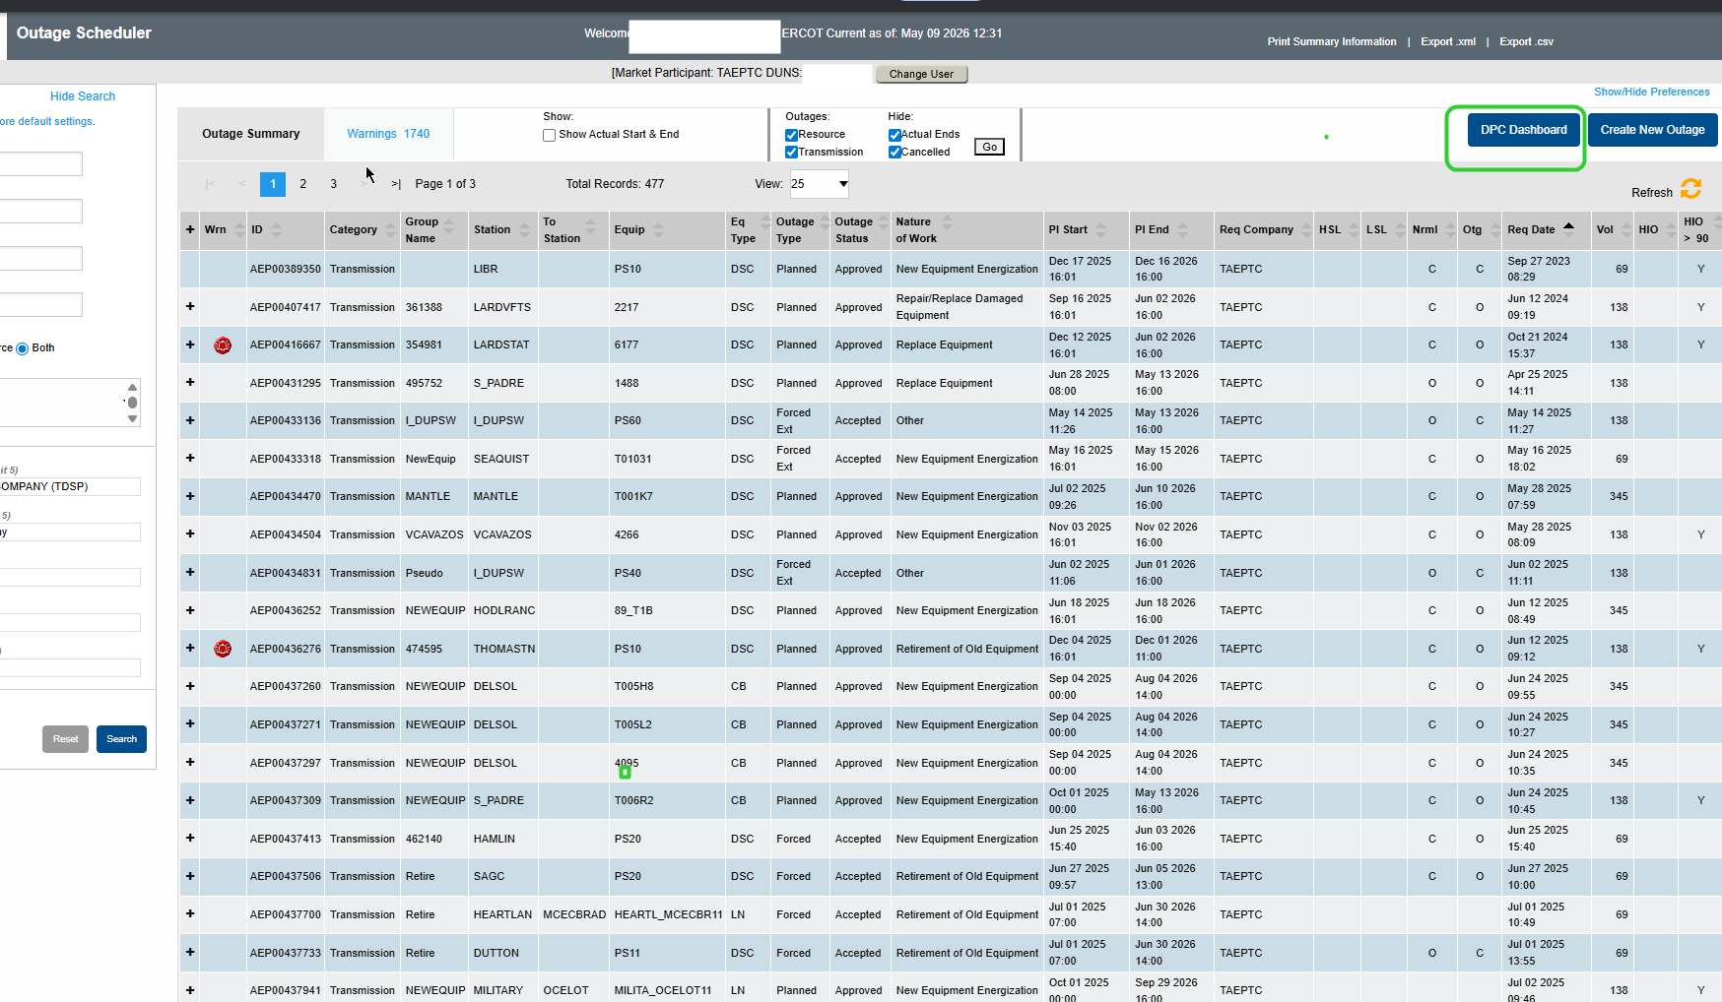
Figure 1 – The DPC Dashboard button (top-right) in the Outage Scheduler
Note: Your current Market Participant and DUNS number are displayed at the top of the Outage Scheduler page. The DPC Dashboard will use the same company context automatically.

3. The DPC Dashboard

3.1 Dashboard Layout
Clicking DPC Dashboard opens the DPC Queue view. The screen is divided into two areas:

- Left panel – Navigation: DPC Queue (active submissions), Archive (historical records), and the + New DPC button to start a new submission.
- Main grid – A table listing all your DPC records with columns for key details and current status.

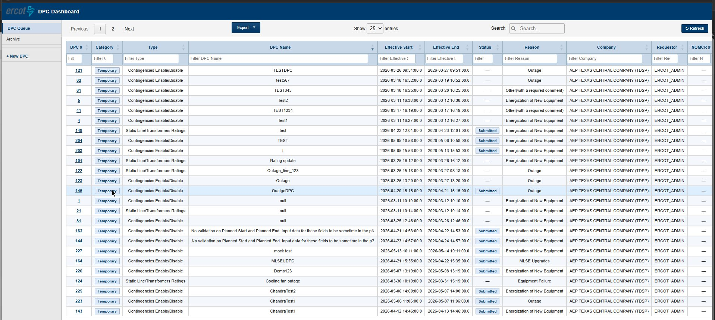
Figure 2 – DPC Dashboard showing the DPC Queue with submitted records

3.2 Dashboard Columns

Column | Description
DPC # | Unique identifier assigned to each DPC. Click the number to open the full DPC detail view.
Category | Temporary – for DPCs submitted through this portal. Permanent – for DPCs submitted from NMMS MAGE.
Type | Static Line/Transformers Ratings or Contingencies Enable/Disable.
DPC Name | The name you entered for the DPC at submission.
Effective Start | The effective start date and time of the DPC.
Effective End | The effective end date and time of the DPC.
Status | Current processing status. See Section 3.5 for full definitions.
Reason | The reason category selected at submission (e.g., Outage, Equipment Failure).
Company | Your requesting company name.
Requestor | The user ID that submitted the DPC.
NOMCR # | Applicable only for Permanent DPCs from MAGE. This field will be blank for Temporary DPCs submitted from this portal.

3.3 DPC Queue vs Archive

View | What it shows
DPC Queue | Your active and recently submitted DPCs. This is the default view when you open the dashboard.
Archive | Historical DPCs that have completed the full lifecycle: Closed, Rejected, or Withdrawn.

3.4 DPC Status Reference
The Status column shows a color-coded badge reflecting where the DPC is in the review and implementation process.

Status | DPC Category | What it means for you | Action needed?
Submitted | Temporary | For Temporary DPCs — submitted from this portal and awaiting approval by ERCOT Shift Engineers for production implementation. | Monitor
Received | Permanent | For Permanent DPCs — ERCOT Network Model Coordinators have accepted and reviewed your submission. | Monitor
Validated | Permanent | For Permanent DPCs – ERCOT Network Modeling Engineers have modeled and validated the DPC and ready for ERCOT Shift engineers approval. | Monitor
Approved for Implementation | Temporary/Permanent | Shift Engineers have approved the DPC for production implementation. | Monitor
Rejected | Temporary/Permanent | The DPC did not meet requirements. A reason is provided. You may modify and resubmit.  Permanent DPCs need to be updated in MAGE only | Optional – modify & resubmit
Withdrawn | Temporary | You have withdrawn this DPC.  Permanent DPCs need to withdraw from MAGE only. | Optional – modify & resubmit
Closed | Temporary/Permanent | The DPC lifecycle is complete. No further action required. | No

4. Submitting a DPC

4.1 Starting a New Submission
From the DPC Dashboard, click + New DPC in the left panel.

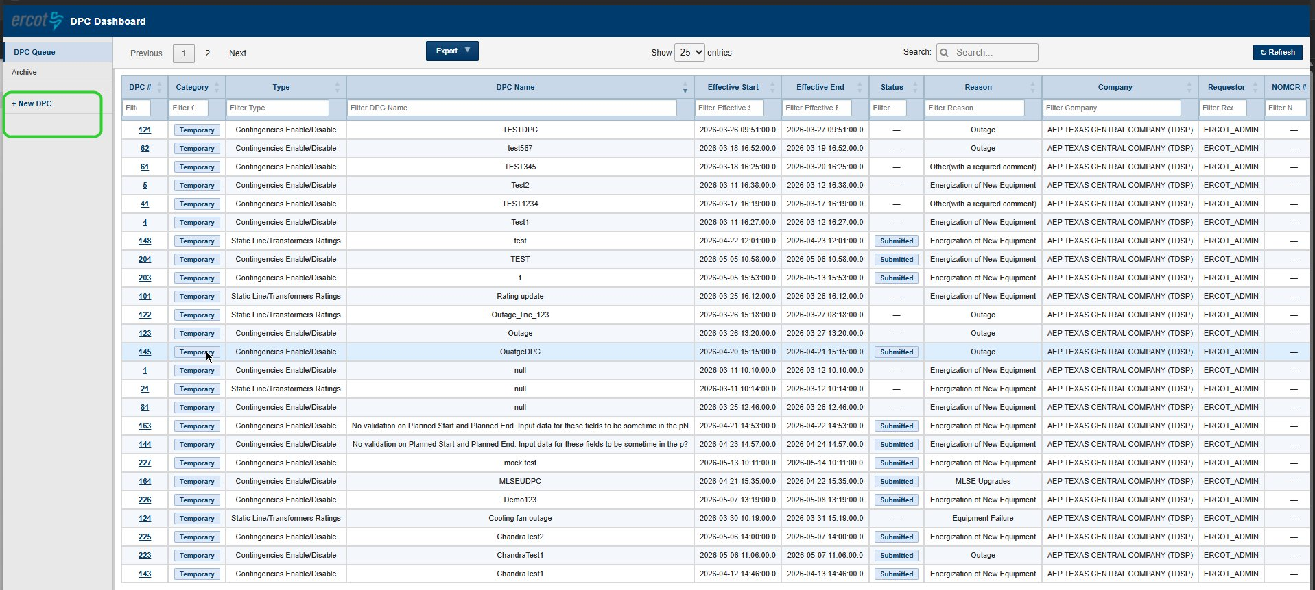
Figure 3 – The + New DPC button in the left navigation panel
The Create Downstream Production Changes Request form opens. The first screen asks you to select your DPC type.

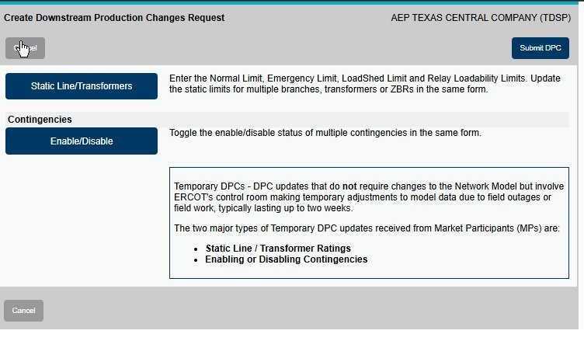
Figure 4 – DPC type selection screen
Select the appropriate type:
- Click Static Line/Transformers to submit a temporary rating change for a line, transformer, or ZBR.
- Click Enable/Disable under Contingencies to temporarily enable or disable contingencies.

Note: The information panel on the right of this screen confirms that Temporary DPCs do not require changes to the Network Model, but involve ERCOT’s control room making temporary adjustments to model data due to field outages or field work, typically lasting up to two weeks.

4.2 General Information Section
After selecting a DPC type, the submission form opens. The General Information section at the top is automatically populated from your account and cannot be edited:

- Request Date – today’s date and time (auto-filled).
- Requestor – your ERCOT user ID (auto-filled).
- Requesting Company – your company name (auto-filled).
- Primary Phone and Secondary Phone – contact numbers from your account profile.

4.3 DPC Data Section
Fill in the following fields in the DPC Data section:
Field | What to enter | Notes
Category | Automatically set to Temporary DPC. | Read-only.
Request Type | Automatically set based on your type selection. | Read-only.
DPC Effective Date – Start | Click the calendar icon to select the date and time the change should take effect. | Required.
DPC Effective Date – End | Click the calendar icon to select the date and time the change should expire. | Required. Must be within the maximum allowed duration.
Reason for DPC | Select from dropdown: Outage, Equipment Failure, Energization of New Equipment, As-build Corrections, MLSE Upgrades, Other (with required comment). | Required.
DPC Name | Enter a short descriptive name (e.g., “Line 17T522 rating update”). | Required. Identifies the DPC in the dashboard.

4.4 Submitting a Static Line/Transformers Rating DPC
Use this type when field conditions require a temporary change to thermal limits on a line, transformer, or ZBR.

4.4.1 Line Rating Submission
After completing the DPC Data section, the equipment selection area appears:

- The Equipment Type field shows LN (Line). Type the equipment name in the Equipment field to search for your asset.
- Once selected, the asset appears in the Selected Equipment table with editable rating columns:
  - Normal Rating – enter the new value. Current value is shown below in grey.
  - Emergency Rating – enter the new value. Current value is shown below in grey.
  - LoadShed Rating – enter the new value. Current value is shown below in grey.
  - RLR Rating (Relay Loadability) – enter the new value. Current value is shown below in grey.
- You can add multiple lines to the same submission — each appears as a new row.
- To remove an item, click the red ✖ button in the Remove column.

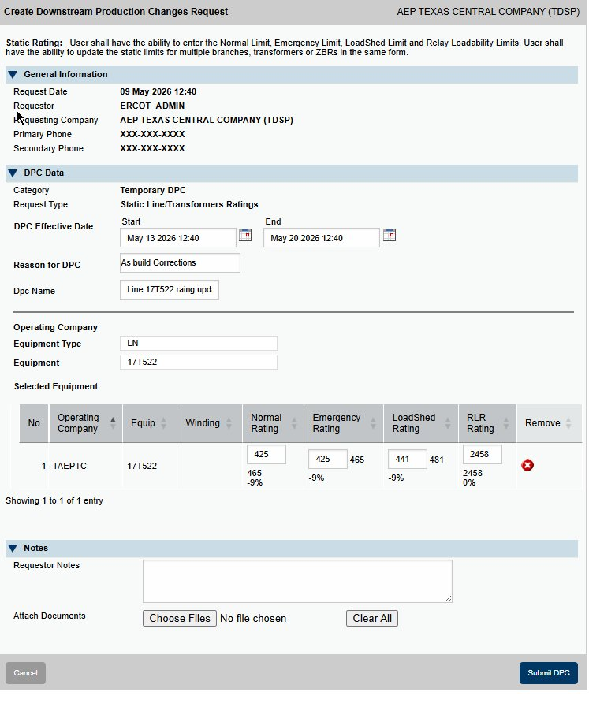
Figure 5 – Static Rating form for a line (LN) showing new and current (grey) limit values
Validation rule: Normal Rating ≤ Emergency Rating ≤ LoadShed Rating ≤ RLR Rating. If this rule is violated when you click Submit DPC, an error will be shown. Correct the values before resubmitting.

If the change in any rating exceeds a system-configured threshold, a popup will appear comparing old and new values before the submission is processed. Review and confirm or adjust before proceeding.

4.4.2 Transformer Rating Submission
The transformer rating form works the same as the line form, with one additional field: Winding Name.

- Set Equipment Type to XF (Transformer).
- Enter the Equipment name (e.g., ALICE_69A1).
- A Winding Name field appears — select the winding identifier (e.g., 138_69A1_H).
- Enter the new rating values in the Selected Equipment table as described above.

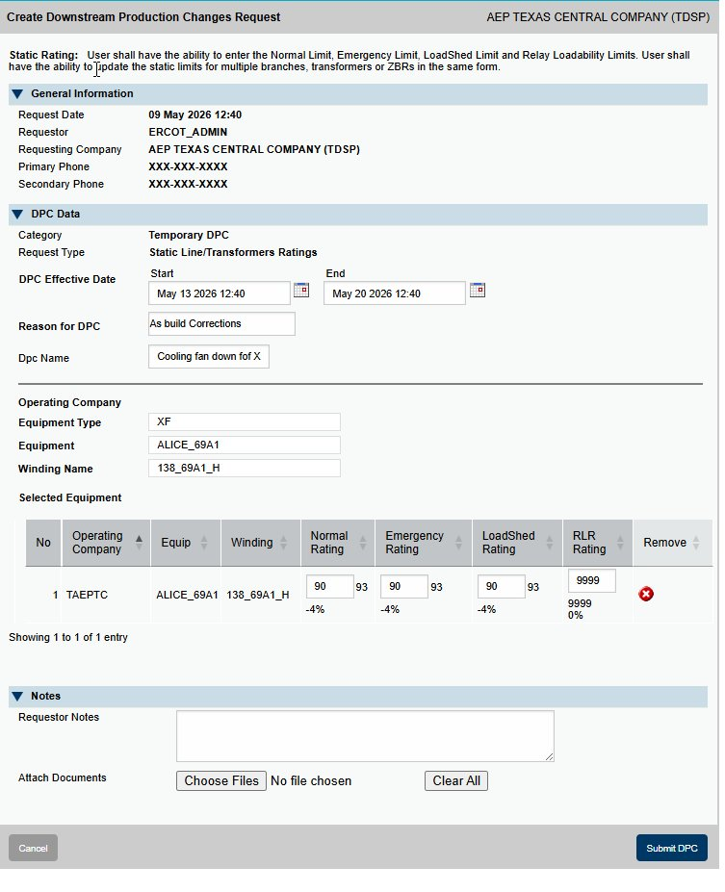
Figure 6 – Static Rating form for a transformer (XF) showing the Winding Name field
Coming in a future release: The Winding Name field is currently a manual entry. A future release will remove this field and auto-populate the winding name based on the selected transformer.

4.5 Submitting a Contingencies Enable/Disable DPC
Use this type when field conditions require you to temporarily enable or disable one or more contingencies.

- Complete the DPC Data section (dates, reason, DPC name) as described in Section 4.3.
- In the Operating Company field, confirm your company name is selected.
- In the Contingency field, type the contingency name and select it from the list.
- The selected contingency appears in the Selected Contingency table showing:
  - Contingency ID – the contingency identifier.
  - Current State – the existing status in the model (Enabled or Disabled).
  - Future State – the new status after the DPC is applied. This is always the inverse of the current state as per the model.
  - Assoc Equip – click View to see associated equipment details.
- Repeat to add multiple contingencies to the same submission.
- To remove a contingency, click the red ✖ button.

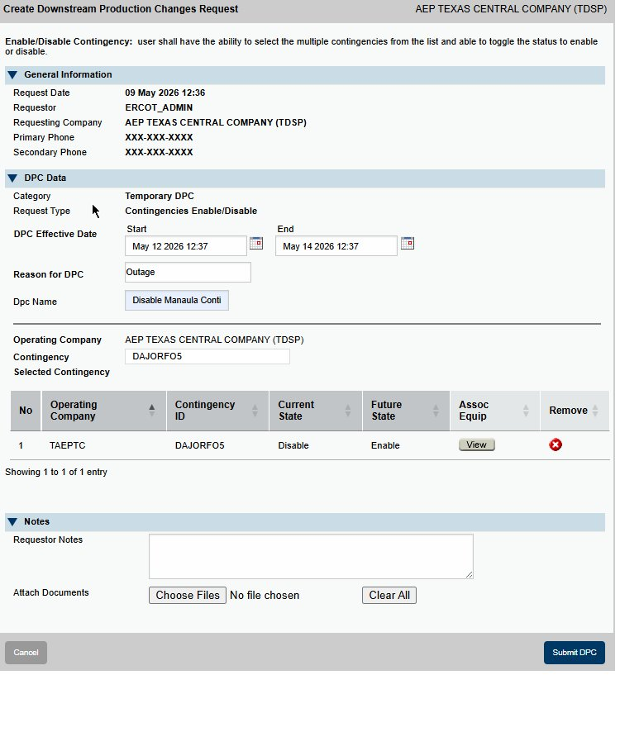
Figure 7 – Enable/Disable Contingency form showing a selected contingency with Current State (Disable) and Future State (Enable)

4.6 Notes and Attachments
At the bottom of both form types is a Notes section:

- Requestor Notes – Enter any additional context or instructions for ERCOT reviewers. Free-text, no character limit.
- Attach Documents – Click Choose Files to attach supporting documents. Multiple files can be attached. Click Clear All to remove all attachments.

Important: For all temporary DPC submissions, attach your completed DPC Attestation Form and any supporting documentation (e.g., field orders, engineering justifications) that will help ERCOT Control Room review and approve the change. Thorough documentation speeds up the review process.

4.7 Submitting the Form
- Review all entries in the form.
- Verify that your Effective Start and End dates are correct.
- Confirm your documents are attached.
- Click Submit DPC (blue button, bottom-right of the form).

If any validation errors are found, they will be displayed and must be corrected before the submission is accepted.

On successful submission:
- A unique DPC # is assigned to your record.
- The DPC appears in your DPC Queue on the dashboard.

To cancel without submitting: Click the Cancel button at the bottom-left of the form at any time to discard the entry and return to the dashboard.

5. Quick Reference

5.1 Submission Checklist
 | Before clicking Submit DPC
☐ | DPC type selected: Static Line/Transformers Ratings or Contingencies Enable/Disable.
☐ | DPC Effective Start and End dates entered and within the maximum allowed duration.
☐ | Reason for DPC selected from dropdown.
☐ | DPC Name entered.
☐ | For Static Ratings: equipment selected and new limit values entered. Normal ≤ Emergency ≤ LoadShed ≤ RLR.
☐ | For Contingencies: contingencies selected and Future State confirmed (always the inverse of Current State).
☐ | DPC Attestation Form and any supporting documents attached via Choose Files.

5.2 Where to Find Things

I want to… | Do this
Open the DPC Dashboard | Outage Scheduler → DPC Dashboard button (top-right).
Submit a new DPC | DPC Dashboard → + New DPC (left panel).
See all my active DPCs | DPC Dashboard → DPC Queue (left panel).
See completed/closed DPCs | DPC Dashboard → Archive (left panel).
Find a specific DPC | Use the Search bar (top-right of grid) or type in any column’s filter row.

5.3 Key Contacts

This email alias could be used for communication.
ERCOT DPC Support ERCOTDPCSupport@ercot.com;

Appendix: Glossary

Term | Definition
DPC | Downstream Production Change. A specific data modification applied to the ERCOT network model between weekly model loads.
Temporary DPC | A DPC that applies a short-term change (up to approximately two weeks). Does not require a Network Model update. Submitted through this DPC Dashboard.
Permanent DPC | A DPC that will be incorporated into the permanent network model. Submitted through NMMS MAGE (not this tool).
TO | Transmission Operator. The entity responsible for operating transmission facilities and submitting DPC requests.
NOMCR | Network Operations Model Change Request. The associated model change record in NMMS.
Static Rating | Thermal limit ratings for a line, transformer, or ZBR: Normal, Emergency, LoadShed, and Relay Loadability (RLR).
RLR | Relay Loadability Rating. The maximum thermal limit for relay protection purposes.
ZBR | Zero-impedance Branch. A special equipment classification in the ERCOT network model.
LN | Line. Equipment type code used in the submission form.
XF | Transformer. Equipment type code used in the submission form.
EMS | Energy Management System. ERCOT’s real-time system for grid operations.
MMS | Market Management System. ERCOT’s system for market operations.
Attestation Form | A document the TO attaches to confirm the accuracy and necessity of the requested change. Required for all temporary DPC submissions.

