

System Operations Test Environment (SOTE)
Outage Studies
Version 1.2

Document Revisions
Date | Version | Description | Author(s)
09/25/2024 | 1.0 | First draft – Doc created, with information on steps for login , loading savecases for SOTE studies and importing outages | ERCOT
10/07/2024 | 1.1 | Second draft – Document updated for steps involved in importing Resource plan into SOTE studies | ERCOT
11/25/2024 | 1.2 | Third draft – Updated steps for exporting resource plan/load plan and added steps for importing them. | ERCOT

Table of Contents
1. Overview 1
2. Access SOTE 1
3. STNET Displays and Outage Study Cases 2
3.1. STNET Displays 2
3.2. Outage Study Cases 3
4. Outage Scheduler Interface 4
5. Editing and Importing Resource Plan/Load Plans 5

Overview
The System Operations Test Environment (SOTE) is an environment of the ERCOT Energy Management System (EMS) where the Network Operations Model and the results of the Real-Time State Estimator (SE) are available for review and analysis within five minutes of the Real-Time solution. This environment is provided as a tool to Transmission Service Providers (TSPs) to perform power flow studies, contingency analyses, and validation of SE results.
SOTE provides TSPs ability to perform studies like ERCOT Outage coordinators. This document would share details about the 60 day and 90 days ahead outage study cases.

Access SOTE
- Login to ERCOT Citrix using https://gateway.ercot.com/
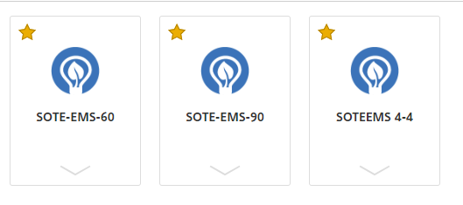
SOTEEMS 4-4 – Provides access to Realtime one lines to run studies using cases generated out of latest last SE results.
SOTE-EMS-60 – Provides access to one lines corresponding to 60 day ahead outage study cases.
SOTE-EMS-90 – Provides access to one lines corresponding to 90 day ahead outage study cases.
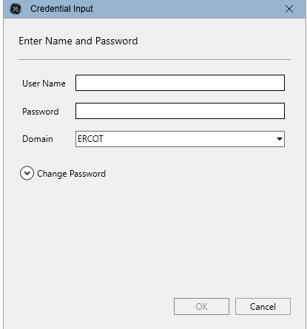
Login to EMS by inputting your credentials.

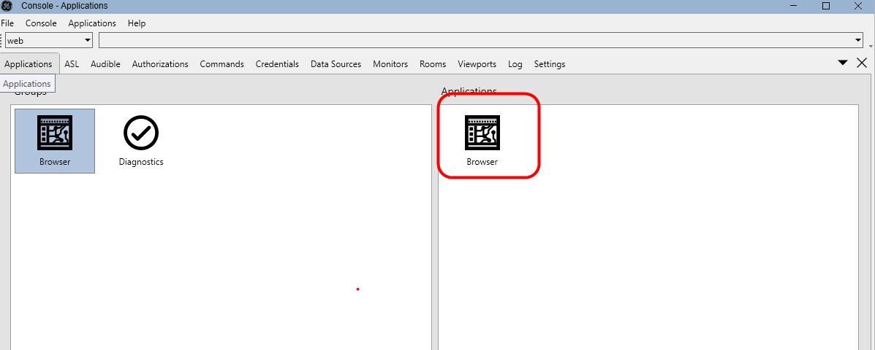
Double click the “browser: icon under “Applications”

STNET Displays and Outage Study Cases

STNET Displays
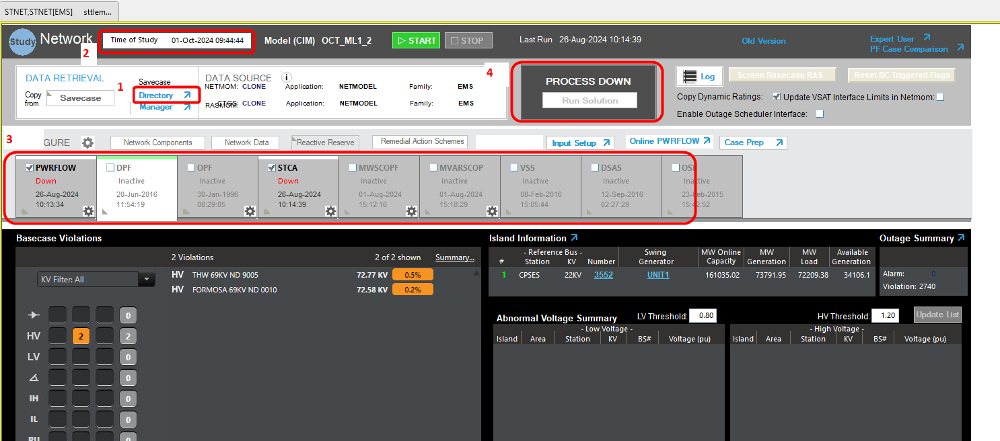

This screen is viewed by pressing the gauge icon on the toolbar
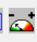

- Savecase Directory, This will pop-up a display where user can load the savecases that will be analyzed.
- Shows the time that the currently loaded save case is referencing.
- Current application that will be run in STNET
- Run Solution button, which starts the applications that are selected. Also shows current status of applications being run.

Outage Study Cases

User will be able to see the Future Outage study cases that will be available during 1st week of each month.

Case Naming:
As shown in screen shot, these are cases generated on AUG_ML1 model.

60 Day Outage Study case based on AUG_ML1- OCT_ML1_2_AUG_OE60_SOTE
90 Day Outage Study case based on AUG_ML1- NOV_ML1_2_AUG_OE90_SOTE

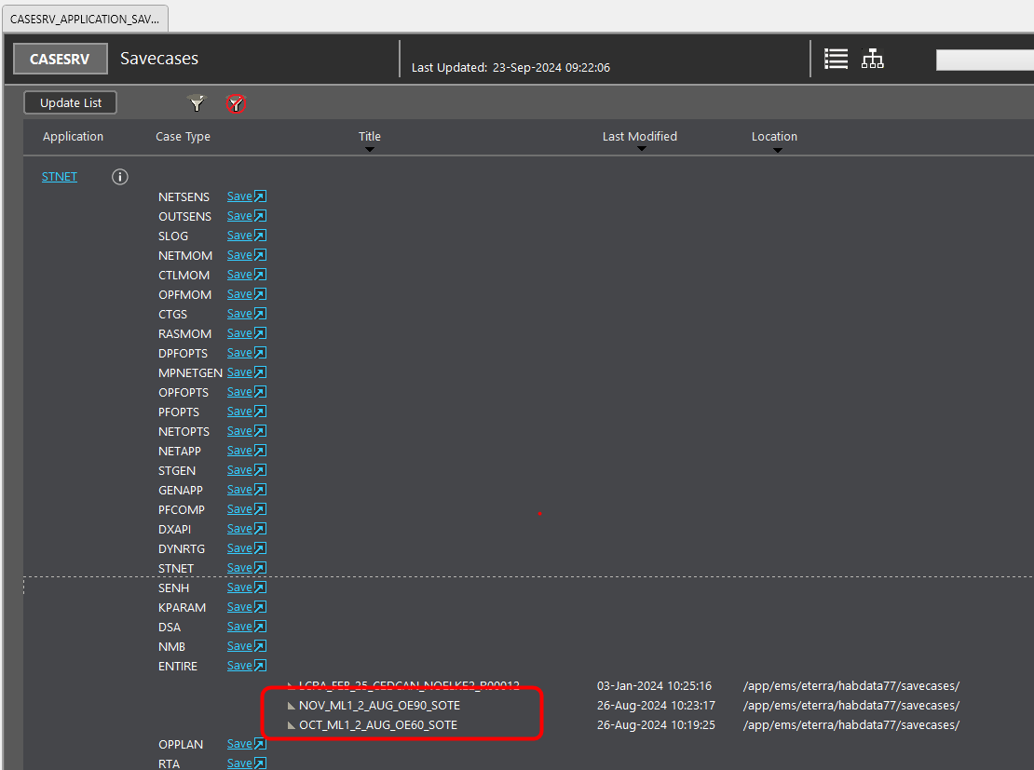

Outage Scheduler Interface

By selecting the flag shown below and running the STNET sequence would import all outages and get applied based on the study time.

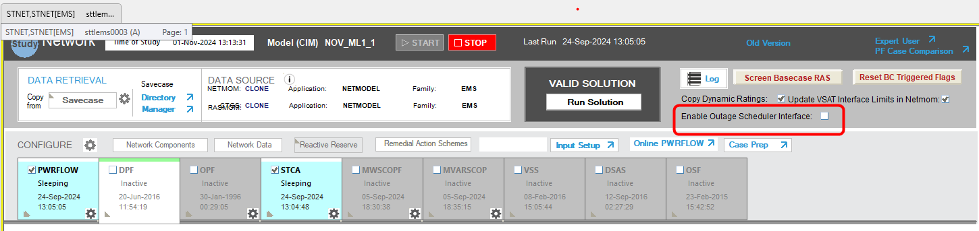

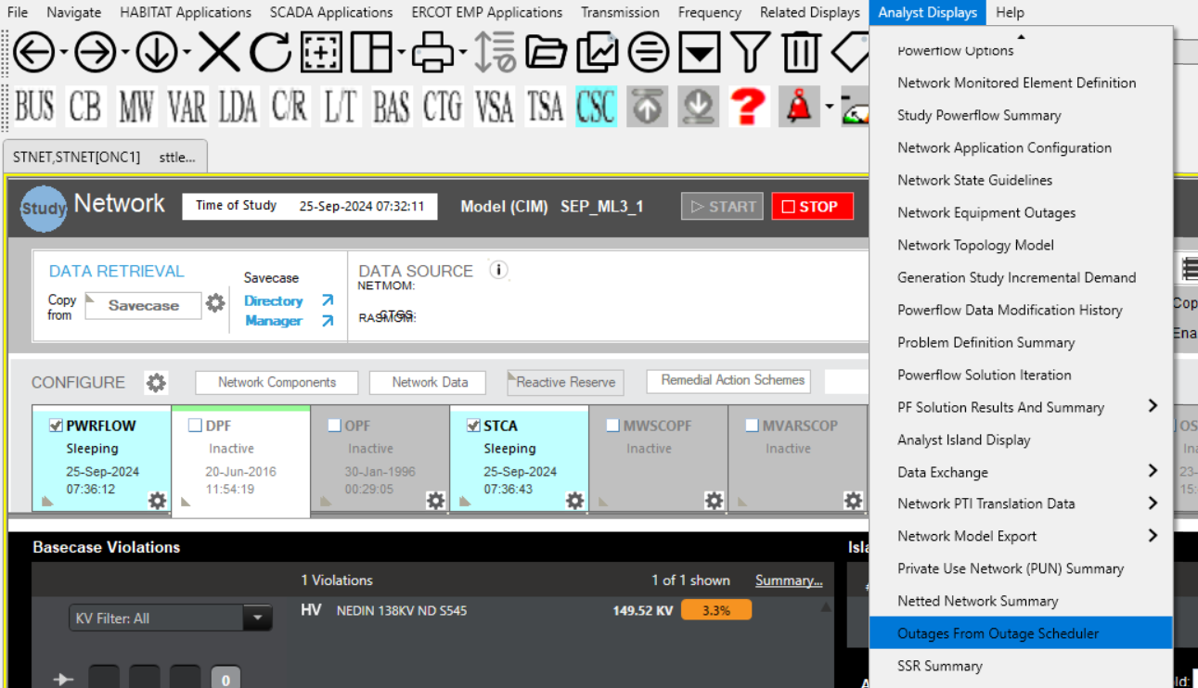
Navigating to Outages display:

Users can Revert/Implement Outages from this display for their studies.
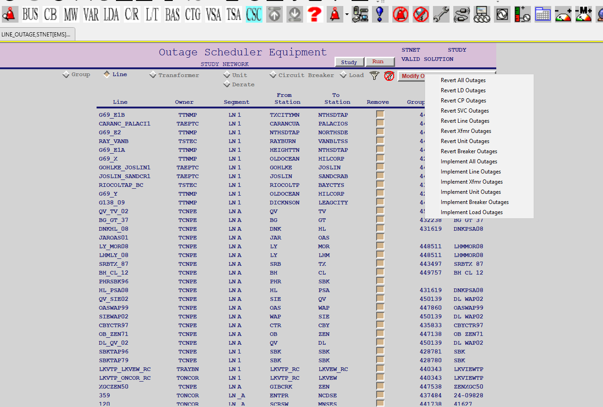

Editing and Importing Resource Plan/Load Plans

- Following folder on Citrix gateway is the location where the files exported and to be imported can be accessed.

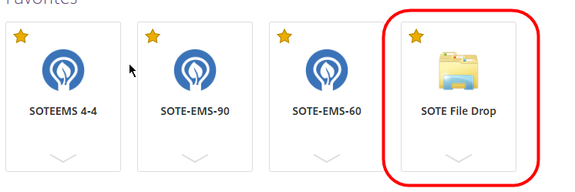

- For exporting Resource Plan(Unit Output) or Load Plan (Load Output) can be done with following steps.
  - Click on the Case Prep that would launch a pop-up.
  - Click on “Export Unit Output” or “Export Load Output” button on the pop-up for exporting resource plan or load plan respectively from current case.
  - Status “STNEXPORTUNMW Done” and “STNEXPORTLDDATA Done” would be shown for successful export.

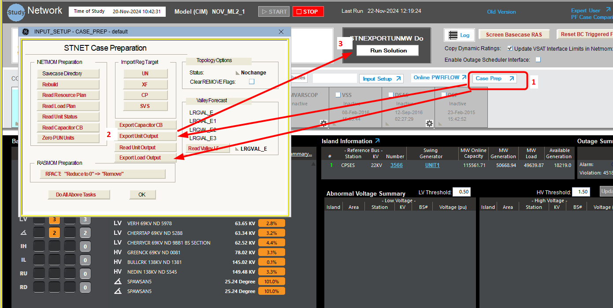

- Based on user clone from where the files were exported, following files would be found.

User clone name can be found on the Webfg as shown below.
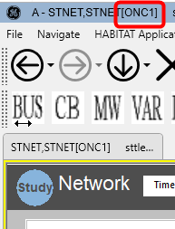

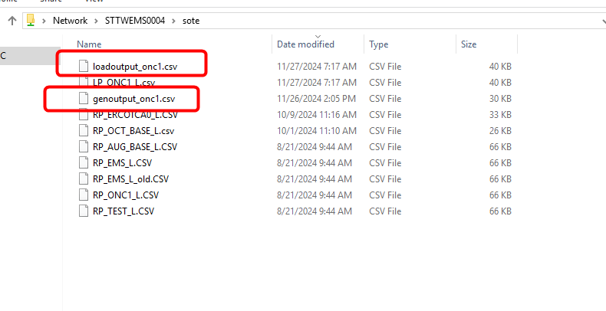
- Updating and Importing the Resource Plan

- Copy the exported “genoutput_onc1.csv” locally. Make your updates and copy the updated file with the same name to Citrix folder
- Click on the Case Prep that would launch a pop-up.
- Click on “Read Unit Output” button on the pop-up.
- Status “STNREADUNMW Done” would be shown for successful completion of resource plan being updated to the study.

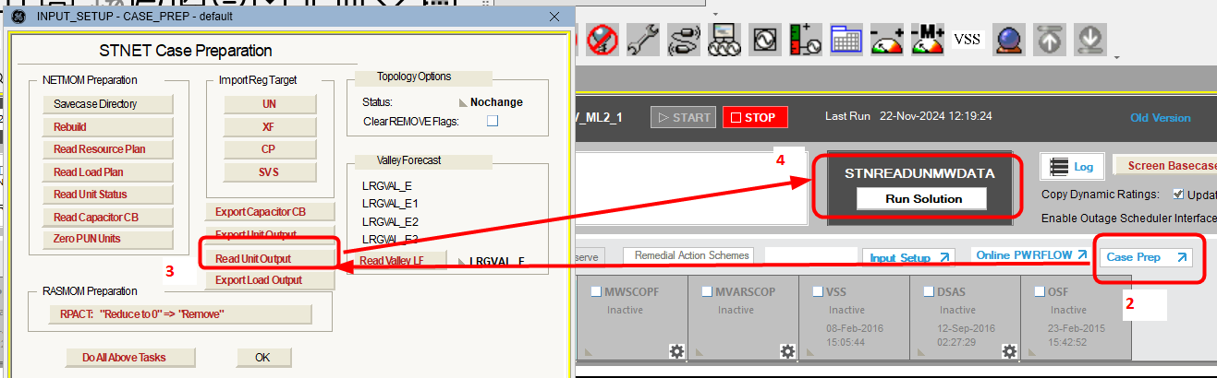

- Updating and Importing the Load Plan

- Considering impacts of load scaling and to avoid unintentional changes in the file imported. We recommend either manually updating the ERCOT system load or individual loads. The below figures show how to modify either the system load or individual loads. If you still wish to import a load plan please follow the next steps.
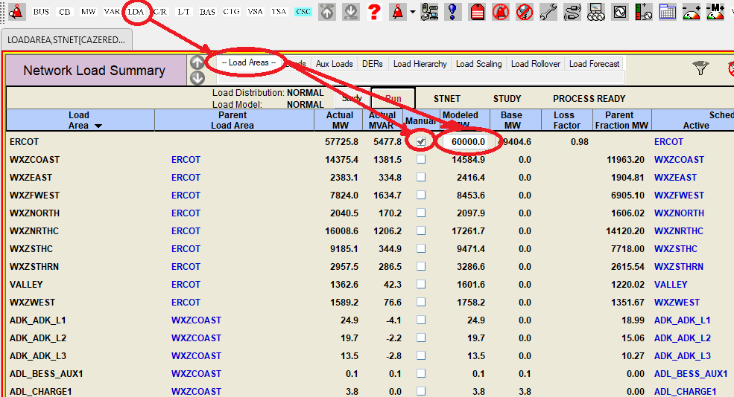

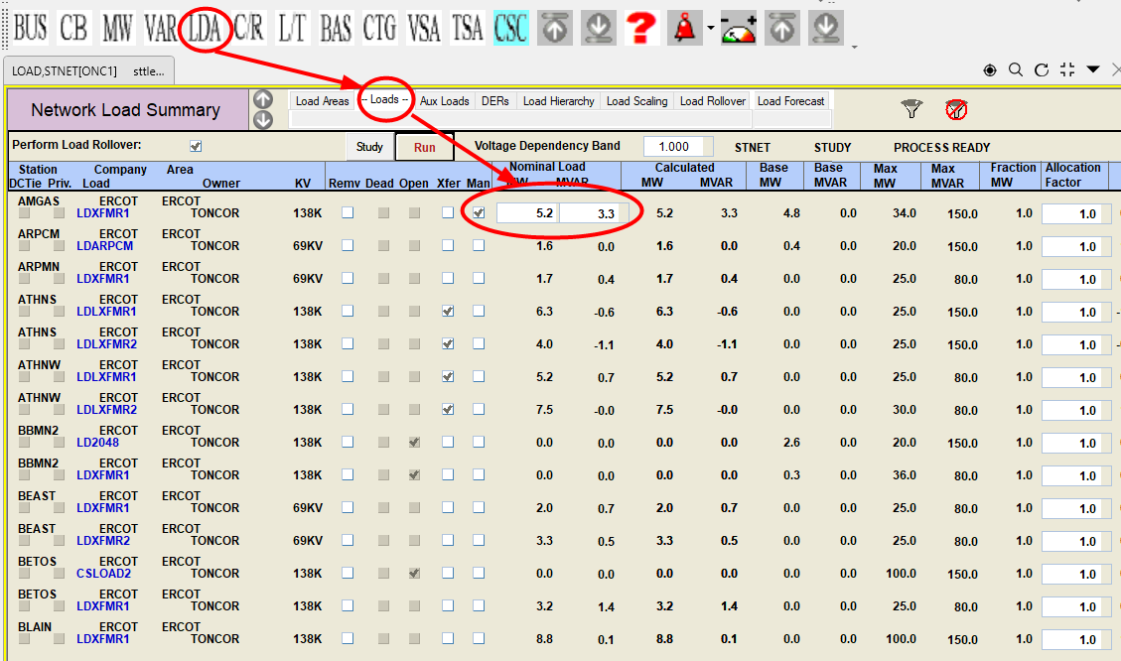

- Copy the exported “loadoutput_onc1.csv” locally. Make your updates and copy the updated file with the name “LP_ONC1_L.CSV” to Citrix folder
- Click on the Case Prep that would launch a pop-up.
- Click on “Read Load Plan ” button on the pop-up.
- Status “STNREADLDDATA Done” would be shown for successful completion of load plan being updated to the study.
